Virginia Beach Housing Study Update
Virginia Center for Housing Research
HousingForward Virginia
January 16, 2024
Table of contents

About this study
This study is a follow-up to the previous Virginia Beach Housing Needs Assessment and Market Analysis completed by the Virginia Center for Housing Research at Virginia Tech (VCHR) in 2016. The goals for this update included analyzing more recent data on housing needs, and the creation of detailed, actionable policy recommendations.
For this report, VCHR conducted stakeholder outreach and completed a new housing affordability assessment. HousingForward Virginia (HFV), a statewide nonprofit organization that provides research and technical assistance to practitioners across the Commonwealth, also contributed to this report by developing the solutions and assembling this final document.
The findings and recommendations provided here reflect multiple rounds of input from elected officials, City staff, community organizations, and residents throughout Virginia Beach. Additional details on the study process and engagement activities are provided in the Preface and Appendices.
Completed January 15, 2024

Executive summary
Virginia Beach’s housing market has progressed since 2016, showing both positive growth and emerging challenges. Home prices are rising yet remain reasonably accessible. The pace of sales and vacancy rates indicates market balance. However, increasing market tightness presents challenges, notably the scarcity of affordable homes for low-income families. The study outlines these trends and proposes policy solutions to ensure housing opportunities for all.
 | The original 2016 report (Virginia Beach Housing Needs Assessment, Market Analysis, and Re-Investment Study), along with the full version of this study update, are available on the Department of Housing & Neighborhood Preservation page of the City’s website: VirginiaBeach.gov/HousingStudy

Market strengths
The city’s housing market is healthier now than in 2016. The median price of homes has increased by 36%, indicating strong demand, and homes typically remain on the market for 40 days, indicating a balanced market. This balance benefits both sellers, who can expect to sell their homes within a reasonable period at a good price, and buyers, who have the luxury of time to explore multiple options without pressure.
In the rental sector, a 5% vacancy rate also suggests a well-balanced market, providing renters with a variety of well-managed properties to choose from and ensuring efficient lease-up times for property managers. These trends indicate a housing market that is stable and accommodating for most participants in the current scenario.

Emerging challenges
Despite these positive trends, Virginia Beach now faces significant affordability and accessibility challenges. A critical concern is the lack of rental units affordable to very-low-income households, many of whom are employed in the city’s top 10 most common occupations. These individuals often bear the burden of high housing costs to remain in the city. Additionally, a shortage of units for above-average earners creates undue pressure on moderately priced housing stock.
Limited homeownership opportunities for low- and moderate-income households represent another pressing issue. The tightening market, coupled with today’s less favorable mortgage options, places these potential buyers at a disadvantage. The inability of working households to build wealth through homeownership could prompt them to seek housing in other areas, adversely impacting the local workforce and business retention in Virginia Beach.

New solutions
When working households don’t have the opportunity to find an affordable apartment or buy a home and build wealth in Virginia Beach, they will seek housing elsewhere. This makes it hard for businesses and other essential public services — including schools and hospitals — to attract and retain workers. Virginia Beach must address its housing gaps by adding suitable, attainable options. This study presents eight policy and program solutions in three categories:
Strategic priorities
Strategic priorities focus on long-term systemic change. They include establishing a Housing Trust Fund as a sustainable financial backbone for affordable housing initiatives and using recently expanded powers of the City of Virginia Beach Development Authority to develop large-scale projects that simultaneously stimulate economic growth and affordable housing opportunities. In addition, a well-designed housing education campaign would give residents a rich, well-informed perspective on housing issues across Virginia Beach.
Easy wins
Easy wins offer quicker, more straightforward solutions that can make an immediate difference. Creating a new Housing Assistance Fund would directly benefit workers and their families who may be struggling to find homes that meet their needs and budgets. Leveraging the Virginia Statewide Community Land Trust could also bring near-term benefits by introducing permanently affordable homeownership opportunities.
Background work
Background work includes important tasks needed within current and future planning efforts to prime Virginia Beach’s core operations in support of its long-term housing goals. These include exploring self-sustaining financing models for mixed-income, mixed-use developments; streamlining permitting and review processes; and establishing a diverse stakeholder group to transform housing elements of the City’s comprehensive plan into new zoning regulations that promote — not hinder — housing affordability.
The full descriptions of each solution offer realistic implementation steps for City leaders, staff, and other partners to follow. While these recommendations are tailored specifically to Virginia Beach, relevant examples of best practices from different communities — both in Virginia and in other states — are included for inspiration.
Informed by thorough analysis of housing market dynamics and meaningful community engagement, this study is a roadmap to lead Virginia Beach toward greater economic opportunity and community stability by making it easier for residents to find, afford, and thrive in their homes.

Preface

About VCHR & HFV
The Virginia Center for Housing Research at Virginia Tech (VCHR) was created by the Virginia General Assembly and Virginia Tech in 1989 to respond to the housing research needs of Virginia and the nation. In its 25-year record of performance, VCHR has established an unparalleled reputation for high-quality research on affordable housing that integrates policy, building technology, and the housing industry. In response to every request, VCHR identifies the best talent within Virginia Tech and beyond providing the capacity, talent, and drive to deliver the best proposal possible. VCHR works with multiple partners and sponsors to fulfill its mission within the commonwealth, including Virginia Housing, DHCD, HousingForward Virginia, and the Virginia Association of Realtors®.
HousingForward Virginia (HFV) is a Richmond-based 501(c)3 nonprofit organization that serves as the commonwealth’s trusted resource for knowledge and insight on affordable housing. HFV is led by a diverse board of directors representing Virginia’s geographies and housing stakeholders. Advocates, planners, developers, and mission-aligned organizations rely on HFV to understand challenges, build solutions, and advance their work. For more than a decade, HFV has helped complete numerous local, regional, and statewide housing studies in Virginia, often in partnership with VCHR. Its collective expertise in policy, finance, and research helps practitioners translate information into meaningful action.

Acknowledgements
This study benefited from data and input from the Real Estate Information Network (REIN), Virginia Beach City staff, Virginia Beach City Council members, focus group participants, and Virginia Beach residents and workers.
REIN provided historic sale data, which is the best data source for analyzing for-sale housing market trends and a fundamental component for estimating housing costs in VCHR’s Naturally Occurring Affordable Housing (NOAH) analysis.
Virginia Beach staff provided data such as the number of dedicated, affordable housing units and real estate assessment data and analysis. They also coordinated and led public engagement sessions; participated in focus groups and supported note-taking; and provided significant feedback and input as the study team refined content and developed potential solutions.
Many Virginia Beach City Council members participated in study interviews to share housing challenges experienced by constituents in their districts, as well as offering their own perspectives as residents, workers, business owners, and committee members. The Virginia Beach City Council also actively contributed feedback and input on study deliverables.
Virginia Beach residents, business owners, service providers, developers, and others participated in the study’s qualitative information gathering process, helping to ground the study in real-life examples of housing-related challenges and concerns. Input from participants in public engagement sessions and expert focus groups helped the study team assess the validity of data analysis and focus policy and program recommendations on the priorities of residents and on the challenges faced by the businesses, organizations, and agencies that serve the city.

Scope of work and process
The City of Virginia Beach requested that VCHR and HFV replicate the housing market analysis and housing needs assessment from the prior, 2016 study, including housing stock characteristics and household characteristics. In addition to study updates, the City requested an analysis of “naturally occurring” affordable housing, an analysis of workforce affordability, and significant public engagement.
The study process began with public engagement. VCHR collaborated with Virginia Beach staff to conduct public meetings and to deploy an online questionnaire for residents via the Virginia Beach town hall online platform. VCHR hosted a training to prepare Virginia Beach staff to facilitate VCHR’s public engagement design, which featured small group discussions. Virginia Beach staff coordinated meetings across the city, facilitated meetings, and took notes. VCHR analyzed meeting notes to draw out shared concerns and themes of the discussion.
VCHR also engaged local experts such as builders, developers, REALTORS, lenders, housing service providers, employers, business groups (i.e., resort area contingency and Town Center business), and school representatives. These important stakeholders in housing helped the research team understand housing-related challenges and opportunities. Virginia Beach staff recruited and scheduled these focus groups, while VCHR facilitated each group and identified themes and critical pieces of information from the groups as a whole.
Following data collection and analysis, VCHR collaborated with HFV to interview each Virginia Beach sitting councilmember as their schedules permitted. Interviews with councilmembers had a dual focus: (1) collecting information about housing challenges by district and perceptions regarding the role of housing in the broader well-being of the city, and (2) understanding perspectives on policy and programs to gauge councilmembers’ willingness/inclination to make policy or dedicate funds and other resources.
HFV led the development of policy recommendations for the study. HFV examined recommendations from the previous study to determine which strategies have been implemented in full, in part, or not at all. Using data analysis from VCHR and information gathered from public engagement, focus groups, and Virginia Beach staff and councilmember interviews, HFV assessed whether any of the recommendations from the prior study or existing programs should be continued, expanded, or changed. HFV worked with VCHR and City staff to develop a preliminary list of housing priorities to be addressed by solutions in the plan update and — in consultation with VCHR and City staff — proposed initial solutions ideas to City Council. Following refinement, a second presentation, and approval, HFV drafted full strategy proposals, including example best practices.
HFV developed 8 detailed policy/program recommendations. Elements of each solution include:
- A high-level summary of how the strategy works and how it will address the city’s housing priorities
- A detailed description that explains the specific mechanics of the policy or program solution
- A list of entities responsible for planning, implementing, and monitoring the solution
- A timeframe for implementation and immediate next steps
- Funding sources and opportunities (if required)
- Methods for tracking progress and measuring success
- Successful examples and best practices from comparable communities

1. Introduction

1.1 Major changes since 2016
The 2016 study, which analyzed 2014 data, reflected a housing market recovering from the 2008-2009 Great Recession and struggling to respond to housing preferences for millennials, who succeeded baby boomers as the largest living generational cohort. The 2016 study identified lagging demand as a threat that could exacerbate underinvestment in housing.
However, since 2016, demand for housing in Virginia Beach has continued to recover, with average days on the market declining by over 50%. A healthier balance between supply and demand incentivizes both homeowners and investors to maintain and upgrade their homes. The new risk is a tightening market. In a tight market, first-time and moderate-income buyers are often edged out in the for-sale market by buyers paying cash or making offers well above asking prices. In addition, the for-rent market is overextended, forcing tenants to compete for units by accepting poor conditions and management.
Housing cost burden — when housing costs consume 30% or more of a household’s income — fell 11% between 2014 and 2021. While 2014 data reflected the lingering impact of the Great Recession, when unemployment and wage growth had not yet returned to pre-Crash levels, 2021 data reflects the mixed impact of the COVID-19 pandemic on the housing market.
On one hand, the pandemic triggered a serious economic shock heavily impacting the tourism and hospitality sectors central to Virginia Beach’s economy. On the other hand, the shock was met with an unprecedented expansion of unemployment benefits, direct economic stimulus, business support, and rental assistance providing meaningful relief to many struggling households. Relief such as the Child Tax Credit and emergency rental assistance was still active and therefore reflected in the 2021 data.
However, it’s likely that as these assistance programs expired, lower-income households have will increasingly struggled with affordability in a way that is only just being reflected in the 2022 national data as this report is being finalized.

Table 1.1: Changes to Major Housing/Household Measure 2014-2021
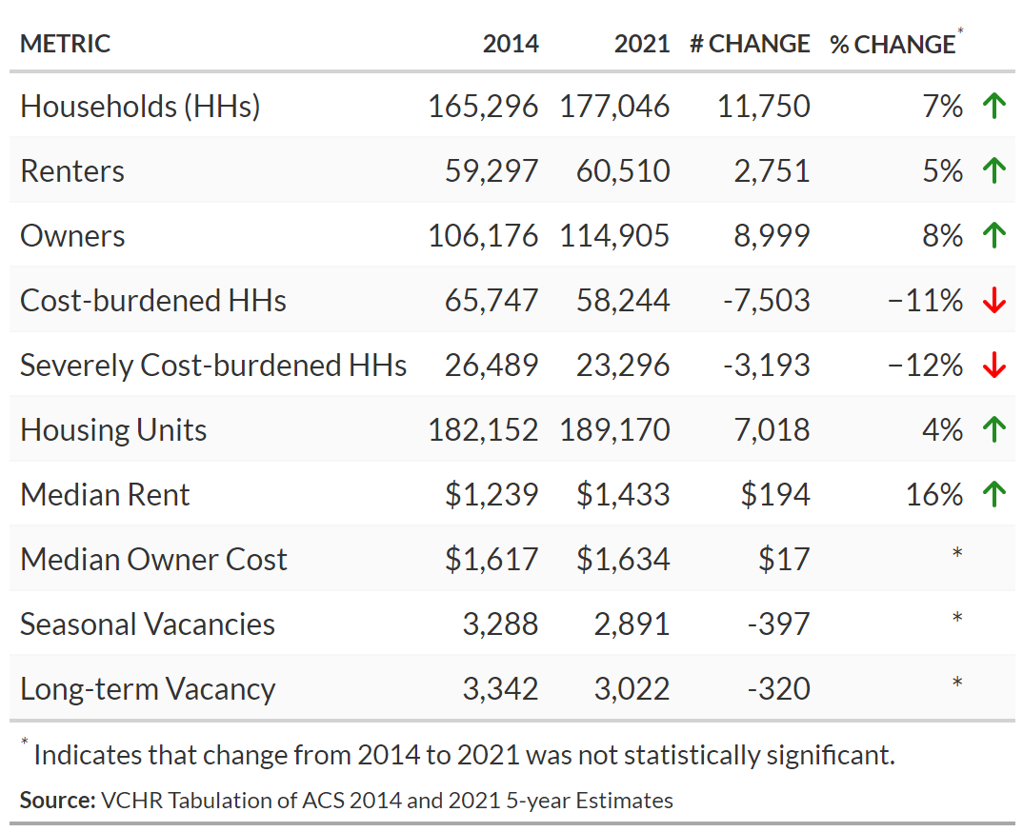

Millennials and boomers
The 2016 study paid particular attention to generational differences in housing preferences between millennials and baby boomers. Housing preference research suggests that millennials as a group prefer walkable, transit-oriented built environments to a greater degree than preceding generations. However, Myers suggests that the unprecedented urban migration of millennials in the late 2000s and early 2010s may have resulted from a synchronization of life cycle, business cycle, and housing market cycle, and is now reversing.
The number of millennial households grew by 30% between 2014 and 2021, from approximately 40,229 to 52,131, reflecting the cohort’s move further into peak household formation. The number of millennial households living in single-family detached houses increased by 84%, from approximately 12,051 in 2014 to 22,168 in 2021. The number of boomer-headed households decreased by 7% and the number of boomer-headed households in single-family detached houses decreased by 11%, indicating a transition to attached and multi-family housing.
The share of millennial-headed households in single-family detached houses increased by 13 percentage points, while the shares living in single-family attached and multifamily dwellings fell by 5 and 7 percentage points, respectively. The share of boomer-headed households in single-family detached houses decreased by 3 percentage points, while the shares living in single-family attached and multifamily dwellings rose by 2 points and 1 point, respectively.
Since the 2016 study, members of the baby boomer generation have moved more fully into retirement years. A greater share of this cohort now lives in homes owned free and clear, from 17% in 2014 to 25% in 2021. However, the considerably higher costs of other forms of tenure may discourage boomer homeowners from transitioning to housing more suitable to aging in place, or from downsizing and thereby increasing the supply of owner-occupied housing available to younger households. Furthermore, older adults are the most likely to live alone, and housing cost burden is pervasive among older, one-person households. As baby boomers age, the need for affordable senior housing in Virginia Beach will continue to grow.

2. Data and methodological notes

2.1 Quantitative analysis
The American Community Survey (ACS) Public Use Microdata Sample (PUMS) is VCHR’s main source of information on city households, including demographic profile (e.g., family size, family type, householder age); occupancy characteristics (e.g., number of occupants, presence of children, seniors, elderly, and/or people with disabilities); and tenure (i.e., whether the household rents or owns the home where they live). The ACS PUMS also enables VCHR to create custom tabulations of U.S. Census data: households headed by a millennial, households headed by a baby boomer, households with one or more senior members, households by income, etc. VCHR analyzed five-year estimates from 2021, the most recent data year at the time of writing. In limited circumstances, VCHR used one-year data for analysis but has reported five-year data throughout the report for consistency. One-year estimates were not reliable for many sub-population measures.
In some instances, VCHR used the ACS published tables to conduct analysis over time. Household non-response increased substantially in the ACS during the COVID-19 pandemic because of the challenges of conducting a household survey, especially for households with lower socioeconomic status — those most likely to experience housing cost burden and other housing-related challenges. Although the Census Bureau has refined its methodology to reduce the effect of non-response bias owing to the COVID-19 pandemic, the organization still labels 2020 data as experimental. As such, VCHR has omitted 2020 ACS data from longitudinal analysis and, where necessary, represented the period from 2019 to 2021 as a broken line.
VCHR used a special ACS tabulation called Consolidated Housing Affordability Strategy (CHAS) data to estimate the degree to which economic means of households are matched with affordability of the housing supply. The housing affordability gap analysis can be found in Chapter 5. The CHAS data designates each unit as affordable to specific income levels based on the size of the unit, the unit’s value or rent, and the level of income required for a household of corresponding size to affordably rent or own the unit. The CHAS tabulation also provides data on the income levels of occupants currently living in units at each unit affordability level.
VCHR used 2020 OnTheMap data from the U.S. Census Bureau’s Center for Economic Studies to analyze commuting patterns and identify groups that disproportionately commute into the city for work. VCHR described the inflow and outflow of workers in the city and documented trends of note by worker’s income, age, and industry. Full details can be found in Section 5.2.
VCHR’s workforce housing affordability analysis compares maximum affordable housing costs by occupation to city housing costs to determine which workers may struggle to afford housing in the city or may commute from outside the city because they cannot find appropriate, affordable housing close to their job.
Using May 2022 annual wage data of the Virginia Beach-Norfolk-Newport News MSA from the Bureau of Labor Statistics, VCHR calculated maximum affordable monthly housing costs (30% of monthly income) for each occupation using three scenarios:
- A single earner with a median wage
- A single earner with a 90th percentile wage to represent highly skilled or experienced workers
- Two earners with a median wage for a single occupation to represent a dual-earner household
VCHR used 2021 ACS survey data on median gross rent and median selected monthly owner costs with a mortgage to define housing costs. Full details regarding the workforce housing affordability analysis methodology can be found in Appendix B.
The concept of Naturally Occurring Affordable Housing (NOAH) has gained attention as home prices and rents increase rapidly and as housing affordability, from both homeownership and rental perspectives, remains a pressing concern for residents in many cities. NOAH refers to affordable housing units that arise in the marketplace without specific incentives or regulations.
VCHR used FY 2022 Income Limits from the Department of Housing and Urban Development (HUD) to categorize affordability levels for 145,498 units in Virginia Beach assessment data. The NOAH analysis is driven by two primary objectives:
- To realistically gauge the costs for low- to moderate-income households to own a home and to evaluate how many homes in the current market align with their affordability thresholds
- To estimate the availability of affordable rental multifamily units in the market
For homeownership, VCHR relies on assessment data, with supplemental datasets helping to estimate other associated costs (e.g., insurance, utilities, HOA and condo fees, interest rates), ultimately leading to the computation of the monthly payment. For rental, VCHR employs CoStar data, extracted in May 2023, to derive monthly housing costs for multifamily units. Full details regarding the NOAH analysis methodology can be found in Appendix C.
VCHR analyzed 2015-2022 home sale data provided by the Real Estate Information Network (REIN) on behalf of the Hampton Roads Realtors Association. VCHR used this data to analyze trends and demand in the homeownership market. VCHR further used this data to adjust assessed value to estimated current market value and to estimate HOA and condo fees for the NOAH analysis.
In addition to using CoStar data to categorize rental units by affordability, VCHR used CoStar data to supplement ACS data on rental market trends. VCHR reviewed 2023-Q1 CoStar data on rental vacancy rate and rental absorption rates to provide a more current perspective on rental market trends.
The City of Virginia Beach provided data including real estate assessment data; data on existing income-restricted housing and on building trends; and housing policies, plans, and prior studies. VCHR used this data throughout its analysis and documented its use in the source lines of graphs and tables. VCHR and HFV used information regarding housing policies and plans to develop solutions. In instances where analysis was not included in this scope of work but has been conducted elsewhere, VCHR noted those references for the reader.

2.2 Qualitative analysis
Qualitative data from experts, stakeholders, and citizens helped the study team assess the validity of quantitative data analysis, identify additional topics for analysis, and contextualize study findings. VCHR has summarized themes of the discussions as a whole to promote earnest conversation and protect the anonymity of participants. Details regarding the data collection approach and findings are documented here and in the report appendices.
VCHR collaborated with Virginia Beach staff to conduct public engagement. VCHR designed a public engagement protocol to be used for in-person meetings and to collect data from residents online through the Virginia Beach town hall online platform. VCHR and City staff conducted one virtual and five in-person engagement sessions and received 109 responses to protocol questions on the town hall platform. Summaries of in-person and online responses are included in the report appendices.
Local experts such as builders, developers, REALTORS, lenders, housing service providers, employers, business groups (i.e. resort area contingency and Town Center business), and school representatives are valuable resources in understanding housing-related challenges and opportunities. VCHR partnered with City staff to conduct eight focus groups with these experts. Themes from these focus groups are documented throughout the report and summarized in the report appendices.
VCHR collaborated with HFV to conduct interviews of each Virginia Beach sitting councilmember. Interviews with councilmembers had a dual focus: (1) collecting information about housing challenges by district and perceptions regarding the role of housing in the broader well-being of the city, and (2) understanding perspectives on policy and programs to gauge councilmembers’ willingness/inclination to make policy or to dedicate funds and other resources. Questions focused on prior and current efforts to expand housing affordability, complementary initiatives in economic development and similar sectors, and aspirational goals for housing in the city.

2.3 Important terms and references
Tenure
The term “tenure” refers to the method by which a household possesses their home: renting, fully owned with no home loan, or owned with a mortgage or other home loan.
Cost-burdened Households
The U.S. Department of Housing and Urban Development (HUD) established the term “cost-burdened” to describe households who need more affordable housing. HUD defines cost-burdened households as “families who pay more than 30% of their income for housing... and may have difficulty affording necessities such as food, clothing, transportation, and medical care.” Severely cost-burdened households pay 50% or more of their income for housing and are likely to be making tough choices between housing and other necessities.
Percent of Area Median Income (AMI)
HUD sets income limits by household size that determine eligibility for assisted housing programs. HUD develops these income limits based on Median Family Income estimates and Fair Market Rent (FMR) area definitions for each metropolitan area, parts of some metropolitan areas, and each non-metropolitan county. These income limits are useful tools for assessing housing needs because they standardize income-based household categories while considering household size. The 2021 and 2023 income limits for the Virginia Beach HUD Metro Fair Market Rent Area are provided for reference, and the appropriate annual income limits based on data vintage were applied in the analysis.
Housing Affordability
Housing affordability is a broad term used to discuss the degree to which housing units in a market or submarket meet the income-based needs of households in that market. Researchers and practitioners generally consider housing affordability for income groups that may face challenges related to affording housing, including (but not limited to) the following:
- extremely low-income households who do not make enough money to obtain decent housing
- young workers who wish to become homeowners but cannot find a starter home with associated costs within their budget
- established owners who cannot find an appropriate home to “upgrade” to as their families grow and they enter their professional prime
- seniors who struggle to find affordable, accessible housing that meets their needs, including maintenance and modifications to make their existing homes suitable for aging
Housing affordability is not usually a concern for higher-income households who can obtain their desired housing without sacrificing other household needs such as safety, transportation, medical care, food, education, and childcare. However, a shortage of housing for households at any income level may affect businesses expanding in the market or economic development efforts for attracting new businesses.
Householder
This report refers to “householders” when the available data pertains to the householder as defined by the U.S. Census: “the householder refers to the person (or one of the people) in whose name the housing unit is owned or rented (maintained) or, if there is no such person, any adult member, excluding roomers, boarders, or paid employees. If the house is owned or rented jointly by a married couple, the householder may be either the husband or the wife. The person designated as the householder is the ‘reference person’ to whom the relationship of all other household members, if any, is recorded.”

3. Household trends
The City of Virginia Beach has a population of approximately 448,573 residents, living in 177,029 households. A majority of Virginia Beach households are family households, containing two or more people related by birth, marriage, or adoption. The most numerous type of family household is married couples without children, of which there are 50,460. The second most numerous is married couples with children, of which there are 38,536. The city also has a large population of older adults, with nearly one-quarter of households led by seniors 65 and older.
Dwelling unit sizes are generally mismatched with household size: 60% of Virginia Beach households consist of one or two people, yet three-quarters of dwelling units have three or more bedrooms. Senior householders are more likely to live alone than other age cohorts. Focus groups participants expressed concern about the isolation and poor living conditions endured by seniors living alone. Many suggested that the City increase outreach and services for this population, including case management, home modifications and in-home aid services where desired, and affordable options for assisted living. Focus group participants expressed the importance of seniors having a choice when either relocating to assisted living or aging in place.
A majority of Virginia Beach households own their homes, although the frequency of each form of tenure varies by householder race, householder age, and household income. A majority of Virginia Beach householders identify as white, non-Hispanic. Householders who identify as Black or Hispanic are more likely to rent than householders identifying as white or Asian.
Racial disparities in housing
In the United States, the homeownership rate of white households is 20%-30% higher than that of Black households, and the disparity increased from the 1970s to the 2010s. Researchers investigating the causes of racial/ethnic disparities in homeownership have noted inter-group differences in important predictors of homeownership. However, the disparity between white and Black households remains statistically significant when controlling for economic indicators, and the size of the disparity increases as household affluence decreases.
The extent and direction of kin-network wealth transfers likely contributes to this disparity. For moderate-wealth households, financial transfers from parents or extended family members are instrumental to meeting down-payment and closing costs. In addition, access to kin-network wealth helps households deal with the costs of emergency repairs and other shocks, making homeownership more secure, and it may influence a household’s decision to apply for mortgage financing. Moderate-income Black households are less likely to receive financial assistance from parents or relatives and more likely to provide such support to parents or relatives in need.
Institutional credit access has also been shown to vary by race. Controlling for indicators of creditworthiness, Black households are more likely than white households to be rejected for a mortgage loan and less likely to apply. The 2007-2008 foreclosure crisis caused disproportionate loss of homeownership among Black households, as the transition from redlining to “greenlining” in majority-Black urban areas meant Black homeowners disproportionately held subprime mortgage loans.
Quantitative analysis cannot evaluate racial discrimination as a causal factor in disparate homeownership rates. However, due to the high share of the Black-white disparity that cannot be explained by confounding variables, as well as experimental and audit evidence that discrimination based on race remains pervasive in housing and credit markets, racial discrimination is likely a causal factor. Furthermore, even when homeownership disparities can be largely explained by group differences in the social, economic, and contextual determinants of homeownership, it’s important to note that these group differences themselves reflect structural disadvantages shaped and perpetuated by discrimination.

3.1 Demographics
The median Virginia Beach householder age is 50 years old, and half of householders are aged between 36 and 63 years. Approximately 41,038 householders, or 23%, are seniors 65 or older. Only 6,976 householders, or 4%, are younger than 25.
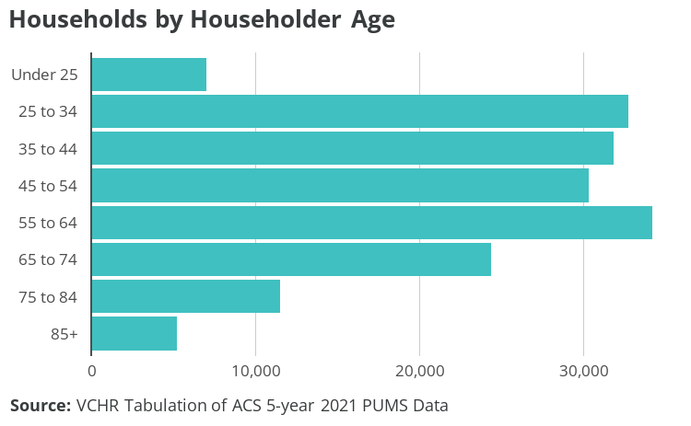
Figure 3.1: Households by Householder Age
Approximately 53,429 householders are baby boomers, aged between 57 and 75 in 2021; 52,131 are millennials, aged between 25 and 40 in 2021; and 6,976 are Gen Z or Zoomers, of whom the oldest are 24 years old.

Housing preferences by age
Households of retired persons or those close to retirement prioritize proximity to friends and family as well as conveniences when choosing a home location. Homebuyers 60 and older prefer suburban, small-town, and resort living over urban or rural places. Convenience to family/friends, health facilities, and shopping — as well as overall affordability — were the highest-ranking factors for buyers 68 and older.
Priorities for younger renters and buyers include proximity to work, affordability, and commuting costs. Although walkability is still important, younger generations’ preferences have shifted toward suburban contexts. Quality of and convenience to schools are also very important to younger buyers.
Regardless of age, recent buyers are looking for turnkey homes that do not require major renovations. Renters are looking for spacious floor plans, a washer/dryer, walk-in closets, balconies, and hardwood floors. The median home size for all buyers was 1,800 square feet, with buyers younger than 23 buying smaller homes (1,500 square feet).
Both renters and owners are gravitating toward single-family homes, and preferences are shifting toward larger homes that are further apart. In doing so, they accept longer commutes to schools and amenities. Internet access is considered very important for renters and owners alike.

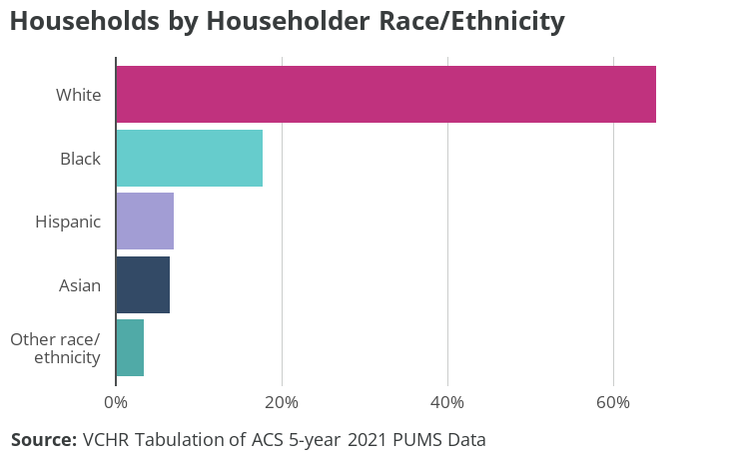
Figure 3.2: Households by Householder Race/Ethnicity
Over 65% of Virginia Beach householders identify as white, 18% as Black, and 7% as Asian. Seven percent of householders identify as Hispanic of any race.

3.2 Composition and living arrangement
The median household size in Virginia Beach is two people. One-person households make up 25% of households in Virginia Beach, and two-person households make up 35%. Seventeen percent of households are three-person, 13% are four-person, and 9% of households are five or more persons.
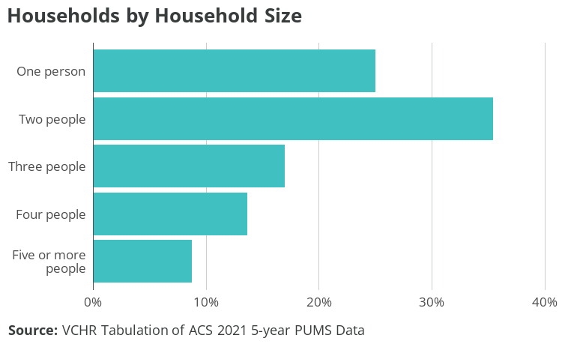
Figure 3.3: Number of Households by Household Size
While 60% of Virginia Beach households are one- or two-person, over three-quarters of dwellings have three or more bedrooms: 39% have three bedrooms, 24% have four bedrooms, and 6% have five or more bedrooms. Twenty-two percent of dwellings have two bedrooms that can accommodate a three-person family. Only 7% of housing units are efficiency/studio style or one-bedroom units. Adding smaller, multifamily units could increase the number of affordable, high-quality units without subsidy in the market. These units would have more appropriate square footage and number of bedrooms, and land costs would be distributed among a large number of units.
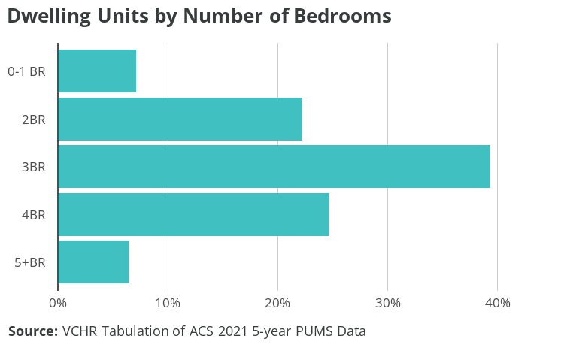
Figure 3.4: Dwelling Units by Number of Bedrooms
Smaller households are particularly common among senior households, the age group most likely to live alone. Approximately 35% of householders aged 65 to 74, and 42% of householders aged 75 to 84, live alone. Nearly two-thirds of householders aged 85 or older live alone. Single-person households who are dependent on fixed Social Security and/or retirement income can be vulnerable to rising rents or owner costs such as taxes, utilities, and insurance.
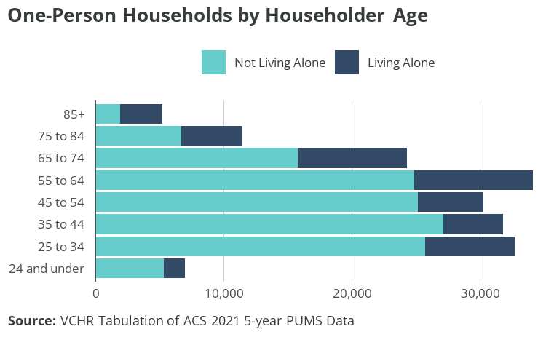
Figure 3.5: One-Person Households by Householder Age
Focus group participants expressed concern about the isolation and poor living conditions endured by seniors living alone. Many suggested that the City increase outreach and services for this population, including case management, home modifications and in-home aid services where desired, and affordable options for assisted living. Focus group participants expressed the importance of seniors having a choice when either relocating to assisted living or aging in place.
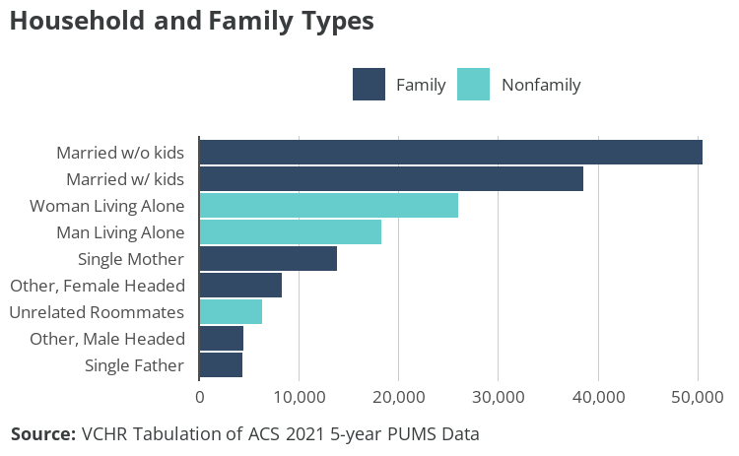
Figure 3.6: Household and Family Types
There are approximately 120,016 family households in Virginia Beach, accounting for 70% of all households. The most common family household configuration is married couples without children, of which there are 50,460. There are approximately 57,511 households with children: 38,536 are married couples with children, 13,850 are led by single mothers, 4,383 by single fathers, and approximately 742 with another living arrangement. There are 12,787 other family households with unmarried householders: around two-thirds are led by women and one-third by men. There are 7,212 multigenerational households, meaning at least three generations, making up 6% of family households of any configuration. Some focus group participants highlighted multigenerational households seeking larger homes as a new trend in city homebuying.
There are approximately 50,710 nonfamily households, and the most common form is one person living alone. Approximately 26,050 women and 18,289 live alone in one-person households. Approximately 6,374 households are made up of unrelated roommates, which accounts for 4% of all Virginia Beach households.

3.3 Tenure
Approximately 114,900 households in Virginia Beach are homeowners: 65% of all households. Around three-quarters of owned homes are owned with a mortgage or loan, while one-quarter are owned free and clear. Approximately 60,510 households are renters: 34% of all households.
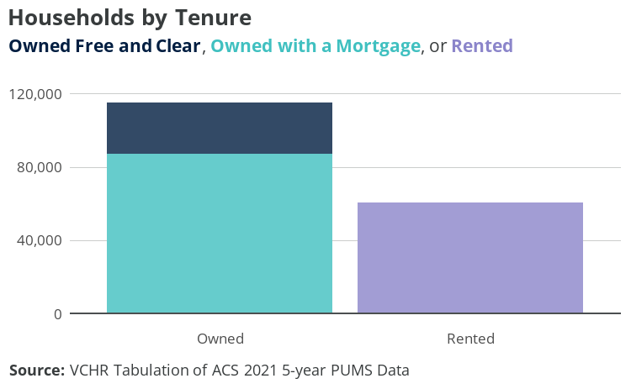
Figure 3.7: Households by Tenure
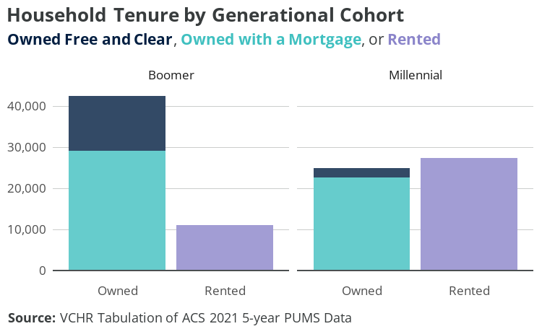
Figure 3.8: Household Tenure by Generational Cohort
Household tenure varies considerably by generational cohort. Nearly 80% of baby boomer–headed households own their homes. Only 1 in 5 boomers rent, compared to over half of millennials and over 90% of Gen Z households. Furthermore, among homeowner households, nearly one-third of boomers own their home without a mortgage or loan payments, compared to under one-tenth of millennial households.
Millennials face a tougher homeownership landscape than both preceding and succeeding generations. They have lower homeownership rates than baby boomers at the same age. The disparity is attributed to economic challenges stemming from entering the workforce during the 2001 recession and the subsequent 2008 financial crisis. These factors curtailed earnings, wealth accumulation, and the ability to purchase homes for an extended period.
On the other hand, Gen Z has a higher homeownership rate compared to other generations at the same age. Gen Z’s success in homeownership is attributed to various factors. Many capitalized on historically low mortgage rates during the pandemic, notably in 2020 and 2021. Additionally, a robust job market and substantial wage growth played a pivotal role. Despite graduating from college around the pandemic’s onset, Gen Z experienced advantageous financial circumstances including federal financial support and near record-low unemployment rates. Remote work also enabled them to explore more affordable housing markets.
While multiple factors influence homeownership among different cohorts, economic factors — particularly low mortgage rates and high employment rates — stand out. After all, the access to homeownership of two generations — millennials and Gen Z, who are most active in the labor market — will likely be impacted by economic conditions and housing supply.
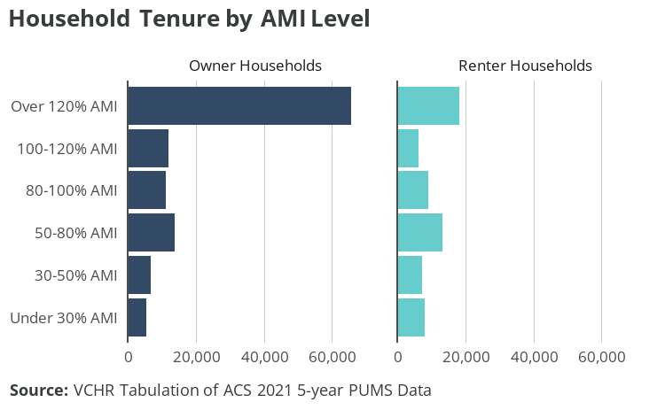
Figure 3.9: Household Tenure by AMI Level
Tenure also varies based on income. HUD definitions of income (Table 3.1) are applied in this analysis because they constitute the basis for many of the programs addressing disparities in access to homeownership and other housing challenges.
Table 3.1: HUD Fair Market Rent (FMR) Income Limits, Virginia Beach-Norfolk-Newport News, 2021
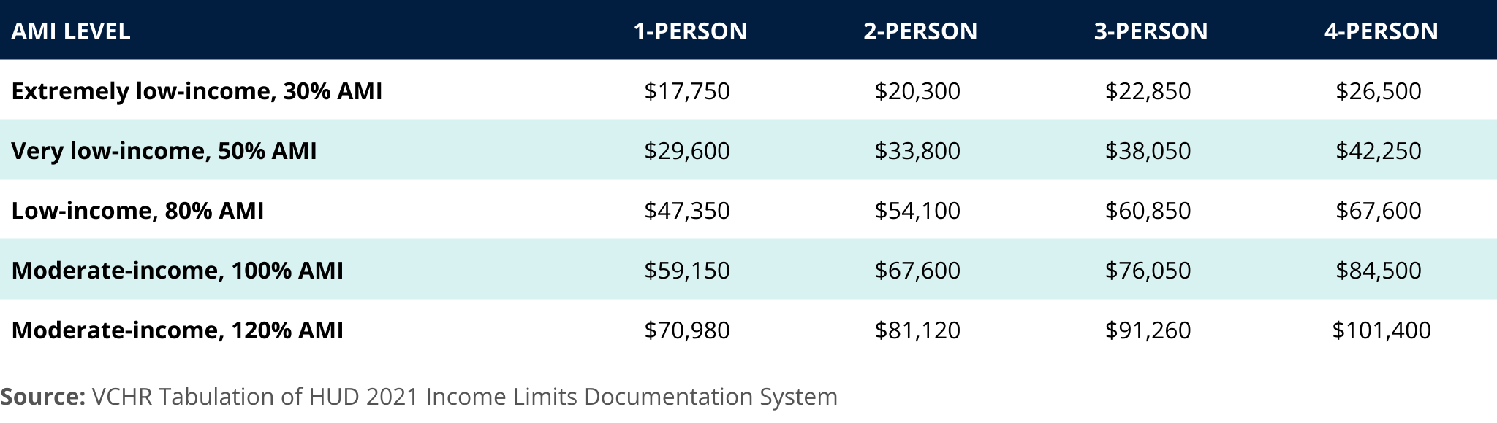
Although 2021 limits are used in the data analysis to align with the data’s vintage, VCHR has provided the most-recent income limits, which better reflect current incomes in Virginia Beach.
Table 3.2: HUD Fair Market Rent (FMR) Income Limits, Virginia Beach-Norfolk-Newport News, 2023
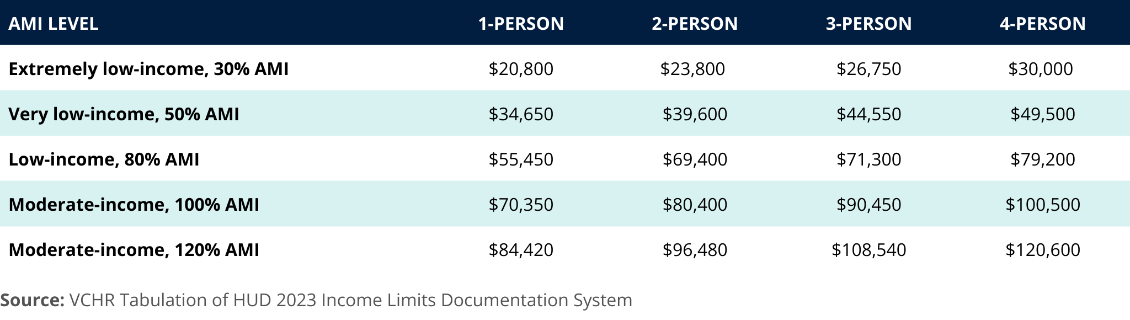
Households with higher incomes relative to AMI are more likely to own their homes. Nearly 60% of homeowners have household incomes above 120% of AMI, while over 60% of renters have household incomes below 100% of AMI. Nearly 80% of households above 120% AMI are owners, while only 22% are renters. Among extremely low-income households — those at 30% AMI or less — 60% are renters and 40% are owners.
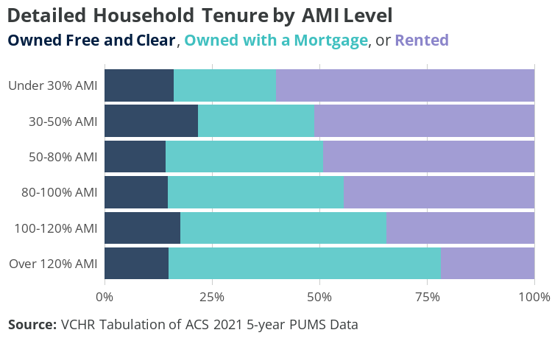
Figure 3.10: Detailed Household Tenure by AMI Level
Households at lower AMI levels are less likely to own their homes, but, as shown in Figure 3.10, lower-income households who do own their homes are more likely to own free and clear. For example, among households below 30% AMI, 40% are homeowners but nearly 60% of homeowners own free and clear. In contrast, among households above 120% AMI, nearly 80% are homeowners, but under 20% of homeowners own free and clear. Given the high cost of homeownership with a mortgage, homeowner households at lower AMI levels are likely to be older households living in a home they have already paid off.
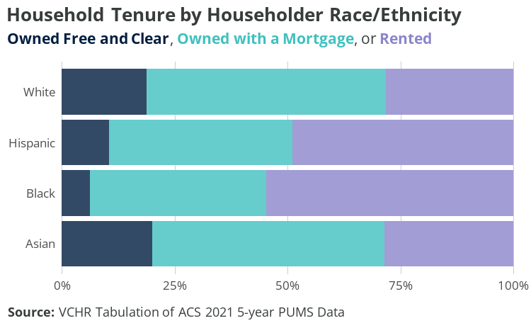
Figure 3.11: Household Tenure by Householder Race/Ethnicity
Finally, household tenure and form of ownership vary by householder race and ethnicity. White and Asian households are twice as likely to own than to rent. A narrow majority of Hispanic households own their homes, while 55% of Black households rent. Among homeowners, a higher share of white and Asian households (over one-quarter) own their homes free and clear, compared to 1 in 5 Hispanic and 1 in 7 Black homeowner households.
Tenure plays a crucial role in housing affordability, with renters more vulnerable to increasing housing costs than homeowners, and a higher rate of housing cost burden among renters than among owners. By definition, cost-burdened households spend more than 30% of their income on housing costs, which can make it difficult to afford other necessities like food, healthcare, and transportation.
While homeowners generally have fixed mortgage payments that change little from year to year, renters often face increased housing costs annually. In competitive markets, they may also be subject to turnover in unit ownership, which is often associated with higher rent increases. Housing affordability is discussed in more depth in Chapter 5.

4. Market dynamics

4.1 Rental
There are approximately 66,302 rental units in Virginia Beach: 62,048 are occupied, 957 are rented but not yet occupied, and 3,297 are vacant for rent. The rental market vacancy rate is 4.97%. Although rental vacancy rates suggest that this quantity of rental housing is adequate, most units have rents close to the median, which is unaffordable for many households and may neglect the preferences of higher-income renters. To promote market health and diversity, the city should add affordable units dedicated to lower-income households as well as units responding to the preferences for higher-end rental products.
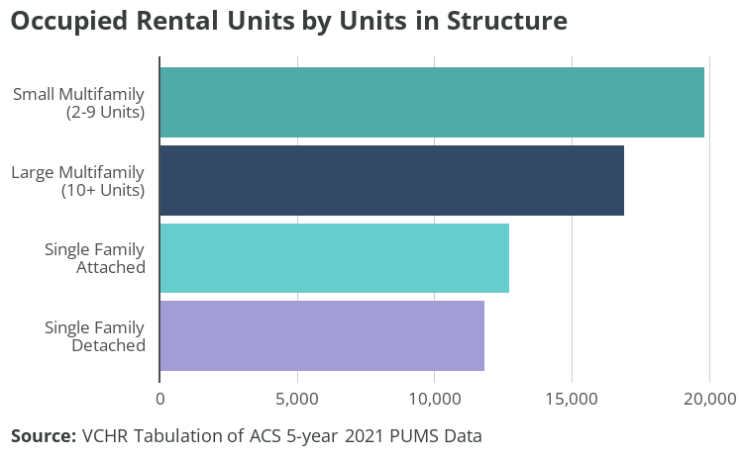
Figure 4.1: Occupied Rental Units by Units in Structure
While over half of Virginia Beach housing units are single-family detached, and another one-fifth are single-family attached, a majority of rental units are in multifamily structures. There are approximately 19,819 rental units in small multifamily structures (2-9 units) and 16,928 rental units in large multifamily structures (10 or more units), together making up nearly 60% of rental units. Single-family detached and attached each make up around one-fifth of rental units. While nearly 90% of single-family detached and over 60% of single-family attached units are owned, less than 15% of units in multifamily structures are owned.
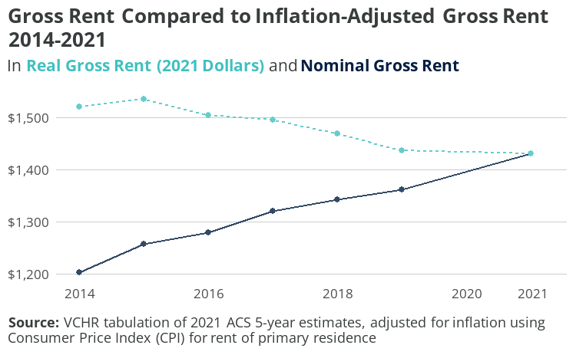
Figure 4.2: Gross Rent Compared to Inflation-Adjusted Gross Rent 2014-2021
Figure 4.2 compares median gross rent to median gross rent adjusted for inflation (in 2021 dollars) from 2014-2021. Median nominal gross rent has grown steadily, from $1,203 in 2014 to $1,431 in 2021 — an 18% increase over eight years; however, inflation-adjusted rent shows a 6% reduction.
Rent estimates in ACS data used here have two important features: first, the figures lag at least one year actual market conditions due to the time required to complete and analyze survey responses; second, they include all housing types, from multifamily apartments to single-family rentals. Furthermore, the annual values for 5-year estimates reflect a rolling average from that period — not a specific figure for that year.
Real versus nominal rents
While nominal rents show the actual values from that year, adjusting for inflation produces real rents. Both measures are important because they reflect different experiences in the economy.
Households whose incomes keep up with inflation have stable purchasing power over time and may feel their position improving. Households whose wages are less responsive to inflation struggle to keep up with the rapidly increasing nominal rent. Lower-wage workers often do not receive cost-of-living adjustments or considerations as often as higher-wage earners for whom companies must compete.
Focus group attendees cited rapidly increasing or severe rent hikes experienced by clients with low incomes. They interpreted these increases as efforts to effectively evict residents with low or fixed incomes in favor of households who can afford higher rents.
CoStar data can be used to supplement ACS rent estimates because its database includes almost all multifamily properties, and is updated continuously. However, CoStar almost exclusively tracks professionally-managed rental properties (i.e. multifamily apartments and some townhome/single-family homes), which excludes many single-family rentals operated by small landlords.
Figure 4.3 shows the average nominal and inflation-adjusted asking rents for Virginia Beach from 2014 through 2023. In contrast to gross rent, these asking rents do not include utilities. Also, unlike the ACS estimates, these data do show a real increase — up 7.3% to $1,522. However, real rents actually peaked at $1,583 in 2021, and slightly declined to 2023. This could reflect a backlog of supply coming online after initial delays created by the COVID-19 pandemic.
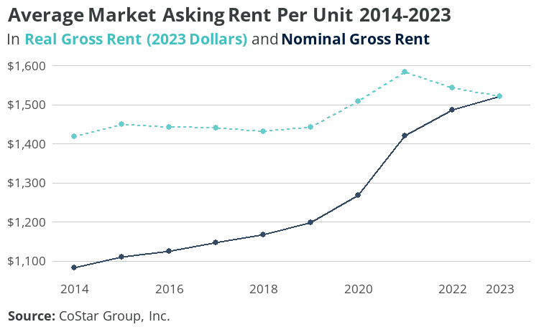
Figure 4.3: Average Market Asking Rent Per Unit 2014-2023
The median gross rent from ACS estimates, which includes utilities, is $1,433, and the median contract rent is $1,260. A large majority of rental units in Virginia Beach have a gross rent of between $1,000 and $2,000. Over 45% of units rent for between $1,000 and $1,499, while 31% rent for between $1,500 and $1,999.
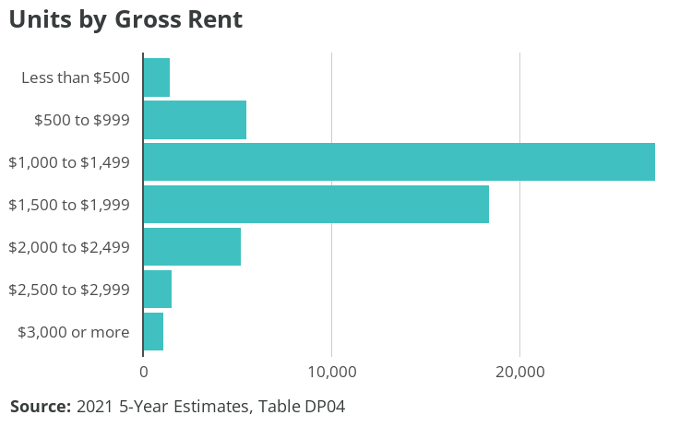
Figure 4.4: Units by Gross Rent
Tabulation of ACS data shows a rental market vacancy rate of 4.97% in 2021. This represents a small decline from the 2014 market vacancy rate of 5.33% but not a statistically significant change. The market vacancy rate is calculated from vacant rental units listed for rent, as a percentage of all rental housing units.
CoStar data, however, shows a higher vacancy rate of 7.06% in 2014. The rate declined significantly during the pandemic, reaching a low of 3.36% in 2021, reflecting a significant shift in supply and demand. Since then, vacancy improved to 5.65% for 2023.
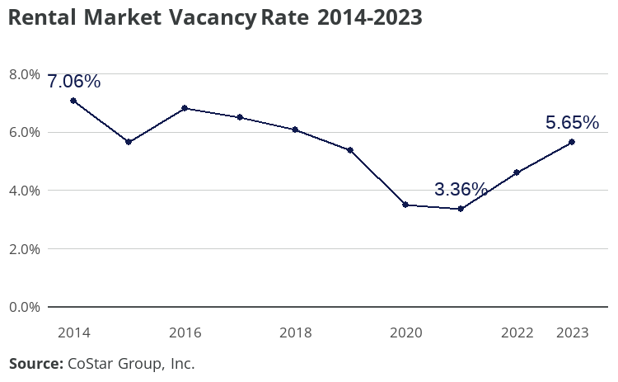
Figure 4.5: Rental Market Vacancy Rate 2014-2023
Vacancy rates from both ACS data and CoStar data suggest that, as of today, the city has a healthy quantity of rental units. Still, units should be added to keep up with continued demand.
Housing submarkets
Housing markets have been theorized as segmented markets, meaning a region’s housing market is made up of overlapping submarkets distinguished by price, location, and other qualitative differences. When a tenant’s apartment search yields many costly but few affordable units, it can lead to the perception that the rental market is tighter on the lower end.
PUMS data partially validates this perception — with the important caveat that the small sample size of vacant for-rent units in the PUMS yields lower-confidence estimates. The market vacancy rate among units renting below the median rent level is 4.5%, while market vacancy among above-median units is 5.8%. These lower-confidence findings show that among the bottom half of rental units by price, demand is higher in relation to supply.
Construction of new apartments has been steadily decreasing since 2018, and although market vacancy does not recommend a substantial reversal of this trend, focus group participants discussed how the competitive rental market increasingly excludes certain households. Higher-income households are often advantaged in the market. Focus group participants recounted practices that prioritize higher-income households and exclude lower-income households, such as requiring three months’ rent as a deposit and refusing voucher holders or other types of housing assistance.
In addition to exposing possible illegal discrimination, these examples are evidence of a tightening market where renters must compete for units rather than landlords competing for renters. Since focus group participants observed the exclusion of families, seniors, and households with low incomes, prioritizing the development of units for these groups could promote market health in addition to addressing a housing gap. More information on rental housing gaps is provided in Chapter 5.
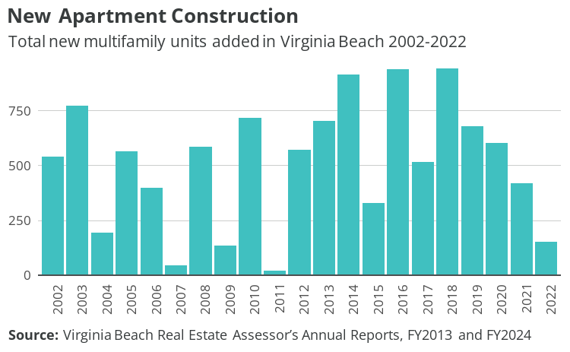
Figure 4.6: New Apartment Construction

4.2 Homeownership
The Virginia Beach homeownership market has attracted a healthy demand, following the Great Recession and a period of stagnant prices and slow pace that lasted until 2016. Median price grew 8% over 2005-2015, which includes the ups and downs of the housing “bubble” period, the Great Recession, federal tax credit support for first-time homebuyers (2009), decline following the removal of those tax credits (2010-2011), and the initiation of unsupported recovery. From 2011-2015, Virginia Beach lagged behind the state in price recovery from the recession, and stagnant demand was associated with less-than-adequate investments in the city’s housing stock.
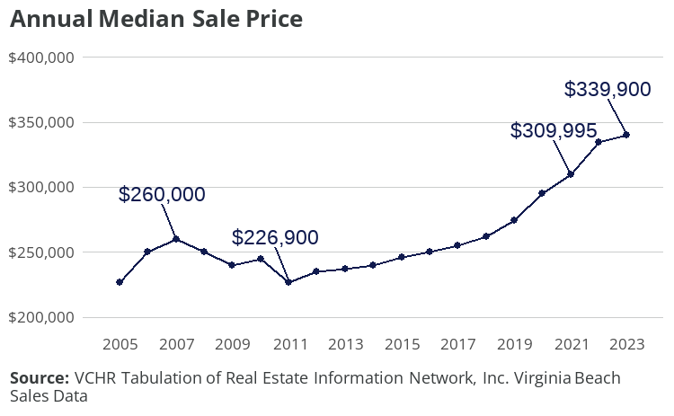
Figure 4.7: Annual Median Sale Price
Median sale price grew 36% from 2015-2022, reflecting increased demand that has balanced the market. Days on the market (DOM), the time it takes for a home to sell once it’s listed, captures both supply and demand dynamics and is a good indicator of market health.
From a community perspective, a market is considered healthy when homes are appreciating enough for owners to recover investments in maintenance and periodic upgrades, as well as build equity required to meet their future housing needs. A healthy market is also well paced, giving sellers confidence they can sell their home when they need to and giving buyers enough time to make good decisions by visiting homes and conducting home inspections upon making an offer. Median DOM between 30 and 60 days is generally considered balanced.
Markets that are too fast paced disadvantage first-time homebuyers and buyers who need unconventional financing such as VA or FHA loans. Markets that are too slow paced introduce uncertainty for owners and, when coupled with slow appreciation, discourage investment. Median DOM reached 40 days in 2022, signaling supply and demand balance.
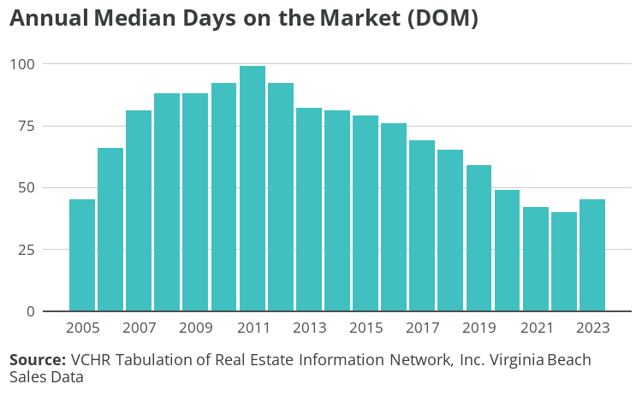
Figure 4.8: Annual Median Days on the Market (DOM)
Despite DOM indicating market health, focus group participants recounted evidence of continued tightening, such as multiple offers over asking price, especially around the median price. They also described increased investor interest, which can have a variety of market implications and is related to demand for rental housing in addition to anticipated price appreciation in the for-sale market.
Virginia Beach will need to continue to add new housing units to meet demand and keep the market balanced. Production of single-family and condo units has largely slowed year-over-year since 2016, which likely supported home appreciation and balancing of supply and demand. Though the city must continue adding units to maintain market health, adding too many units could reverse positive market trends.
Market health and moderate levels of demand create an opportunity for the City to set housing goals and prioritize housing needs of existing residents and workers, which are discussed further in the following sections. Furthermore, creating housing that meets the needs of those who are being excluded from the for-sale market has the potential to relieve hardship related to intense competition in the middle and low end of the market without negatively impacting needed home appreciation.
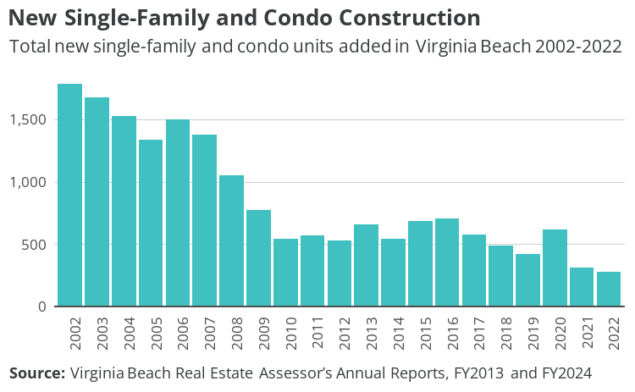
Figure 4.9: New Single-Family and Condo Units Constructed Annually

4.3 Vacant housing
There are approximately 12,141 vacant housing units in Virginia Beach. Approximately 3,297 are vacant for rent and 1,353 are vacant for sale, while 1,578 units have been rented or sold but not yet occupied. Approximately 2,891 vacant units, about 1.53% of total units, are vacant for seasonal, recreational, or occasional use. Approximately 3,022 units, about 1.6% of total housing units, are vacant for other reasons. See Figure 4.10 for vacant housing units by status.
Vacant units in the "other" category — generally interpreted as long-term vacancy — are unoccupied for one of the following reasons:
- Unit is foreclosed or held as part of a legal proceeding or dispute such as divorce or estate settlement
- Unit is undergoing, or in need of, repair or renovation
- Unit is being prepared for rent or sale but not yet on the market
- Unit is uninhabited for personal or family reasons, such as staying with family members or relocation to a nursing facility
- Unit is uninhabited due to the occupant’s extended absence, such as a work assignment, military deployment, or incarceration
- Unit is presently unoccupied and designated as specific use housing, such as worker or student dormitories, model units, and church-owned units
- Unit is abandoned (does not include units that are dilapidated or uninhabitable)
- Unit is vacant for a reason unknown by the survey respondent or field representative.
Estimates for "other" vacant units by detailed reason are not available at the county/city level, and estimates at the MSA and even the state level can be unreliable due to high margins of error relative to sample sizes. Finally, the estimate of vacant units does not include housing units that are exposed to the elements or otherwise uninhabitable.
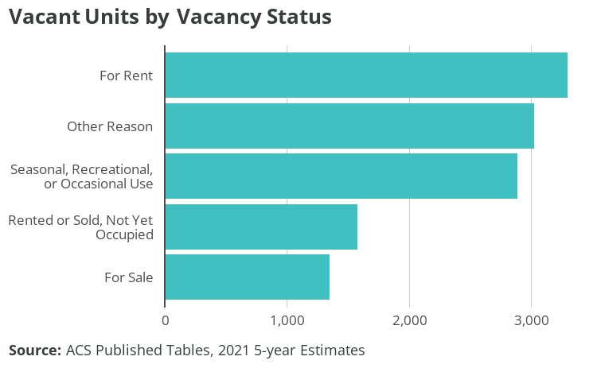
Figure 4.10: Vacant Units by Vacancy Status

5. Housing affordability

5.1 Cost burden
VCHR uses housing cost burden to measure the need for more affordable housing and to identify associated housing insecurity. When homeowners are cost-burdened, they may choose to defer maintenance or forgo upgrades in favor of necessities like food, childcare, and medical care. When renters are cost-burdened, they may make choices between housing and other necessities, and their limited ability to save makes them vulnerable to eviction or homelessness in the event of an unexpected expense. Furthermore, inability to save may effectively prevent households from investing in educational enrichment to advance their earnings and from building wealth and security through homeownership.
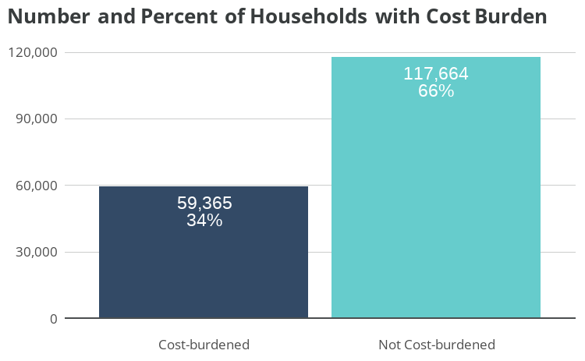
Figure 5.1: Number and Percent of Households with Cost Burden
Approximately 59,365 Virginia Beach households, over one-third, are cost-burdened, meaning their housing costs are at least 30% of household income. Among cost-burdened households, 41%, approximately 24,301 households, are severely cost-burdened, paying 50% or more of household income in housing costs.
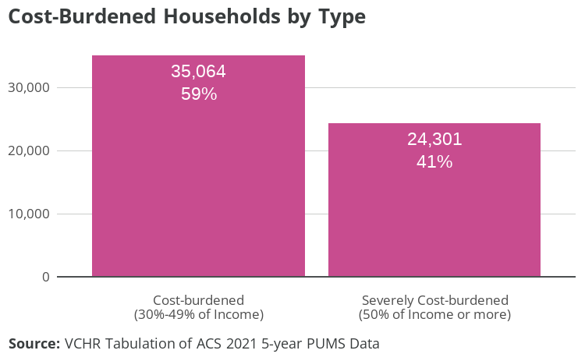
Figure 5.2: Cost-Burdened Households by Type
Cost burden has been trending down in Virginia Beach: cost burden among all households fell from 40% in 2014 to 33% in 2021, according to ACS 5-year estimates. However, some improvements likely resulted from temporary pandemic-related programs in 2020-2021, including the Child Tax Credit and moratoria on evictions and rent increases.
The COVID-19 pandemic had a mixed effect on housing insecurity. The pandemic initiated an economic shock disproportionately impacting lower-income, Black, and Hispanic households, but the policy response saw an unprecedented expansion of eviction moratoria, renter assistance funding, and unemployment insurance payments surpassing 100% wage replacement for some low-income workers. Implementation varied widely by jurisdiction, however, and not all households in need were able to receive assistance.
As lower-income households face more competitive housing markets without this added support, gains in affordability may begin to erode. Indeed, cost burdens have increased post-pandemic, among all income levels and racial/ethnic groups, and the increase is driven mostly by renter households.
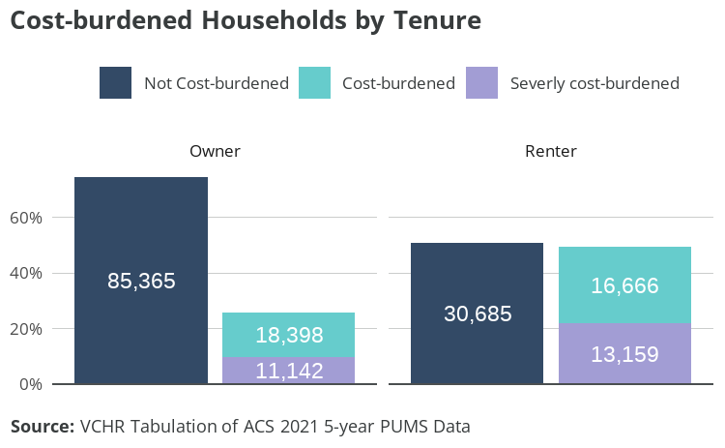
Figure 5.3: Cost-burdened Households by Tenure
Housing cost burden is more common among renter households than owner households. Nearly half of renter households are cost-burdened (29,825 households), compared to just over one-quarter of owner households (29,540). Among cost-burdened households, a higher share of renters is severely cost-burdened: 44% of cost-burdened renters compared to 38% of cost-burdened owners.
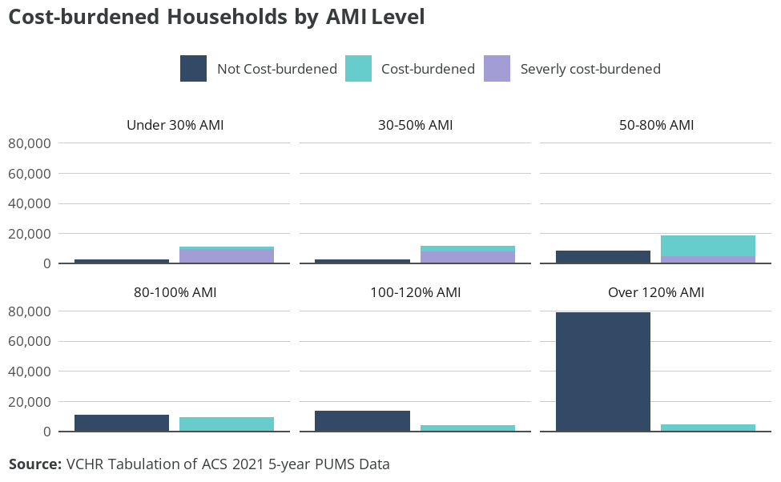
Figure 5.4: Cost-burdened Households by AMI Level
Households with lower incomes relative to AMI are cost-burdened at higher frequencies, and their cost burden is more likely to be severe. Large majorities of households under 80% of AMI are cost-burdened. Moderate-income and higher-income households are less impacted by housing cost burden. Approximately 45% of households between 80% and 100% of AMI, 23% of households between 100% and 120% of AMI, and 6% of households above 120% AMI are cost-burdened.
Cost-burdened households under 30% of AMI, and severely cost-burdened households between 30% and 50% of AMI, are at risk of homelessness due to housing unaffordability. Survey responses show particular concern for the lack of dedicated affordable housing or Section 8 vouchers available to these very low-income households.
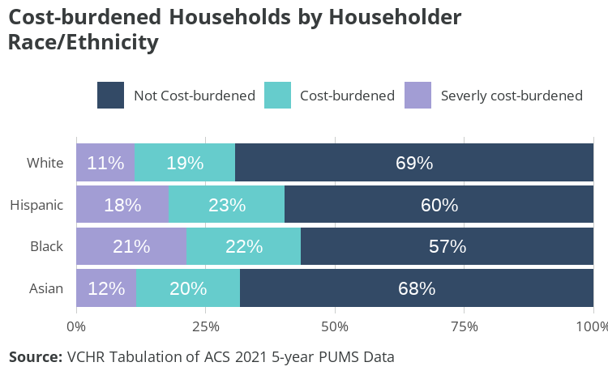
Figure 5.5: Cost-burdened Households by Householder Race/Ethnicity
Levels of housing cost burden vary among householders by race and ethnicity. The share of cost-burdened households among Black- and Hispanic-led households is around 40% — 10% higher than white- and Asian-led households. Nearly half of cost-burdened Black-led households are severely cost-burdened, compared to 36% of Asian-led, 37% of white-led, and 44% of Hispanic-led cost-burdened households.
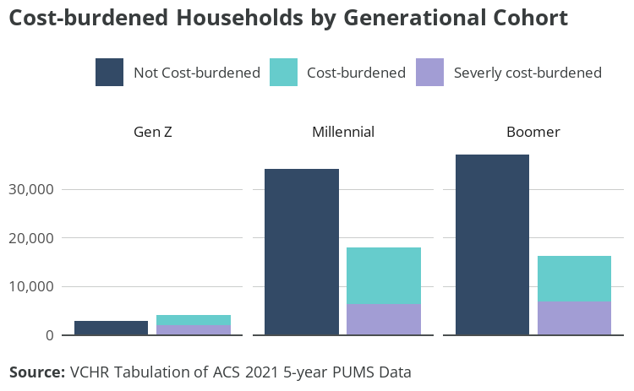
Figure 5.6: Cost-burdened Households by Generational Cohort
The share of cost-burdened millennial households is slightly higher than that of boomer households: 34% and 31%, respectively. Among cost-burdened households, however, boomers are more likely to be severely cost-burdened: 43% of cost-burdened boomer households are severely cost-burdened, compared to 36% of cost-burdened millennial households.
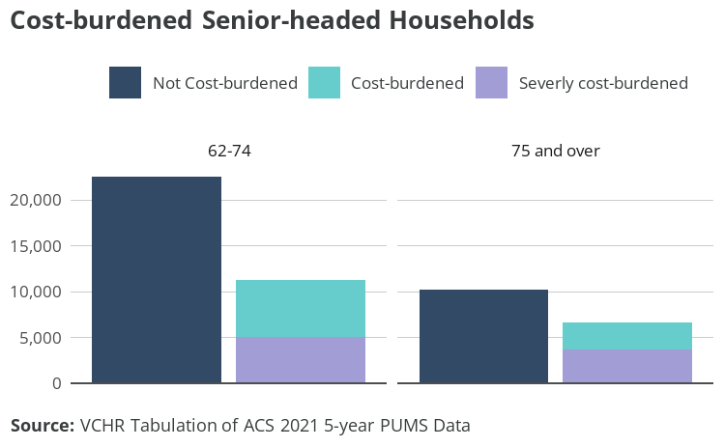
Figure 5.7: Cost-burdened Senior-headed Households
Senior-headed households have high rates of cost burden and severe cost burden, particularly for seniors 75 and older. Nearly 40% of householders aged 75 and older are cost-burdened, and among these, over half are severely cost-burdened.
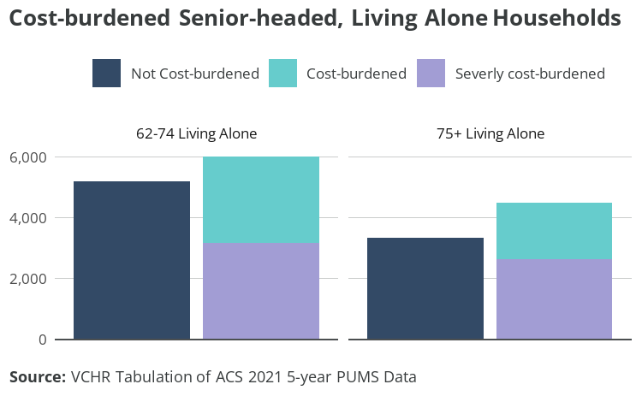
Figure 5.8: Cost-burdened Senior-headed, Living Alone Households
Seniors are more likely than other age groups to live alone, and housing cost burden is most acute among senior-headed, one-person households. A majority of these households are cost-burdened, and a majority of those are severely cost-burdened.
Survey responses noted a lack of affordable housing options for seniors, especially middle-income retirees receiving both Social Security income and a private pension. According to PUMS data, the median income of a person receiving Social Security is $32,745, while the median income of a person receiving both Social Security and retirement income is $46,972. These households may have incomes too high to qualify for housing assistance but too low to purchase housing on the open market. Should these seniors wish to vacate a long-owned home for a smaller or more accessible dwelling, affordability may prevent such a transition.
Households with low incomes and high housing costs are at particular risk of homelessness in the event of sudden income loss or emergency expenses. Approximately 18,847 households in Virginia Beach are at risk of homelessness. That’s over 10% of all Virginia Beach households. Approximately 10,953 households have incomes below 30% AMI and have housing costs of at least 30% of household income. Another 7,894 households have incomes between 30% and 50% of AMI and pay at least 50% of household income in housing costs.
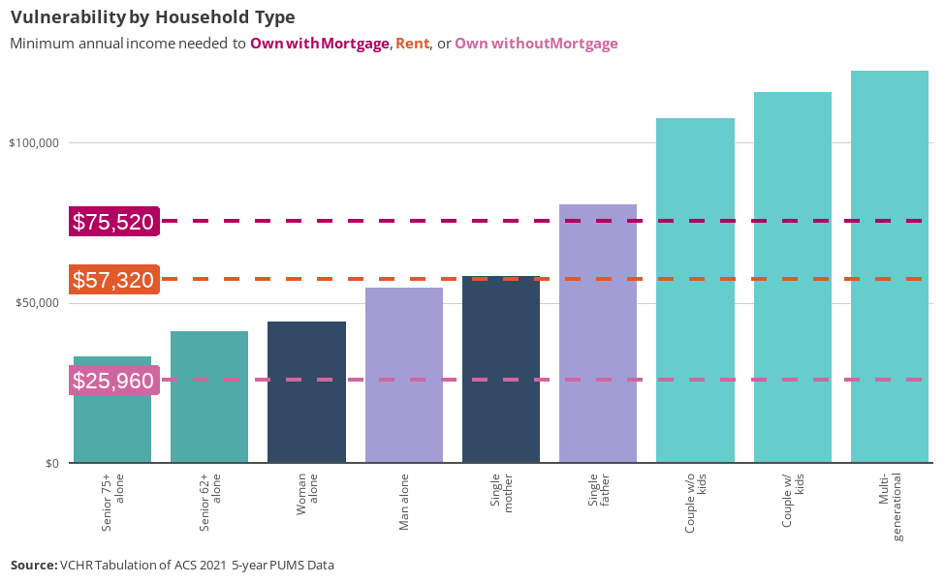
Figure 5.9: Vulnerability by Household Type
Figure 5.9 shows median household income of common or notable household types in Virginia Beach. The red horizontal lines represent the annual income needed to afford the median housing unit by tenure. From highest to lowest, the lines illustrate owning with a mortgage or loan ($75,520), renting ($57,320), and owning free and clear ($25,960).
Family households, shown in light green, tend to have incomes enabling them to afford the median housing unit for any form of tenure. Single-earner households are shown in purple when male-led and in blue when female-led. Both male- and female-led one-person households have median incomes below the amount needed to afford the median rental unit. Among single-parent households, the median single father household has an income high enough to afford the median owned unit with a mortgage, while the median single mother household is just above the level needed to afford the median rental unit.
Among senior-led, one-person households (shown in dark green), only the median cost of owning free and clear is affordable to the median household. This means that long-term owners can afford to stay in their homes but may be unable to relocate to smaller or more accessible dwellings, and those who don’t own their home free and clear may struggle to make ends meet. The lack of affordable options can keep seniors in homes unsuitable for aging in place. It can also prevent those homes from being vacated and becoming available to younger families facing a shortage of starter homes, as many survey respondents noted.

5.2 Workforce housing affordability
City staff, councilmembers, employers, and citizens all expressed concerns about workforce housing affordability in the study’s engagement process. Employers discussed instances of employees having difficulty securing housing and even turning down contracts because they couldn’t find housing. Working citizens recounted difficulties finding affordable housing that meets their needs and promotes their financial goals. Indeed, many resident workers in Virginia Beach do not earn enough to comfortably afford rent, and even more do not earn enough to access homeownership opportunities.
Most households (81%) in Virginia Beach include at least one worker. Those households who are not working (19%) are likely to be retired, although a minority of households may have disabilities or family circumstances that prevent them from working. Twenty-three percent of households are headed by someone 65 and older, and 28% of households receive retirement income. Approximately 3% of households receive Supplemental Security Income (SSI), a good proxy for households that include at least one person with disabilities or an older adult who has little to no income or resources.
Table 5.1: Households by Number of Workers
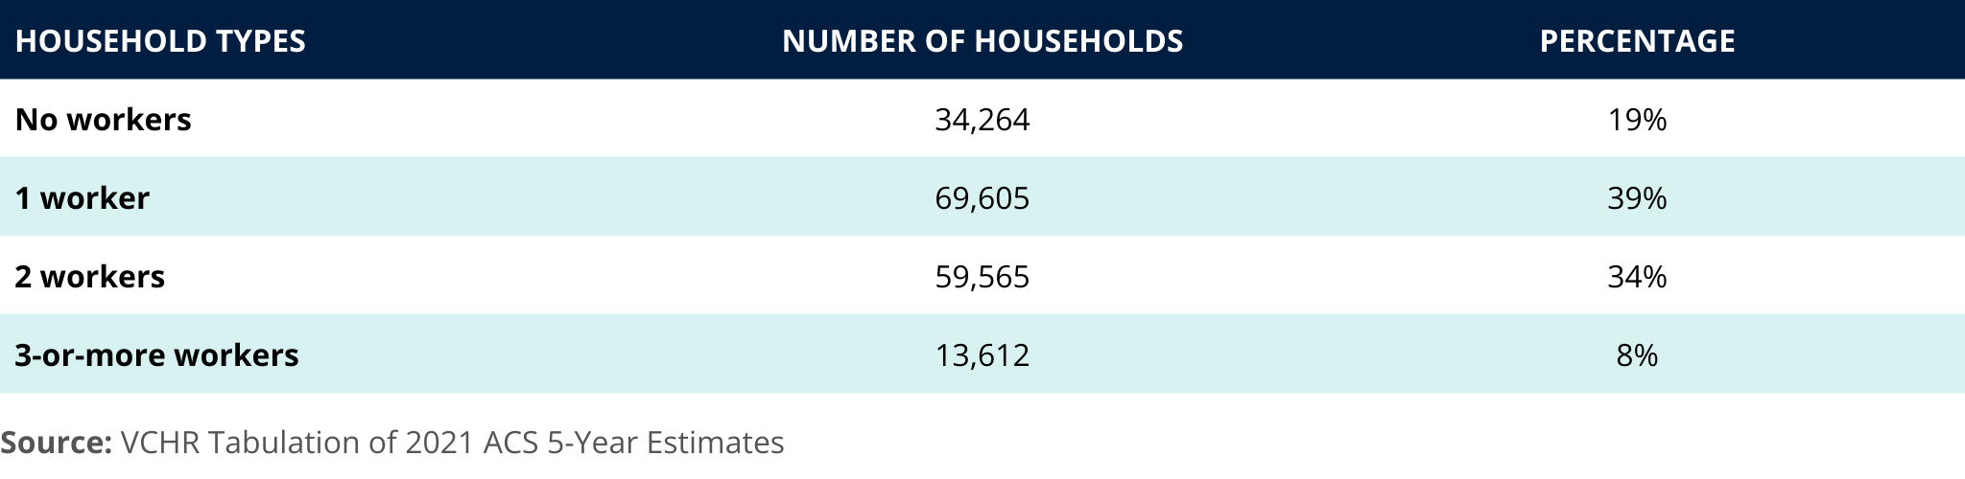

Commuting patterns
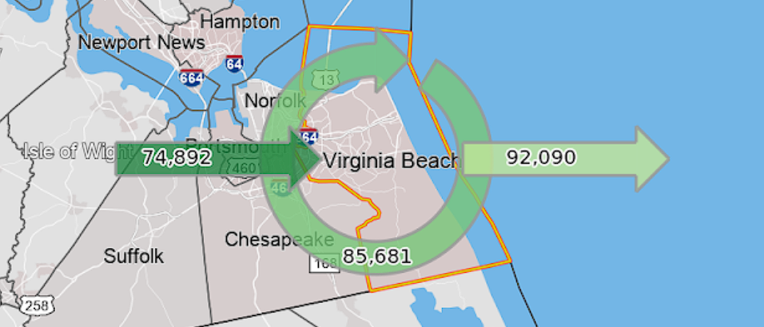
Figure 5.10: In-commuting, Resident Workers, and Out-commuting for Primary Jobs
Nearly 75,900 workers, roughly half (47%) of Virginia Beach’s workforce, commute into the city for their primary job. In-commuters are disproportionately aged 29 or younger, earning $1,250-$3,333 per month (low-income for a single-earner household or a dual-earner household supporting a dependent), and working in the trade, transportation, and utilities industries. Meanwhile, resident workers are disproportionately 55 and older and earning more than $3,333 per month. Lower-income workers earning less than $1,250 per month make up 24% of the workforce and 24% of in-commuters, indicating they’re not excluded from the city even though they’re likely to endure housing cost burden and associated hardship.
The majority of workers in the top 10 occupations by employment, primarily service sector roles with typically lower wages, face challenges in securing affordable housing. Eight out of these 10 occupations can’t afford the lower quartile rent when they’re single earners. For the majority (7/10), even earning in the 90th percentile doesn’t allow them to affordably rent or own in the city as single earners. Housing affordability improves in a dual-earner household scenario (both at median wage), but workers in three roles (fast food and counter workers, cashiers, and home health and personal care aides) still find the median rent unaffordable. Only the general and operations manager role can afford homeownership as a single earner, with registered nurses also being able to manage homeownership costs under specific conditions.
VCHR also identified disparities in housing affordability among selected state and local government sector and mandatory service occupations. Home health and personal care aides and childcare workers face severe housing affordability challenges. Neither can afford the lower quartile rent as a single earner, even when earning at the 90th percentile. In dual-earning scenarios, they can’t manage the median rent. Firefighters and postal service mail carriers are better positioned. They can afford the median rent at the 90th percentile and homeownership when their earnings are combined with that of another earner. Other occupations like teachers (spanning from kindergarten to secondary) and registered nurses can afford the median rent as single earners. When their earnings are at the 90th percentile or combined, they can also manage homeownership costs.
Housing affordability remains a significant concern in the City of Virginia Beach, particularly for those in service-sector roles and mandatory service positions. Although workers in some occupations manage to find affordable housing, a significant share of the workforce is either cost-burdened or unable to access suitable housing altogether. As discussed earlier in the report, 76% of low-income households experience housing cost burden.
This analysis highlights an urgent need for policy and strategic interventions to bridge the affordability gap for these essential roles. Further tabulations and analysis are included in Appendix B.

Military households
There are approximately 15,893 Virginia Beach households with at least one member in active-duty military service (“military households”), around 11% of all households in the city. Families account for 77% of military households, while non-family living arrangements, mostly people living alone, make up 23% of military households.
Around 50% of military households own their homes, and 49% rent. The vast majority of homeowner households have a mortgage or loan.
The median household income of military households is approximately $87,140, around 6% higher than the citywide median. Nearly 60% of military households have a household income above 100% AMI. Around 25% of military households earn below 80% AMI. Approximately 5,891 military households are housing cost-burdened: over two-thirds of military households. More than 25% of homeowners and nearly 50% of renters are cost-burdened. Indeed, studies suggest that military households experience similar affordability challenges despite receiving a Basic Allowance for Housing (BAH) intended to cover 95% of the average housing costs for an off-base housing unit and utilities.

5.3 Affordable housing
VCHR conducted an affordable housing gap analysis and estimated the extent to which affordable housing occurs “naturally” in the market to evaluate whether available affordable housing can meet the needs of current and future Virginia Beach residents.

5.3.1 Rental housing gap analysis
Each pair of bars in Figure 5.11 compares the number of households in each income group to the number of housing units affordable to that group. Each bar provides additional information: cost burden in the “households” bar and information about the income of the unit occupants in the other bar
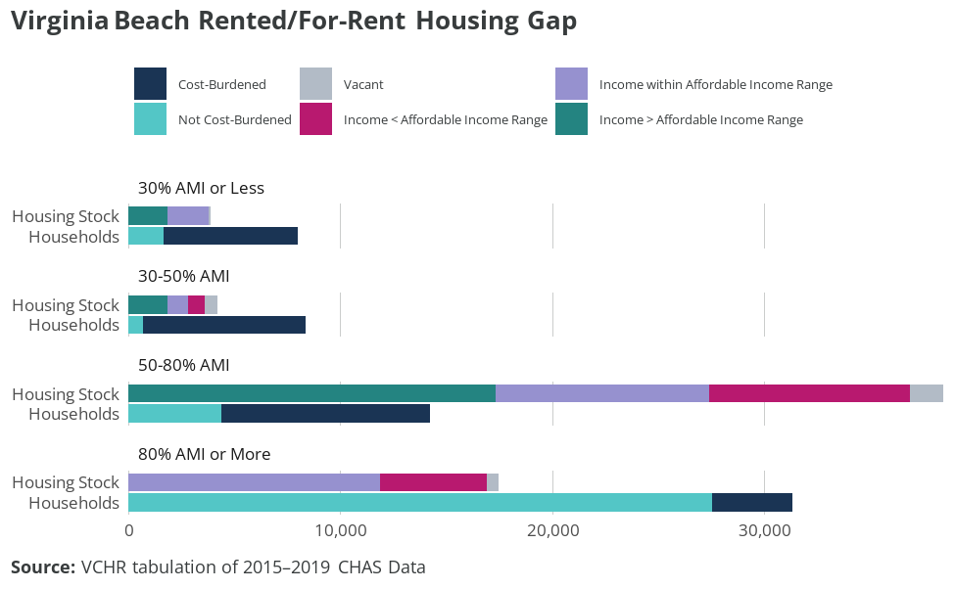
Figure 5.11: Virginia Beach Rented/For-Rent Housing Gap
There aren’t enough housing units in Virginia Beach to serve extremely low (less than 30% of AMI) and very low (30%-50% of AMI) income renters living in Virginia Beach. As a result, most of these households struggle with housing cost burdens and may consume housing more affordable to households with incomes in the 50%-80% of AMI range. Housing that is affordable to and occupied by households with extremely low incomes (51% of the units in this category) is likely to be committed affordable units. This housing is reserved for households with low incomes through incentive or subsidy programs such as the Low-Income Housing Tax Credit or HUD’s project-based vouchers. However, 46% of units affordable to extremely low- and very low-income households are occupied by households in higher-income groups.
More than half (60%) of rental stock in Virginia Beach has rent affordable to households with low incomes between 50% and 80% of AMI. Because there’s not enough stock to serve households on either end of this category, both lower-income households and higher-income households compete for these units. Though there’s an adequate total amount of rental housing in Virginia Beach, the concentration of rental units in a single income category disadvantages low-income households and results in hardships for households not able to compete for an affordable unit. There are 4,600 rental units reserved for households with low incomes, and they are likely to be the residences of about 70% of the low-income renters who are not cost-burdened.
Building units on either end of the 50%-80% income category would help relieve competition to access these units. Some higher-income renters may choose to “upgrade” to a unit with more space, amenities, nicer features, and/or a better location if the unit were available and still affordable to them. Renters who are currently enduring a housing cost burden would likely welcome a unit that is affordable and meets their needs. Some renters may also choose to become homeowners if a unit that is affordable and meets their needs were available. Availability of homeownership opportunities is discussed more in the following sections.

5.4 Owned/for-sale gap analysis
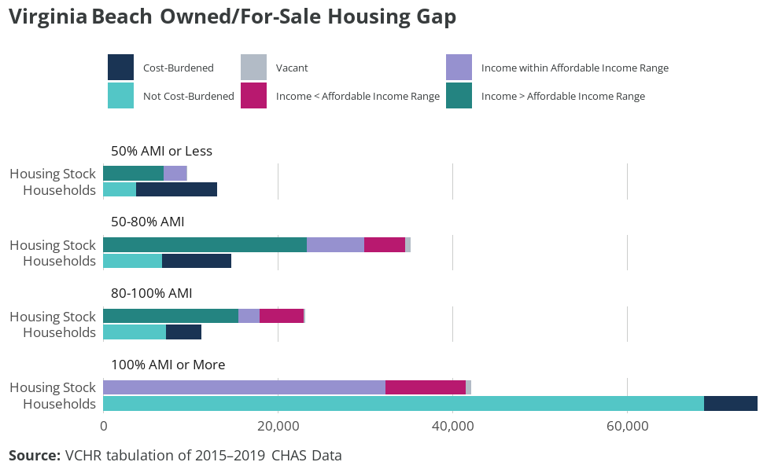
Figure 5.12: Virginia Beach Owned/For-Sale Housing Gap
Affordability concerns and gap analysis for owners differ substantially from the gap analysis for renters. The mortgage finance system generally prevents homeowners from being cost-burdened when they buy their home, and often homeowners’ income increases over the life of their mortgage. Homeowners also face relatively little change in housing costs compared to renters. When homeowners do become cost-burdened, it’s often due to economic hardship such as job loss, death of a family member, or fixed incomes that do not keep up with rising costs of taxes, utilities, and insurance. Because many homeowners had the opportunity to reduce their housing costs by refinancing their mortgages during the 2014-2021 period, decreased rates of cost burden among owners with a mortgage are expected. However, inflation and associated increasing interest rates since 2021 have decreased access to homeownership among low- and moderate-income buyers.
Housing cost burdens shown in the top bar of each pair are far more common among homeowners with low and very-low incomes. Like the rental scenario, these households may have to make choices between housing and other necessities. However, these owners may own their home free and clear or, when they have a mortgage, be able to work with their mortgage lender on a payment plan that keeps them from becoming delinquent. To avoid foreclosure and potential homelessness, they may defer home maintenance, forgo needed upgrades and modifications, and/or forgo utilities to pay for other necessities like food, medicine, or childcare. These sacrifices represent a clear threat to the household, but also represent a risk for the locality. While households come and go, housing units stay with a community for generations. Allowing the housing stock to deteriorate can decrease the competitiveness of the market overall and require substantial investments in rehabilitation or in demolition and infill development. Ensuring that owners who represent two-thirds of residents can maintain their homes is part of the stewardship responsibility of local governments and communities.
Quantity and occupancy of the housing stock across income affordability levels, shown in the bottom bar of each pair, also provide important insights. Most owners have higher incomes than they need to comfortably afford their unit, which though anticipated based on relatively fixed housing costs and expected increases in income, also represents the potential for upgrade. Over time, as households’ size and income grow, many owners will seek to move to new homes that better accommodate new needs. However, there is not enough housing stock to accommodate households with incomes above 120% AMI. This gap in housing for higher-income households may limit options to upgrade and require higher-income households to stay in their starter home longer, restricting supply housing that is affordable for first-time homebuyers and to lower- and moderate-income households and also potentially inflating the price of that stock.

5.5 Naturally occurring affordable housing (NOAH)
VCHR used HUD FY 2022 Income Limits to categorize affordability levels for 145,498 units in Virginia Beach real estate assessment data. The categorization is based on income limits for two household sizes (1.5-person and 4.5-person) intended to proxy the position of first-time homebuyers and more-established households who benefit from longer careers and existing home equity. VCHR adjusted the tax-assessed values based on differences observed in close prices in the Virginia Beach sale data for 2022, providing a more realistic estimate of market prices. Using Freddie Mac’s 30-year fixed rate from December 2022 and standard mortgage formulae, VCHR estimated mortgage payments for each unit.
This analysis considers two down-payment scenarios: 5% and 10%. The monthly mortgage was combined with average insurance payment, median utility costs, estimated real estate taxes, and estimated HOA and condo fees to determine the total housing expenditure.
Of 145,498 units from the Virginia Beach assessment data, using a 5% down payment as a criterion, about 8,123 properties were found to be affordable to first-time homebuyers (households with income up to the 1.5-person limit) with an income in the 80%-100% range. When considering the same down payment, roughly 9,213 units were within reach for those earning $70,150 or less, while around 45,091 units were accessible for more-established households (households with income up to the 4.5-person limit) earning $97,250 or less.
Table 5.2: Number of Units by Down Payment Percentage (1.5 person / 1 bedroom)
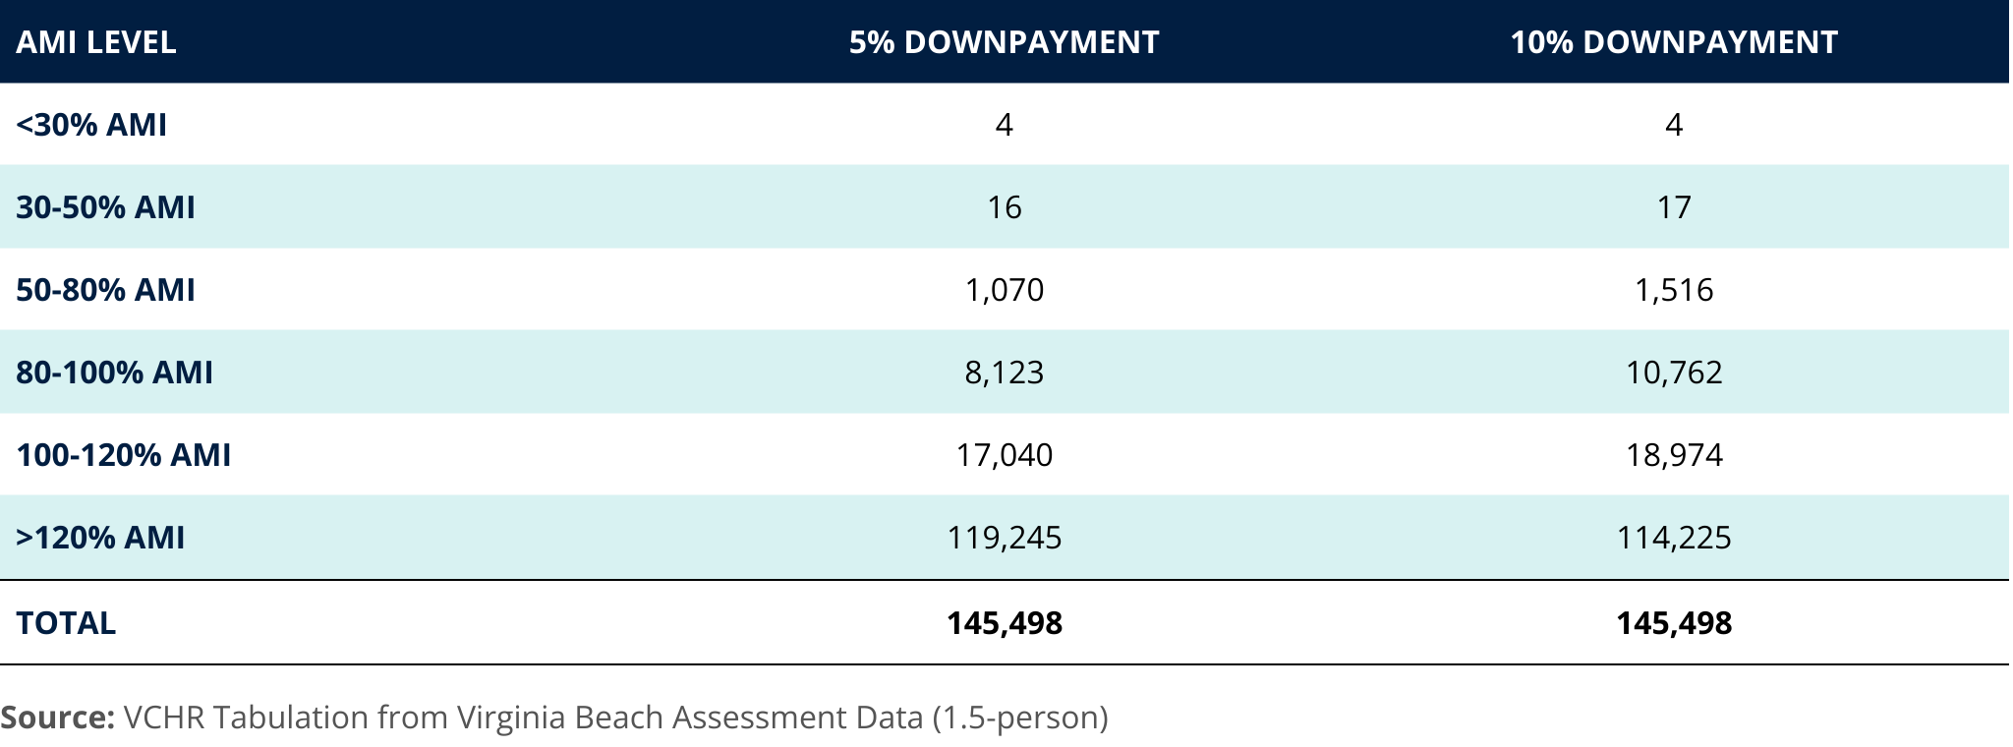

Table 5.3: Number of Units by Down Payment Percentage (4.5 person / 3 bedrooms)
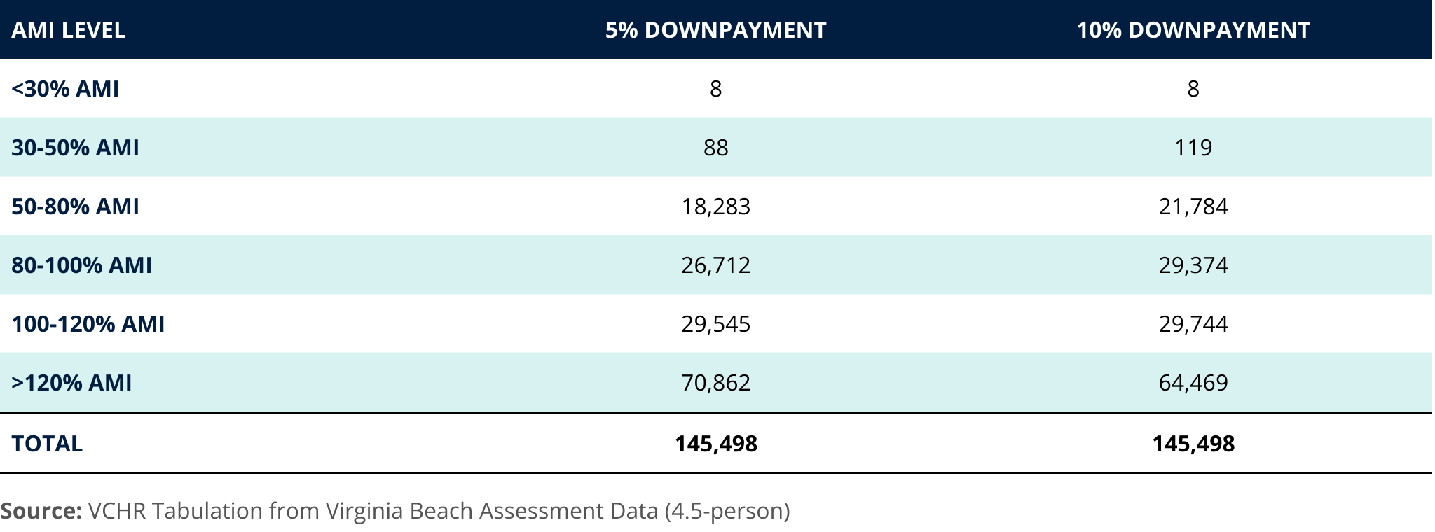
However, while these units are theoretically affordable, many are occupied by households with incomes that exceed the designated affordability brackets. This means that even though a property might be affordable on paper, it isn’t necessarily available in the market for lower-income families. The analysis also indicated a scarcity of affordable housing options, with only 35% of the overall housing market deemed affordable to households with income less than 100% AMI when considering a 10% down payment. Potential additional costs for maintenance and renovation due to age are also a concern since 98% of these affordable units were constructed before 2000.
The disparity in affordable units across City Council districts further emphasizes the uneven distribution of affordable housing options. For instance, City Council District 4 exhibited a significantly higher proportion of affordable units compared to City Council District 2, which had a notably lower percentage.
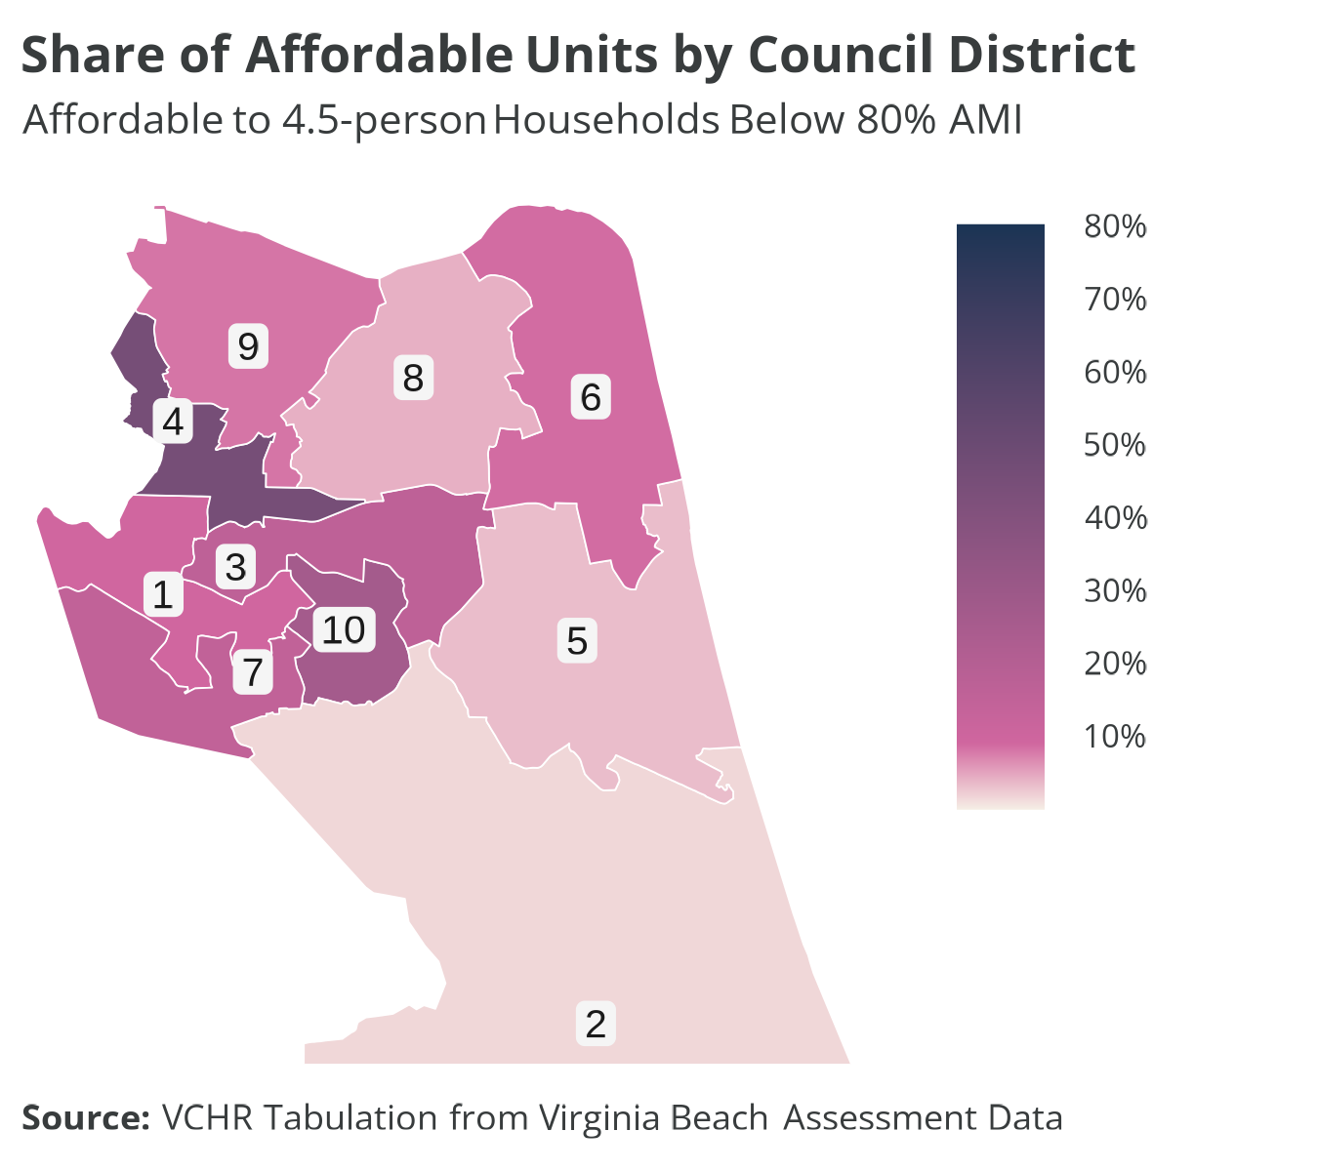
Figure 5.13: Share of Affordable Units to 4.5-person Households Below 80% AMI
Using HUD Income Limits and specific rules for occupancy and associated housing affordability (see Appendix C for details), VCHR also categorized the affordability levels of 42,021 units, representing about 81% of the estimated multifamily rentals in Virginia Beach. Within the analyzed properties, 230 properties encompassing 36,367 units are entirely at market rate, with no subsidies or affordability restrictions. As such, the data reflects the present state of the multifamily rental market in Virginia Beach.
A notable observation from the data is how unit types are distributed based on affordability. Over half the affordable units are 2-bedroom units, followed by 29% being 1-bedroom units. The remaining distribution comprises 16% of 3+ bedroom units, with studios representing a mere 2%. While a large proportion of units (nearly 90%) are affordable for households with incomes ranging from 50%-100% of AMI, there’s a lack of units affordable to those with incomes below 50% of AMI. While a substantial portion of units are accessible to mid-income households, there remains a need for more affordable housing options for extremely low- and very low-income households.
Further tabulations and analysis are included in Appendix C.

6. Conclusions
Housing market conditions have improved substantially since 2014. A slower pace of building since 2016 coupled with increasing demand from the two largest living generations (boomers and millennials) has balanced the market, encouraging housing investments across the city. The city needs to keep adding units to maintain housing market health. Because there isn’t excess demand pressure, the City has an opportunity to strategically address housing needs and increase the diversity of the housing stock.
Affordable, attainable housing is the city’s most critical need. The highest levels of housing insecurity are among extremely low- and very low-income renters, as well as senior householders 75 and older. Additional housing dedicated to low-income households is required to stabilize households experiencing housing insecurities and to reduce periods of homelessness among Virginia Beach residents. Purpose-built senior housing and permanent supportive housing, along with services to support households, would address this critical need.
Homeownership opportunities for low- and moderate-income households will further stabilize Virginia Beach households and help retain workers. Homeownership is critical to wealth-building, and the City can help ease housing transitions and upgrades by creating straightforward steps from committed affordable rental housing to equity-building opportunities. These steps would support the city’s economic and social systems by stabilizing lower-wage workers and promoting worker retention. Workers are likely to leave the city if they cannot find affordable housing that meets their needs throughout their lives and do not have the opportunity to build wealth that will benefit generations to come.
Though the Virginia Beach market is healthy, it’s trending toward tightness and housing shortage. Stakeholders already recount evidence of how the most vulnerable households are being excluded from the market. Aggressive development of dedicated affordable housing will benefit the market by relieving pressure on median-priced rental housing and the most affordable homeownership opportunities. It will also prevent the tightening market from incentivizing cursory housing “flips” intended to capitalize on higher rents and desperation of the most vulnerable renters.
Increasing market health encourages investment in owner-occupied homes because homeowners will feel more confident that they can recoup investments if they choose to sell their home. However, some households don’t have the resources to make those investments. Cost-burdened owners may defer maintenance and forgo upgrades, so support for existing homeowners will similarly support housing preservation efforts while improving their quality of life.
The following chapters of this report details the study team’s recommendations for the City. The solutions respond to market conditions and specific challenges identified in the study process. Each of the approaches has been vetted with Virginia Beach staff and introduced to the City Council. The study team developed the details of these solutions based on best practices, resources available in the city and the state, as well as specific guidance from staff and the council.

7. Current housing efforts
The City of Virginia Beach currently promotes housing affordability both directly and through partner organizations using City, state, and federal funds.

7.1 VBCDC
The Virginia Beach Community Development Corporation (VBCDC), a non-profit organization created by the City Council in 1985, is the largest developer and operator of affordable housing in Virginia Beach. It owns and operates over 500 scattered site affordable housing units and provides rental assistance, homelessness prevention services, and supportive housing for veterans.
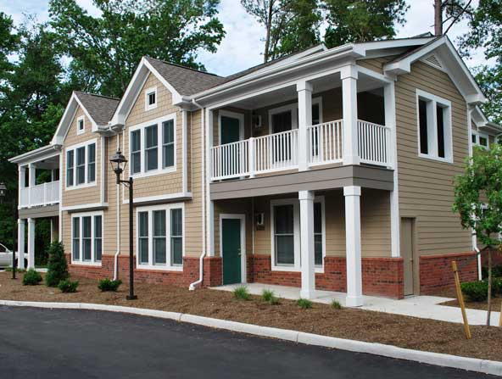
VBCDC won the BEST AFFORDABLE HOUSING, ENERGY CONSERVATION EFFORT award at the 2010 Virginia Governor’s Housing Conference for Beach Park West Apartments. The ten-unit community serves special-needs residents and was built to EarthCraft standards for sustainability and energy efficiency. Photo: GMF + ASSOCIATES.
The VBCDC has close links to the City: the City Council appoints its Board of Directors and provides funding and policy direction, and it frequently coordinates with the City Departments of Housing and Neighborhood Preservation and of Human Services.
While VBCDC’s major focus is on permanent rental housing, it has also administered low-income homeownership programs and developed single-family units for sale to low-income owners. Since the mid-2010s, the City has stopped providing direct funding for VBCDC’s operations and administration, but it continues to provide federal pass-through funds.
 | Learn more  The VBCDC website has additional information on their mission, administration, and services.

7.2 Funding
The City also partners with other non-profit and for-profit low-income housing developers and operators, distributing HOME and CDBG funds via Housing Opportunity Funds Requests for Proposals issued at least once per year. Since 2000, the City has provided $10.1 million in federal pass-through funds and $5.3 million of City funds to partner organizations, creating 1,280 affordable rental units, preserving 413 affordable rental units, and providing 309 rental assistance vouchers.

7.3 Development incentives
In addition to pass-through funds for developers and operators, the City provides other assistance, such as facilitating land transactions, and funding infrastructure improvements to enable affordable housing development. Zoning and land use tools have also been used to encourage and incentivize affordable housing development. These include reduced parking requirements for affordable housing sites, increased density allowances in Strategic Growth Areas, limited approval of single room occupancy (SRO) housing, and a voluntary Workforce Housing program offering density bonuses in exchange for workforce-affordable set-aside units.

7.4 Housing Resource Center

Along with housing and supportive services, the HRC also includes a cafeteria and learning facilities. Photo: S.B. Ballard Construction Company.
Finally, the Housing Resource Center, developed with $32 million in City funds, provides emergency housing for unsheltered families and individuals, and services for households experiencing a housing crisis, as well as 29 permanent supportive housing units.
Learn more
The HRC website has a full list of resources and services provided on site.

8. Proposed solutions
This section proposes and describes eight different policy and programmatic recommendations for the City to pursue as part of its efforts to address housing affordability and opportunity.
The recommendations are based on VCHR’s analysis of housing needs in the city, VCHR’s engagement with community members, and conversations with City Council and City staff. They also incorporate input from two City Council working sessions between August and September.
Solutions are organized into three categories: Strategic priorities, Easy wins, and Background work.

8.1 Policy matrix
To help evaluate and prioritize housing policy strategies, Virginia Beach can use a matrix like the one below. Relative to one another, proposals are ranked according to their expected positive impact and their complexity (or level of effort) to implement.
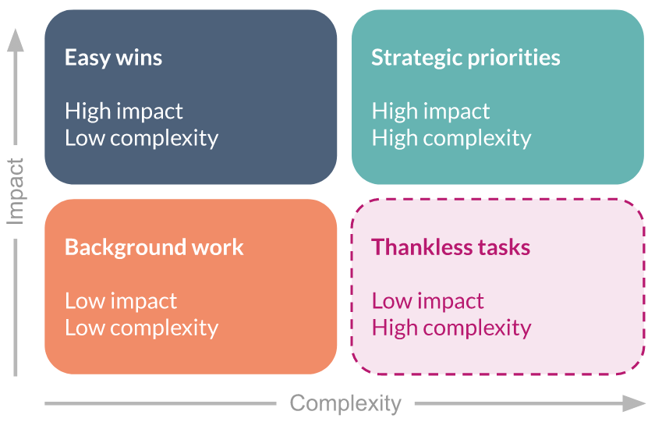
Each strategy then falls into one of these categories:
Strategic priorities build the City’s capacity to make significant strides, but may require substantial planning and investment.
- Focused activities that require more effort but have the biggest payoff.
- Build long-term capacity to address housing needs.
- Provide opportunity for the City to innovate and lead among peers.
Easy wins require fewer decision points and could demonstrate meaningful success in the near future.
- Simple tasks to begin soon that do not require as much work but still result in progress.
- Fewer decision points required, but some may involve novel funding or policy choices.
- Build on clear, proven examples of success.
- Take advantage of existing infrastructure without much need for additional capacity.
Background work activities take advantage of ongoing or upcoming efforts to improve the City’s planning, regulatory, and operational approaches to housing.
- Additional homework is needed, but can likely be completed within current or future planning efforts.
- Long-term objectives to migrate day-to-day City operations to support its housing goals.
Thankless tasks are not advisable. Revise or abandon tasks in the future if they begin to meet this criteria.

8.2 Policy rankings
Based on these criteria, these are the rankings for the eight solutions.
Strategic priorities
- Develop a City-managed Housing Trust Fund (HTF)
- Use Virginia Beach Development Authority to fund new large-scale, mixed-use development projects
- Design housing education campaign to incorporate into successful community engagement
Easy wins
- Create a Housing Assistance Fund for workers
- Leverage Virginia Statewide Community Land Trust (VSCLT) to create permanent affordable homeownership opportunities
Background work
- Pursue self-sustaining mixed-income, mixed-use rental development options
- Research opportunities to simplify and streamline the permitting and review processes
- Consider an advisory board to guide new zoning ordinance and redesign Workforce Housing Program

9. Develop a City-managed Housing Trust Fund

STRATEGIC PRIORITY 1

Develop a City-managed Housing Trust Fund
A major barrier to affordable housing production in Virginia Beach is a shortage of capital with limited regulatory hurdles. A Virginia Beach Housing Trust Fund (HTF) would create a pool of capital that provides gap funding for a wide range of affordable housing projects in the city, including both rental and homeownership.
Local HTFs aren’t new in Virginia. Other cities like Alexandria and Richmond use them to provide flexible and vital funding for affordable housing developments when federal and state resources fall short.
HTFs can be capitalized by both public and private sources. Funding is awarded through a competitive process to ensure that development is meeting the needs and standards of the community. A locality may provide both grants and loans with flexible terms.

9.1 HOW IT WORKS
To build a successful HTF, the City will need to decide how the fund will be funded, governed, and administered. Below are nine program design elements that describe the major components of HTF operations.
Legal structure
HTFs are chartered by local governments through an enabling ordinance or law. Establishing the fund’s specific legal structure sets a clear purpose for funds, assigns core responsibilities, and gives power to distribute funding.
There are several possible avenues for incorporating an HTF, including:
- Wholly operating as a local government program (most common)
- Delegating authority to an existing or new quasi-public body, such as a housing authority or regional commission
- Delegating authority to an existing or new nonprofit organization
- Using a public-private hybrid model
The most appropriate option for Virginia Beach will likely be to create a HTF as a program administered by the Department of Housing and Neighborhood Preservation.
Governance and oversight
In general, HTFs are either entirely or predominantly composed of public dollars. Therefore, HTFs require proper governance and oversight to set funding levels and priorities and to make award decisions. These actions should balance public transparency with efficiency.
Important governance and oversight-related decisions include:
- Choosing whether to assign fiduciary responsibility to an existing public body (e.g., the City Council), a new public body (e.g., appointed advisory board), or defining distinct roles for both
- Creating regulations to conform to Virginia open meeting laws, as applicable
- Establishing avenues for collecting and using public input
- Determining processes for fiscal audits and other regular checks and balances to ensure public trust
One option for Virginia Beach would be to use the existing Housing Advisory Board (HAB) as the body for working with staff to design the HTF and evaluate applications. The HAB could make non-binding award recommendations to the City Council, who would be responsible for final approvals.
Administration and overhead
While a legal structure provides a broad outline of how an HTF will function, the successful administration of an HTF requires capable staff and funding to operate and sustain the fund. Administrative staff is typically housed within a local government department, nonprofit organization, or a newly established entity.
Important administrative decisions include:
- How operations of the HTF governing body/bodies are supported
- How overhead costs are estimated and covered
- Who serves as day-to-day financial stewards of the HTF monies
- Who accepts, reviews, and recommends applications for approval
- Who monitors awardees for compliance and success
If the HTF is housed within the City, department leaders and the City Council should determine the expected increase in staff workload to make appropriate investments in new positions.
Strategic partnerships
Successful HTFs aren’t developed and sustained within a bubble. Robust partnerships with housing organizations can facilitate a strong HTF that consistently meets the needs of clients served by the local affordable housing industry. These partnerships can lead to a steady and increasing applicant pool, resulting in higher standards through competition. Other important community organizations also have a vested interest in housing and can help strengthen HTFs with additional funding, complementary resources, and political support.
HTF stakeholders should conduct strategic outreach to:
- For-profit and nonprofit housing developers
- Housing, homelessness, and other social service providers
- Anchor institutions, including universities, major employers, and philanthropic foundations
- Grassroots community groups and faith-based organizations
- Related trade and advocacy associations, such as business leagues
Funding amounts and sources
A HTF needs financial seeding to get off the ground, but long-term financial sustainability is just as important. HTFs require a dedicated revenue source that comes either from an annual budget appropriation or through a revenue source such as real estate transfer taxes or developer fees. Determining funding levels is contingent on community needs and requires an understanding of housing needs.
Important funding-related decisions include:
- Choosing whether to make annual appropriations through a regular budgeting process or to establish a dedicated source of funds
- Confirming the initial funding level for the HTF
- Identifying potential revenue sources (e.g., taxes and fees, interest, sale or lease of government property)
- Determining funding levels through housing need assessments, housing provider surveys, or comparable program applications
The potential funding section below has more specific information on funding sources for Virginia Beach to explore.
Types of housing activities funded
While many existing housing programs focus on a specific housing activity such as weatherization or new construction, HTFs can act more broadly depending on community priorities. The broad ability of HTFs to fund different activities can ensure that all aspects of a community’s housing needs are addressed, while also filling the void where other housing programs may fall short.
Possible uses for HTF funding include, but are not limited to:
- Equity to support the creation or preservation of affordable rental housing
- Revolving low- or zero-interest loans to help finance affordable housing development
- Land acquisition grants
- Homebuyer assistance for down payments, closing costs, and other expenses
- Rehabilitation, energy efficiency, and weatherization projects
- Operational support for homelessness prevention and related services
- Matching grants for CDBG, HOME, and other federal or state funds
Income and household priorities
Communities can support their members most in need by setting income and household priorities. This allows for more flexibility and responsiveness than other state and federal programs can offer. Definitions for income ranges and households served are often defined in enabling legislation, but priorities may change over time to reflect a community’s evolving needs.
HTF resources can be prioritized in several ways:
- Targeting homeownership, rental, homelessness, or some combination of those needs
- Focusing on new supply or improving/preserving existing housing stock
- Concentrating on extremely or very low-income households, or promoting a broader range of affordability
Based on the affordability analysis earlier in this report, Virginia Beach should likely focus its HTF on the creation of new rental homes affordable to households below 50% AMI. Additional priorities should include affordable senior housing and permanent supportive housing. These projects are some of the most difficult to successfully finance due to the additional investments needed per unit.
Award criteria and application scoring process
A structured application and scoring process for partners will ensure an efficient and transparent use of funds. HTF administrators are responsible for establishing this process, as well as developing criteria for potential applicants. A successful HTF is a two-way street and requires strong partners to make sure funds are used properly.
Relevant decisions to make for this program design element include:
- Determining who gets to establish criteria and how
- Deciding whether criteria will be regularly re-evaluated with public feedback
- Establishing minimum requirements for applicants (e.g., years incorporated, annual budget, legal status)
- Choosing the application and award schedule (e.g., annual cycle, rolling basis)
- Outlining the decision-making process from submission to final award
Financial sustainability
Virginia Beach’s housing challenges were not created in the course of only a few years, so efforts to solve these problems will likewise take time. One major consideration for HTFs is how to maintain or increase funding beyond any initial startup investments.
Important actions to ensure fund sustainability include:
- If funding is allocated each year (i.e., no dedicated revenue), determining how to make it a consistent priority for policymakers
- If there is a dedicated source of revenue, analyzing potential threats and challenges to those collection streams (e.g., if using a meals tax, what would happen in another pandemic?)
- Investigating ways to diversify revenue sources, such as corporate and philanthropic gifts
- Understanding the differences between and weighing costs/benefits for pure grants versus low-to-zero interest loans, which are paid back to the fund
Designing the HTF as a revolving fund would likely be the most appropriate approach to maximize the City’s investments. The fund can provide working capital to affordable housing developers at rates well below market, paired with repayment schedules that allow the project to sustainably transition to permanent financing.

9.2 HOW TO DO IT
Within 6 months:
- Create a task force to guide the design and creation of the HTF. This group should pull from existing experts and leaders, especially the Housing Advisory Board and ideally one or two members of the City Council.
- Design a curriculum to guide the task force throughout the HTF development process. The program design elements described above can be a starting point.
- Determine a meeting schedule for the task force, along with clear plans for receiving input from other partners and the public.
- Start the task force work on legal and governance decisions so that core design aspects are agreed upon early in the process.
- Engage other localities with HTFs in Virginia (and elsewhere) to ask specific questions and learn from their successes or challenges.
Within 1 year:
- Determine the level of support that is achievable with city general funds in the next two years.
- Explore the potential for “dedicated” sources of revenue for the fund; consider administrative fees associated with real estate transactions.
- Identify and recruit additional sources of capital—including participation from lending institutions, corporations, and charitable foundations.
- Develop a set of ideal projects that the HTF may serve based on housing type (e.g., rental, homeownership, supportive housing) and client type (e.g., income level, age, household type)
- Determine whether the program will provide loans, grants, or both and at what levels. Base this determination on the ideal projects served and their anticipated needs.
- Convene potential HTF applicants for feedback and begin drafting application and scoring criteria.
Within 2 years:
- Draft any and all necessary award documentation, including underwriting material and development agreements.
- Make the first dedicated allocations into the HTF and establish a schedule for the first award cycle.
- Launch the HTF and begin taking applications. If desired, conduct feedback sessions with interested applicants to answer questions and provide guidance on their submissions.
- Proceed with the formal decision process and select projects to award. Execute contracts.
- Track and monitor progress to ensure compliance; make modifications as needed.

9.3 WHO DOES WHAT
City staff: Help organize and support task force, (likely) serve as HTF administration to manage funds and process applications.
HTF task force: Take lead role in designing HTF, liaison with the City Council and other partners, support staff with specific tasks.
Housing Advisory Board (or similar entity): Assume permanent responsibility for overseeing HTF and reviewing applications with staff, make recommendations to the City Council.
City Council: Participate in and oversee task force, make decisions about funding types and levels, evaluate and approve HTF award recommendations.

9.4 FUNDING SCOPE
- To have any significant impact, the initial HTF capitalization should be at least $1,000,000 per year. This level of funding would allow for a range of housing projects to be supported annually. Most HTFs in the state are capitalized at levels that meet or exceed this amount.
- Based upon anticipated funding levels, the HTF should set production goals for a period of 3-5 years. Because developing and fully funding complex affordable housing projects (especially rental communities) can take lengthy periods of time, these projects will frequently carry over from one year to the next. The HTF should set goals for commitment as well as completion of housing units per year over a 3-5-year window.
- The HTF will need to establish clear criteria for project readiness in order to avoid locking up funding for projects for a year or years before construction begins.
- To support and build a pipeline, the HTF may wish to allocate some of its funding for predevelopment activities. These funds need to be flexible and forgivable in the event that a project does not move forward.

9.5 POTENTIAL FUNDING SOURCES
Low barrier options:
To get the HTF started—while longer-term solutions are explored—Virginia Beach can consider both general funds and its existing allocation of federal housing and community development dollars. These two sources are the most common options found in HTFs throughout Virginia.
General fund appropriation
General funds are used by nearly every HTF in the commonwealth, usually to supplement other sources. However, they can be an important starting point, since the City Council has full authority to allocate these dollars within the context of annual budget planning. While this flexibility is desirable, it also means that funds are at risk of disappearing should non-dedicated revenues decline and/or City funding priorities change.
Federal funds
Several localities in Virginia also include CDBG, HOME, and other federal housing grants in their HTFs. These funds are more reliable than general funds but are subject to program requirements outside City control. They are also not “new” funds—the Department of Housing and Neighborhood Preservation already distributes these grants each year. Therefore, the main purpose of including federal funds in HTFs is to consolidate application processes for a streamlined funding system.
Dedicated sources:
Dedicated revenue sources are a prerequisite for successful HTFs. These sources typically rely on a special tax or fee created specifically to fund housing investments. This stability is highly desirable, but must be planned with respect to a locality’s overall fiscal position—alongside more challenging political barriers as well.
“Penny” (or more) on real estate tax
One of the most common dedicated sources of revenue for HTFs is a supplemental assessment on local real estate taxes. This is often an additional $0.01 collected per $100, on top of the base real estate tax rate. Based on projections in the proposed FY 2023-2024 operating budget, an additional cent on the real estate tax in Virginia Beach would generate over $7,000,000.
New development extractions
Several localities in Virginia use new residential development (or other types of development) to help fund their HTFs. Incorporating “in lieu fees” as an option for the city’s Workforce Housing Program would likely be the most consistently effective mechanism, in addition to avoiding legal challenges. To receive a density bonus, developers could provide a financial contribution to the HTF as an alternative to providing on-site affordable units. Alexandria currently uses this as a successful revenue source. However, this option hinges on the Workforce Housing Program being widely adopted by new residential development across the city.
Alternatively, Virginia Beach may pursue voluntary “linkage fees” for commercial development. These fees are always negotiated on a project basis. For example, Fairfax County recommends a $3.00-per-square-foot surcharge for commercial development in Tysons Corner. The proceeds support the development of affordable and workforce housing in Tysons.
Transactional fees
While special taxes or fees on certain purchases and other economic activity are frequently used to fund HTFs, non-housing uses are more common. Examples include real estate transfer taxes, meals taxes, and hotel taxes. These options may be more palatable than a real estate tax increase but are usually more sensitive to volatile economic conditions. Virginia Beach should evaluate its current array of targeted taxes to determine the best opportunities for capturing additional revenue for housing.
Special Revenue Funds
Virginia Beach already has several Special Revenue Funds (SRF) that connect specific income streams with specific uses.
- Parks and Recreation Special Revenue Fund: Collected from user fees and a portion of real estate taxes. Estimated to be over $32,000,000 in FY 2023-2024.
- Tourism Investment Program Fund: Collected from 5% of the hotel tax, half the $2.00 Hotel Flat Tax, 1.06% of the meals tax, $0.05 per pack of the cigarette tax, and all the amusement tax. Estimated to be over $61,000,000 in FY 2023-2024.
High-impact solutions:
Transformational investments in affordable housing are usually debt-financed. While still uncommon in Virginia, bonds specifically for housing are increasingly being issued by local governments in other states. This option may not be appropriate for Virginia Beach in the near future, so the City should also investigate an alternative approach newly authorized by state law.
Virginia Resources Authority
In 2023, the General Assembly adopted HB1805/SB1401, which adds affordable housing to the list of projects eligible to be financed by the Virginia Resources Authority (VRA). For localities with high bond ratings (such as Virginia Beach), municipal bonds issued by VRA have no impact on bond capacity.
Virginia Beach has previously partnered with VRA to finance $6,000,000 for the Lynnhaven Oyster Restoration and Estuary Protection project. While VRA is still evaluating how to support activities that support affordable housing as of October 2023, officials recommend that any interested locality proactively contact them to explore options.
General obligation bonds
Should Virginia Beach’s future fiscal priorities present the opportunity, the City can explore issuing its own general obligation (GO) bonds to raise capital for the HTF.
Using GO bonds
Because GO bonds are secured by general revenue and not a specific income stream (e.g., public utility service fees), orienting a portion of the city’s tax-supported debt to a new priority is a major long-term strategic decision. Housing needs should be evaluated against concurrent public investment needs, such as hard infrastructure and school facilities, and incorporated into the city’s debt management policy and capital improvement plan (CIP) accordingly.
Historically, Charlottesville, Harrisonburg, and Alexandria have been the only Virginia localities to use GO bonds for housing. However, Richmond recently committed $50,000,000 in bond revenue over five years to accelerate affordable housing production. LISC has also partnered with the city to leverage an additional $50,000,000.
Private and philanthropic support
A wide range of nonpublic funding sources support affordable housing. These include banks and other financial institutions that provide low-cost loans and grants, as well as investments by corporations and philanthropic foundations. More recently, community anchor institutions (including hospital systems, colleges and universities, and churches) are also finding ways to support affordable housing through monetary gifts and land donations.
However, private sources are rarely “mixed” into publicly operated HTFs, and instead serve as separate complements. HTFs that are managed by quasi-public or nonprofit organizations can more easily blend public and private dollars into a single fund, but these cases are rare.
Therefore, should Virginia Beach’s HTF be operated in full by the City, private and philanthropic sources can augment these efforts by:
- Providing matches to public investments, especially to cover discrete activities (e.g., site planning, community amenities, support services)
- Funding experimental approaches and pilot projects (e.g., innovative construction methods)
- Proactively designing special low-interest loans and lines of credit that easily pair with HTF awards

9.6 METRICS TO EVALUATE SUCCESS
The success of an HTF can be measured by both what it does (outputs) and what impact it’s able to have (outcomes). Outputs refer to the tangible deliverables and activities generated by the HTF, while outcomes capture the broader impact and effectiveness of the fund. Importantly, outcomes can help determine whether the HTF is effectively addressing the priority challenges it was designed to address.
Below are suggested examples to measure both.
Outputs:
- Number of housing units created or preserved
- Locations of homes across city
- Cost metrics (e.g., per-unit subsidy, total development costs)
- Funding leveraged
- Time to completion and occupancy
Outcomes:
- Beneficiary demographics
- Affordability levels (e.g., resident cost burdens, costs relative to market average)
- Economic impact
- Quality-of-life (e.g., access to jobs, transportation)
- Sustainability (HTF performance and ROI)
- Partner satisfaction (surveys and feedback from stakeholders)

9.7 IMPORTANT CONSIDERATIONS
- Staff should conduct an assessment of new legal and financial liabilities that accrue from administering funds from new sources—including local governments, banks, corporations, and charitable institutions. When funds are provided to the HTF from any of these sources in the form of grants, the HTF should have a standard set of requirements outlined in the grant agreement, including clarity around procedures and reporting for liability, lending, and grant making.
- Staff should evaluate the capacity to undertake traditional bank style “underwriting” if HTF awards are structured as loans. Additional training may be needed, as well as potential upgrades to accounting programs and other software.
- If some tasks are too burdensome for staff, a qualified third party could be hired to conduct underwriting, service loans, process payments, and other related duties. It is possible to outsource these functions to a community lending institution or to Virginia Community Capital, Virginia’s statewide community development financial institution (CDFI).

9.8 EXAMPLES
New River Valley Housing Trust Fund
- Brand-new and seeded with a Virginia Housing PDC grant
- Regional oversight board (appointed by New River Valley Regional Commission) will help staff evaluate proposals; final approval by NRVRC Board
Arlington Affordable Housing Investment Fund
- Mix of dedicated county revenue sources (e.g. recordation tax) and traditional federal funds
- Led by staff; awards are officially approved through advisory committee and board of supervisors
Alexandria Housing Opportunities Fund
- Funded by developer payments (in lieu of providing affordable units), 1 cent real estate tax, and 1% increment of meals tax
- Led by staff; awards are officially approved through advisory committee and board of supervisors

10. Expand VBDA’s housing role

STRATEGIC PRIORITY 2

Use City of Virginia Beach Development Authority to fund new large-scale, mixed-use development projects
Economic development authorities (EDAs) are subordinate agencies created and supported by local governments in Virginia. EDAs have a wide range of powers to support the creation of new economic opportunities within their respective localities. These powers include the ability to finance major projects, acquire property for development by other entities, and promote the community to prospective businesses.
IDAs and EDAs
Virginia state code uses the term “industrial development authorities” (IDAs). However, many localities choose to replace “industrial” with “economic” to reflect the greater range of activities supported by the authorities. This text uses the latter due to its higher familiarity among policymakers and the public.
Traditionally, EDAs focus on attracting private investments that significantly increase the number of jobs—and commercial tax base—in a community. Because housing markets with limited affordable and available options can seriously hamper job creation, numerous EDAs across Virginia also support affordable housing in a variety of ways.
Recognizing the growing importance of housing to economic development, the General Assembly expanded the powers of EDAs in 2022 to include grant-making associated with the construction of affordable housing. More specifically, this change impacted only localities with a housing authority; prior code already permitted this power for EDAs in jurisdictions without housing authorities (such as Virginia Beach).
While VBDA may not necessarily have “new” powers, this new legislation is important to note, as it has contributed to increasing interest about affordable housing among EDAs. As a result, the array of best practices is growing, and should be followed with significant interest.
VBDA continues to be an important engine powering greater business diversity and strong event and tourism industries in the city. By strategically expanding its activities to also support housing, particularly through new mixed-use and mixed-income developments, VBDA can help ensure that its economic investments are not stymied by limited housing choices for workers and their families.

10.1 HOW IT WORKS
The City of Virginia Beach Economic Development Plan (September 2021) highlights the tight housing market and resulting affordability challenges as the second-most important trend influencing economic growth in the community. Should the status quo remain unchanged, or get worse, population stagnation in the city will continue to reduce the workforce. However, the plan makes just one recommendation related to this issue: Strategy 1.4.2 calls for social entrepreneurship and reverse-pitch competitions to spur innovation among localities and businesses.
Below are activities VBDA might undertake should it look to expand its work to address housing affordability and secure economic vitality throughout the city. To align with the City’s objective of a higher ratio of nonresidential to residential real estate assessments, these strategies should prioritize mixed-use projects that also spur new commercial, institutional, industrial, and other nonresidential activities.
Financial support
EDAs now have a wide range of tools available to make affordable housing projects more financially feasible. These investments can occur within the context of major mixed-use development projects but can also be offered to one-off projects that might strategically benefit VBDA’s broader objectives.
Revenue bonds
EDAs can issue tax-exempt bonds that provide large, low-cost funding to create transformative capital projects. As referenced earlier, VBDA has used multifamily revenue bonds to help boost the construction or rehabilitation of affordable housing in Virginia Beach. These bonds are guaranteed by the future income (“revenue”) of the project and are commonly used for affordable housing throughout the commonwealth because of their low interest rates. Neither VBDA nor the City loans money; the arrangement provides developers with access to capital markets at attractive rates. In fact, VBDA earns income via fees collected from the bond recipient.
Prior VBDA housing bonds
VBDA already uses its bonding authority to occasionally issue revenue bonds for residential projects, including affordable housing. According to MSRB records, VBDA issued 29 multifamily revenue bonds between 1987 and 2011.
For example, the $6,000,000 bond for New Sands Apartments (“The Sands”) in 2011 helped finance the acquisition and rehabilitation of a 120-unit affordable rental property for seniors. It was used in conjunction with Low-Income Housing Tax Credits (LIHTC) and an existing Section 8 contract.
More recently, VBDA approved $33,000,000 in bonds to help renovate the Atlantis Apartments complex in 2021. On Oct. 17, 2023, VBDA approved $525,000,000 in revenue bonds to Westminster-Canterbury. This will allow the organization to build more than 200 new independent living units and related amenities.
Real estate tax abatements
EDAs can facilitate tax abatements to affordable housing projects in the form of rebates granted by the locality. These require a city ordinance to authorize, for example, annual rebates equal to the incremental increase in property taxes following project completion. In exchange for providing affordable housing, the developer/owner will pay taxes only on the original value of the property, which helps reduce long-term operating costs — which in turn can secure better financing.
Richmond EDA tax grants
The City of Richmond is about to approve the second and third examples of this tax rebate arrangement for affordable rental projects. These “performance grants” are structured contracts between the City, its EDA, and the developers. The annual grant payments will run for 30 years and total the incremental real estate tax revenues generated by the developments. The projects must provide units affordable at 60% AMI in accordance with the Low-Income Housing Tax Credits they are also receiving. Furthermore, the City requires the developers to award at least 30% of construction costs to minority business enterprises (MBEs).
Grants
One common function of EDAs is to provide grants to businesses and other entities to foster innovation, workforce development, and other activities that support the community’s economic growth objectives. While these grants are usually not targeted to housing-specific uses, VBDA may want to explore options to use its discretionary funds for strategic housing activities in the private sector.
VBDA currently awards cash grants under the Economic Development Investment Program (EDIP). These incentives are provided to companies that meet specific performance criteria, including number of jobs created, salary levels, and capital investments. For FY 2022-2023, VBDA awarded over $4,000,000 in EDIP grants to 12 recipients.
As one potential strategy, VBDA could proactively advertise and seek EDIP application from firms involved in the production of lower-cost housing, or who can strengthen the construction workforce, especially through innovative methods.
Land support
VBDA can pursue acquiring, consolidating, and leasing various parcels of land that are strategically located for mixed-use development. Having land readily available reduces a significant barrier for developers, expedites the development process, and allows for long-term control over land use. It also gives Virginia Beach a proactive way to encourage development in areas targeted for growth.
Land banking
EDAs can purchase and hold onto land until suitable development partners are selected, utilities are planned, and financing terms established. This does not necessarily mean that VBDA needs to become a formal land bank in accordance with the Virginia Land Bank Entities Act.
Land swaps
Along with market acquisitions, EDAs can organize and execute property swaps to strategically trade land with private owners or other public entities.
Discounted sales
When selling off land for mixed-use development, EDAs can discount acquisition costs in exchange for certain terms, such as the inclusion of below-market rate residential units, or donation of a section of the property to a separate affordable housing developer.
Long-term ground leasing
EDAs have the option to retain ownership of the land and create a ground lease agreement with the developer for the improvements. The property is leased at a nominal cost, and the developer is exempt from paying real estate taxes on the value of the land. This arrangement gives the public a formal stake in the development and provides an EDA with more permanent oversight to ensure compliance with any performance incentives.
Public-private partnerships
Public-private partnerships (PPP) are collaborative agreements between public entities and private developers. Numerous EDAs in Virginia, including VBDA, have established PPPs to execute specific development projects.
Current PPPs in Virginia Beach
VBDA’s 25th Street Mixed-Use and Parking Development PPP with Breeden Co. is one of the few, if not the only one, that includes a residential component. Here, the redevelopment of a City-owned parking complex led to a brand-new parking garage with almost 600 spaces, nearly 150 new apartments, and additional commercial space. After selling the property to Breeden Co., the City purchased and generated revenue from the new parking garage.
VBDA can continue its successful PPP track record by intentionally seeking out collaborations with developers experienced in affordable housing. Sharing the financial risk and benefit can make large-scale projects more feasible and can ensure the inclusion of housing available to low- and moderate-income households.
Planning and technical assistance
Working with community, regional, and state partners, VBDA and the Department of Economic Development can position themselves as an important resource for planning, executing, and managing mixed-use, mixed-income projects. Building this capacity would help local developers—especially those with less experience—increase their confidence with affordable housing and related community development programs.
Planning grants
EDAs are increasingly serving as an intermediary for applying to state planning grants to help study development options for specific sites and properties. Sources include Virginia Housing, the Department of Housing and Community Development (DHCD), and the Virginia Economic Development Partnership (VEDP). VBDA can provide this service to help investigate mixed-use opportunities on City-owned properties, or to assist private owners with assessing options for certain properties whose development would be a strategic win for the city.
EDA planning activity in Virginia
The Paige County EDA recently secured a Virginia Housing grant to assess the potential for residential development on land it owns. The Henrico County EDA is pursuing a $50,000 brownfields grant from the Virginia Economic Development Partnership to help a property owner determine remediation needs on a parcel formerly used as an unregulated landfill but potentially suitable for mixed-use development, including residential. If successful, the EDA will assist the owner with applying for funds to cover actual remediation.
Knowledge sharing
VBDA can explore hosting open houses or symposiums to encourage networking between affordable housing practitioners and developers of residential/commercial properties.
EDA-organized housing summits
For the past two years, the City of Danville and Pittsylvania County Offices of Economic Development have organized the Southern Virginia Regional Housing Summit. The event is a chance for officials to promote residential and mixed-use development opportunities in their communities.

10.2 HOW TO DO IT
Within 6 months:
- Convene stakeholders from the Department of Economic Development, VBDA board, and other important partners to discuss shared goals and opportunities related to affordable housing.
- Develop preliminary housing-related objectives for the VBDA and seek adoption by the board and the City Council. Use these as guidance to prioritize future housing investments by VBDA.
Within 1 year:
- Identify affordable housing projects in the predevelopment stage in Virginia Beach that could benefit from VBDA support. Meet with these developers to understand their needs and to determine what types of financial support would be most beneficial.
- Identify opportunities for property assemblage or acquisition to support large-scale, mixed-use development.
- Identify City-owned or privately owned properties that could benefit from intentional planning activities.
- Reach out to relevant state agencies to pursue funding opportunities that would facilitate site planning, feasibility studies, and/or environmental remediation work.
Within 2 years:
- Develop a competitive bid process that requires affordable housing as a component of a mixed-use development.
- Develop a transparent process that offers grants and other resources to affordable housing projects through VBDA.

10.3 WHO DOES WHAT
VBDA board: Work with staff and partners to set major goals and objectives. Evaluate and approve bond issues and other financial agreements. Liaison with the City Council.
Department of Economic Development staff: Support VBDA board with decision making. Gather information on best practices from economic development colleagues elsewhere in Virginia. Draft policies, procedures, and contracts related to programmatic activities.
Department of Housing and Neighborhood Preservation: Assist Department of Economic Development and VBDA board with housing-related programs. Connect affordable housing developers with VBDA.
Private and nonprofit developer partners: Seek out VBDA partnerships and demonstrate specific ways for the City to provide support.

10.4 FUNDING SCOPE
Administrative costs: Meaningful progress is likely difficult unless VBDA or Department of Economic Development staff increases by one FTE position. Salary for this hire can be estimated using the average compensation for all current department staff.
Revenue bonds: Revenue bonds issued by VBDA for any mixed-use or residential project would be backed by the development’s future income. The City does not guarantee any debt and has no expenses other than staff time dedicated to preparing and executing the issuance. Fees received by the applicant may cover that cost.
Real estate tax abatement: Grants that rely on reimbursement of future real estate tax income are revenue neutral. However, the City may want to consider certain payment-in-lieu fees to at least cover the projected need for additional public services.

10.5 POTENTIAL FUNDING SOURCES
Increased administrative costs may be funded by additional support for personnel in the Department of Economic Development and VBDA budgets.
Revenue from the sale or long-term lease of properties could be another source to cover operational costs, and/or housing-related grant-making.
Planning grants are available from multiple state agencies and depend on specific scenarios and objectives:
- Virginia Housing (several)
- Department of Housing and Community Development (several)
- VEDP Virginia Brownfields Fund

10.6 METRICS TO EVALUATE SUCCESS
- Number of new affordable housing units created in mixed-use, large-scale developments
- Number of new affordable housing units supported with VBDA funding
- Demographics and income levels served within new affordable housing
- Amount of additional funding leveraged for every dollar of VBDA investment
- Increase in assessed values (and real estate tax revenue) from new development
- Scope of new jobs created (e.g., number, average wages)

10.7 IMPORTANT CONSIDERATIONS
- EDAs will need guidance from affordable housing developers and practitioners on how to evaluate projects that include affordable housing, as this is not their expertise.
- In the context of a new, large-scale mixed-use development negotiation, VBDA may need support to evaluate the affordable housing aspect of the proposal to ensure it’s feasible and sufficiently affordable.
- Legal eligibility requirements on certain types of funds can restrict usage or eligible applicants (some require nonprofit 501(c)(3) developer status) or create added reporting and coordination demands.

10.8 EXAMPLES
Loudoun County: EDA Housing Initiatives
- EDA is partnering with nonprofit and for-profit developers to provide low-interest financing, including tax-exempt revenue bonds, to build hundreds of below-market-rate housing for Loudoun’s workforce that earn below the county’s average wage.
City of Atlanta: Invest Atlanta, Westside TAD
- The EDA, now known as Invest Atlanta, is a key player in the redevelopment of the Westside Tax-Allocation District (TAD), including neighborhoods of historically disinvested single-family communities struggling with population decline over the past several decades.
- The project aims to utilize existing tax increment to provide gap financing for redevelopment and capital projects in the Westside TAD, including a requirement to include housing designed for a mix of income levels.

11. Design housing education campaign

STRATEGIC PRIORITY 3

Design housing education campaign to incorporate into successful community engagement
Overcoming the stigma of increased density and affordable housing is a necessary step if existing residents consistently oppose the type of development most needed in communities. Housing education campaigns can help dispel common misconceptions and prejudices as well as create new supporters for housing.
By grounding a campaign in local human stories and data, a housing campaign can have a profound impact on the public. Cross-sector education campaigns that also show the benefits of increased housing affordability on economic development, public health, and human services have successfully built support for housing.
Virginia Beach has an important opportunity to capitalize on its ongoing comprehensive plan update by intentionally incorporating housing education into the effort’s community outreach. Although it can be difficult to reach all residents—specifically those in less connected or underserved areas—a proactive approach can seed productive conversations and grow support for coming policy changes.

11.1 HOW IT WORKS
This solution involves four major components:
Campaign planning
A successful campaign requires significant, intentional planning. The City should identify all core stakeholders and set clear objectives and roles for each member. A set of campaign goals—or just one overarching goal—should be drafted. This will allow for the campaign’s success to be measured later.
Content development
The City should expect to build different types of content catering to various learning preferences and making complex issues more understandable. Additional partners—especially affordable housing practitioners and other housing market experts—should be consulted to provide data, stories, and other helpful information.
Community engagement
By working with community leaders and stakeholders, the City can organize different types of events and engagement opportunities, both in person and online. To begin, the City should prioritize participation in existing events (e.g., comprehensive plan meetings, neighborhood fairs) to meet community members where they are already.
Evaluation
Brief and low-barrier methods for collecting feedback can help determine the campaign’s effectiveness. These could include short surveys with only one or two questions. The City must determine what outcomes are most important to assess: for example, increased understanding of housing issues and programs versus increased support for the creation of new affordable housing. As able, the City should revise and adapt content and outreach strategies for future engagement.

11.2 HOW TO DO IT
Within 6 months:
- Coordinate with the Planning and Community Development Department to explore opportunities to incorporate housing education into a comprehensive planning engagement process.
- Explore formation of a work group to oversee the education campaign at a high level and ensure consistent messaging.
- Choose campaign ambassadors among work group members to lead outreach efforts.
- Outline major talking points needed for audience types (e.g., general public, elected officials, institutions, business leaders, real estate professionals, neighborhood associations).
- Investigate funding opportunities to sustain dedicated outreach efforts and potentially hire marketing consultant(s).
Within 1 year:
- Create outreach materials as needed, including fact sheets, social media posts, “layperson” policy briefs, presentation slides, and other relevant content; this work can be done in-house or in collaboration with a PR firm.
- Identify local housing stories to highlight during the campaign.
- Evaluate progress to determine long-term goals of campaign(s); assess, reevaluate, and redesign outreach efforts, as necessary, to reflect changing housing needs in the city.
Within 2 years:
- Consider a formal public opinion poll on attitudes toward housing development and affordability. The Campaign for Housing and Civic Engagement (CHACE) conducted a statewide poll in 2017 with the help of William & Mary, and should be used as a reference.

11.3 WHO DOES WHAT
City staff: Appropriate staff from the Department of Housing and Neighborhood Revitalization, along with the Communications Department and other departments, would be responsible for coordinating a housing education campaign in-house or with a PR consulting firm.
Community partners: Neighborhood organizations, churches and faith groups, nonprofits, and others should be recruited by the City early on to help embrace and promote the campaign to their constituencies.
HousingForward Virginia: Potentially can assist the city in the initial stages of campaign development and provide support through data and best practices.

11.4 FUNDING SCOPE
The scope of funds required depends on the level of outreach desired. The lower end of this scale would be achieved by City staff incorporating these actions into their standard workload on a limited basis. The upper end would include new, dedicated funding to support new staff, contracted professionals, or both to assist with the work, particularly where capacity is currently stretched thin.
Sustained, professional-level marketing and public relations will likely require the use of paid consultants. It will also be important to secure access to electronic platforms and communication tools to disseminate information, which may require new licenses or subscriptions.

11.5 POTENTIAL FUNDING SOURCES
Public sources: Education campaigns for housing might be funded through local operating funds. Funding may also be available via grant opportunities from Virginia Housing.
Private sources: Philanthropic and corporate partners may also be interested in funding educational efforts. The City should approach known funders who have an existing interest in housing and community development.

11.6 METRICS TO EVALUATE SUCCESS
The campaign’s reach, audience engagement, behavior change, and economic impact can be evaluated using both quantitative and qualitative data. Specific examples are suggested below.
Campaign reach:
- Number of people exposed to the campaign across all platforms
- Number of unique website visitors or landing page visits (if applicable)
- Number of social media impressions and reach, split by platform
Audience engagement:
- Number of social media interactions, including likes, shares, comments, and retweets
- Number of subscriptions or sign-ups for more information or follow-up resources
- Number of attendees at campaign-related events, webinars, or workshops
Behavior change:
- Pre- and post-campaign surveys to measure changes in knowledge, attitudes, or behaviors related to housing issues
- Number of inquiries or applications for housing assistance or other housing programs promoted during the campaign
- Changes in patterns of housing searches or inquiries, potentially tracked through partnerships with real estate platforms or local housing authorities
Economic impact:
- Increases in investment or funding for affordable housing projects
- Increases in the number of affordable housing units built or planned
- Changes in housing policy that can be linked to increased awareness or advocacy related to the campaign
Feedback and testimonials:
- Qualitative feedback collected through surveys, focus groups, or interviews
- Stories or testimonials from people who have been positively impacted by the campaign

11.7 IMPORTANT CONSIDERATIONS
- There are no legal boundaries preventing these educational efforts.
- The City may be able to use existing infrastructure and staff through the Communications Office to support this work.
- The housing market can change rapidly, and keeping housing information relevant requires periodic updates.

11.8 EXAMPLES
Richmond Regional Housing Framework (Chesterfield, Henrico, Richmond, Hanover)
- Designed to guide policy and investment decisions over the next 15 years, to enhance regional cooperation and public engagement, and to provide more affordable housing options for all residents.
- Over 1,900 people in the region were reached in community meetings, focus groups, and interviews to identify priority housing challenges and common values.
Workforce Housing Now (Community Foundation for Loudoun and Northern Fauquier Counties)
- Data-based effort to expand awareness of housing affordability issues and make specific requests for solutions (e.g., expand Loudoun County’s housing trust fund)
- Focuses on housing needs for core community workers, including teachers and other public servants.

12. Create worker housing fund

EASY WIN 1

Create a Housing Assistance Fund for workers
Rising housing costs and limited options in the city are forcing a high number of essential workers to accept housing cost burdens or live elsewhere in the region. Increasing commutes are contributing to more and more traffic congestion, as well as a decreasing sense of belonging in the community these workers serve. These challenges affect local government staff, hospitality workers, members of the military transitioning to the private sector, and many other important members of the workforce.
Providing down-payment or rental assistance can help ensure that these workers live affordably in the same community where they dedicate their labor. These types of incentives can help attract and retain talent across many different occupations. Assistance can come in many forms, including grants and loans, and can be targeted to workers whose wages cannot easily cover average housing prices.

12.1 HOW IT WORKS
Forms of assistance
Virginia Beach could structure awards from a Housing Assistance Fund in a number of ways to best meet workers’ needs. At this time, the following three options seem most appropriate. However, the City may want to consider selecting only one of these approaches to begin as a pilot program to demonstrate success.
- Down payment assistance (DPA) to help with the purchase of a home. DPA could be offered as “soft second” mortgages to ensure that funds are used effectively. This involves structuring the DPA as a loan subordinate to the first mortgage, provided at zero (or very low) interest and with deferred payments. The DPA can be forgiven if the borrower lives in the home for a set of time, or it could be repaid from sale proceeds.
- Short-term rental assistance to cover temporary financial challenges faced by current workers. Funds can be distributed based on documented needs, be used only for certain eligible expenses, and have specific dollar and/or time limits. This approach would effectively serve as an eviction prevention program to proactively keep workers and their families in a stable home.
- Relocation assistance to help fill critical positions with skilled workers from outside the city. Grants can help pay for moving expenses, security deposits, and other one-time costs associated with relocation.
Eligibility and prioritization
To deploy these funds successfully, Virginia Beach can design specific eligibility criteria. However, these standards should not be overly restrictive. In this way, the City can prioritize outreach and awareness among certain groups to encourage participation — without artificially limiting opportunities for others.
- Income limits will help ensure that assistance doesn’t go to workers otherwise able to comfortably afford their homes. If the City uses only its own funding for the program, it can establish income limits at will. However, staff should explore aligning criteria with existing housing assistance programs to expedite income certification.
- Purchase criteria for DPA could include maximum home prices, completed home inspection, or designation as a first-time home buyer.
- Location criteria for relocation assistance could be limited to workers moving from outside the immediate region or from outside the state.
- Occupation priorities can include certain high-demand jobs that the City or private companies are having trouble filling. Rather than restricting eligibility to these positions, the City can strongly promote the program to hiring managers and any applicable professional associations.
Administration
The City should strive to design a Housing Assistance Fund with as little additional overhead as possible. Avoiding redundancies and administrative burdens will keep the program efficient and allow staff to dedicate more time to strategic challenges.
- Low-barrier applications involve short, brief forms, and focus eligibility only on the most important criteria. Electronic versions should be available and favored to avoid transcription from paper forms.
- Program alignment includes proactively designing these awards alongside existing forms of assistance, such as Housing Choice Vouchers and the one-time relocation funds offered to residents displaced by hazardous living conditions. Staff should evaluate opportunities to replicate successful processes and avoid past mistakes.
- Streamlined reporting is achieved by establishing clear metrics during program design, rather than as an afterthought. Suggested metrics are described further below. Collecting initial data should be done within the application form, and post-award data should be collected alongside pre-existing communication channels (for example, a short survey sent to DPA recipients in their real estate assessment notices).

12.2 HOW TO DO IT
Within 6 months:
- Engage with community organizations, local employers, and other stakeholders to solicit input and determine priorities.
- Decide which form of assistance to pilot first, based on assessment of needs and administrative capacity.
- Develop initial projections for the number of workers who can be assisted at a range of funding levels.
- Determine staffing and administrative needs to effectively operate the program.
Within 1 year:
- Secure general revenue funds in the City budget to implement the pilot program.
- Establish partnerships with local employers and nonprofits to broaden reach and effectiveness.
- Roll out additional forms of assistance based on the success of the pilot.
Within 2 years:
- Secure a stable funding mechanism for ongoing program costs.
- Continuously monitor, review, and refine the assistance programs to ensure they achieve goals.
- Produce a detailed report outlining the program’s success, challenges, and recommendations for the future.

12.3 WHO DOES WHAT
Department of Housing and Neighborhood Preservation: Design the fund and application process, provide housing assistance to approved applicants, and report on program successes.
Public and private sector employers: Help identify critical roles that need to be filled, promote the program to current and prospective employees, and potentially match funds.
Local banks and lenders: Help facilitate DPA funds and pair with other attractive financial products, and provide financial literacy education.
Community organizations: Provide outreach, education, and support to potential applicants, and assist the City with fine-tuning the program as needed.

12.4 FUNDING SCOPE
Funding level is dependent upon the type(s) and depth of assistance provided. Most meaningful DPA programs generally offer $10,000 or more to each buyer, but some are as much as $25,000. Short-term rental assistance and relocation assistance would likely be lower per recipient. For example, three months of the average rent payment in Virginia Beach would be around $4,500.
Administrative costs should be factored into the cost of the program. Staff should provide a more specific estimate during program design, but for initial planning purposes, this share should be at least 10%.
Potential DPA funding scenario
A hypothetical DPA program for workers could provide assistance up to $16,750 per eligible buyer, which is roughly 5% of the median sales price in 2022. Assuming 10% overhead costs, a general revenue allocation of $1,000,000 would serve approximately 53 households.

12.5 POTENTIAL FUNDING SOURCES
Virginia Beach can pilot a Housing Assistance Fund most quickly by allocating a portion of the City’s general revenue. This does not obligate the City to dedicate money to the fund in future years.
The City could pursue partial (or full) matching funds from major employers to demonstrate a joint public-private investment in workforce development and retention.
In the long term, the City should secure an ongoing, dedicated source of revenue for this program. If desired, this can be done within the recommended Housing Trust Fund solution described earlier. The Housing Assistance Fund could be a special reserve account within the HTF that is funded generally by the same mechanism(s) as the whole HTF; or it could have a specific dedicated revenue source not shared among other uses of HTF dollars.
Dedicated revenue options
See the Housing Trust Fund solution for examples of dedicated revenue options for funding housing investments in Virginia Beach.

12.6 METRICS TO EVALUATE SUCCESS
- Number and demographics of workers (households) served
- Salaries and wages of workers served
- Number of open positions filled
- Increased employee retention
- Years of professional experience across workers

12.7 IMPORTANT CONSIDERATIONS
Many examples, like in Fairfax and Loudoun, pair assistance with affordable dwelling unit (ADU) programs to simultaneously achieve smart growth goals in desirable areas. Virginia Beach should explore a similar path if its existing Workforce Housing Program is reevaluated and strengthened.

12.8 EXAMPLES
Henrico County Home Purchase Assistance Program
- Up to $20,000 in home purchase assistance to full-time county employees who are first-time homebuyers. Home must be located in Henrico.
- Income eligibility set by Virginia Housing’s limits. Employees must match DPA with at least $1,000 of their own dollars, complete a homebuyer education course, obtain home inspection, and occupy their home for at least five years.
- Additional information: Boosting Affordable Housing Through Employer Housing Assistance Programs (PlanRVA, August 2023)
Fairfax County First-Time Homebuyers Program
- Provides down-payment and closing-cost assistance to eligible buyers. This program aims to make homeownership more accessible to low- and moderate-income workers in the county.
- Helps place homeowners in for-sale Affordable Dwelling Units (ADUs) created in new privately developed projects via an ADU program.
Loudoun County Public Employee Homeownership Grant Program (PEG)
- Provides down-payment and closing-cost assistance to employees of the Loudoun County government, Loudoun County Public Schools, and Loudoun Water who are first-time homebuyers in the county.
- Administered alongside the county’s Down Payment / Closing Cost Assistance Program (DPCC), which both serve annual household incomes within 30% to 70% AMI.

13. Leverage VSCLT

EASY WIN 2

Leverage Virginia Statewide Community Land Trust to create permanent affordable homeownership opportunities
Community land trusts (CLTs) allow low- and moderate-income individuals and families to access homeownership in markets where homeownership is out of reach. They stand apart from other varieties of affordable development in how they preserve investments into single-family homes and offer stability against gentrification and escalating housing costs.
Using limited equity, CLTs can establish a crucial step between renting and fee-simple homeownership. The majority of CLT homeowners who sell their homes gain enough equity to purchase a market rate (AKA, fee-simple) home and effectively move up the ladder of wealth generation.
Virginia Beach has an important opportunity to tap into a growing statewide CLT program that can deliver this model without the need to design and stand up new programs. Today, the Virginia Statewide Community Land Trust (VSCLT) can be an important partner to bring permanently affordable homeownership to the city.
CLT homebuyer outcomes
CLT homeowners are typically first-time buyers and stay in their homes for extended periods of time: 87% of the 9,650 “shared-equity” households in the United States are first-time homebuyers. Furthermore, the average annual move rate for CLT homeowners is only 2.6%, compared with the 14% average American households that move annually.
Overall, 74% of CLT homeowners stay in their CLT home for at least six years. When they do move, the majority of CLT sellers purchase a new home on the open market, accessing a median $14,000 in equity for their next purchase.

13.1 HOW IT WORKS
The CLT model has proved effective in creating permanently affordable housing across the nation. While the homeowner owns the improvements on the land, the CLT retains ownership of the land itself and limits the equity gained at the home’s resale, effectively keeping the cost of the home below market.
This arrangement is made possible through the use of a ground lease between the homeowner and the CLT that outlines the initial purchase price, as well as the resale formula that tracks value increases over time. Unlike traditional forms of affordable housing, homes remain affordable in perpetuity through the CLT; ground lease terms are 99 years and are renewed at each sale.
Defining shared equity
Establishing a resale formula tailored to the specific housing market is crucial for a CLT to effectively fulfill its mission. The formula should consider local real estate conditions, such as property appreciation rates and income levels, to ensure that homes remain affordable over time. By adapting the resale formula to the market, the CLT can strike a balance between providing homeowners with a fair return on their investment and preserving affordability for future buyers.
CLTs deploy a range of formulas nationwide, with the most common three models being:
- Fixed-rate: The CLT sets a specific, unchanging percentage amount by which the home’s resale price will appreciate over time. Rates set at 1%-3% above the initial purchase price each year are most typical.
- Index-based: The CLT ties the appreciation of a home to a certain economic indicator, such as the median income in the area. The resale price adjusts based on changes in the chosen index, reflecting broader economic conditions of the market.
- Appraisal-based: Through a standard real estate appraisal, the homeowner is entitled to a set fraction of the appraised value, while the CLT retains the remaining portion.
Each of these formulas offers a different approach to maintaining affordability in CLT homes, with varying levels of predictability and adaptability to market fluctuations. Thanks to the way CLTs preserve a one-time subsidy to lower the initial purchase price of the home, one CLT home may serve ten or more low- and moderate-income households during its life cycle as compared with traditional models of affordable homeownership.
Joining an existing CLT
The Virginia Statewide Community Land Trust (VSCLT) is an operational CLT that already serves the commonwealth and can be readily implemented in any community. Joining an existing CLT bypasses the time and resources needed to establish a new organization, and uses established channels to facilitate new home sales and development immediately.
VSCLT accomplishments so far
Since 2021, VSCLT has completed eight new homes, all developed through Habitat for Humanity affiliates. These include one homeowner in Fauquier County, three homeowners in Warrenton, one in Loudoun County, and three in Alexandria.
Two more homeowners in Leesburg and two more in Warrenton are in the pipeline for FY 2024, and VSCLT is actively working to expand its work to other localities.
While some communities in Virginia have already established local or regional CLTs, Virginia Beach can benefit from VSCLT’s existing presence. The existing statewide model can immediately administer new CLT homes closings in Virginia Beach alongside the local Habitat for Humanity or other affordable developers. Furthermore, VSCLT actively supports homeowners throughout the pre- and post-closing process, and devotes time to guiding communities, municipalities, developers, and homeowners through the CLT process.
Virginia Beach can help bring VSCLT to the city via both financial incentives and non-financial assistance.
Financial incentives
- Federal funding: The City can orient a share of its Community Development Block Grant (CDBG) and HOME funds to homes supported by VSCLT. HUD has steadily embraced the CLT model and does not have major barriers preventing the use of federal housing and community development dollars for CLT homes.
- City funding: Locally generated funds for housing—potentially within a new Housing Trust Fund—can be prioritized for CLT homeownership. Dollars can be used to cover land acquisition and construction or to contribute to homebuyer assistance. These funds should be used to strategically supplement any federal dollars.
- Fee waivers: The City can explore waiving or reducing development fees (e.g., utility hookups, permit application fees) to lower development costs and streamline the construction of CLT homes.
Non-financial assistance
- Land donation: The City can examine its real estate holdings to determine whether it owns any lots suitable for single-family development. If appropriate, these parcels can be donated (or provided at discounted prices) to lower the overall development costs.
- Property assessment: Assessors are generally unfamiliar with a split land/improvement arrangement, and require some guidance. Virginia law (§ 58.1-3295.2) requires assessors to consider restrictions on the fair market value of a CLT home; they cannot assign value above the affordable price enumerated in the ground lease. The City can proactively develop an implementation plan to ensure that its real estate assessment system can incorporate CLT arrangements.
- Securing lender partnerships: While the number of banks and credit unions lending to CLT homebuyers is expanding, some lenders remain unfamiliar with the model. The City can help VSCLT conduct outreach and education with local lenders, especially those already actively serving first-time buyers, to ensure that favorable mortgage products are reliably available.

13.2 HOW TO DO IT
Within 6 months:
- Housing staff can have initial conversations with VSCLT on opportunities to serve the City of Virginia Beach, addressing city funding capacity, operational capacity of VSCLT, and models of collaboration.
- Explore a scenario wherein VSCLT can be designated as the city’s land bank to streamline the transfer of City-owned land.
- Identify ideal partners engaged in affordable housing efforts that could easily partner with VSCLT to bring more homes into existence in the area.
- Develop plan for incorporating CLT model into proposed priorities for CDBG and HOME funds during the next Annual Action Plan (AAP) and Consolidated Strategy and Plan (CSP) updates.
Within 1 year:
- Start conversations with major corporate, institutional, and philanthropic funders about seed funds for operations and acquisition; include VSCLT in those conversations.
- Engage mortgage lenders in the region, especially community banks and credit unions, about loan products for CLT homebuyers.
- Recommend that developers utilize VSCLT to secure benefits of the Workforce Housing Program.
Within 2 years:
- Work with the Real Estate Assessor’s Office and VSCLT to establish guidelines for the “decoupling” of land and improvements for CLT properties.
- Begin educating the community about CLTs to cultivate homebuyers. Leverage connections with trusted institutions, such as congregations, civic associations, and employers.
- Depending on acquisition funding, identify viable city surplus land for single-family use, vacant parcels for new construction, or for-sale homes for purchase and rehab. Explore opportunities for CLT neighborhoods as well as infill development.

13.3 WHO DOES WHAT
Department of Housing and Neighborhood Preservation: Engage with VSCLT and coordinate conversations between VSCLT and other potential supporters in the community (e.g. funders, lenders). Assist VSCLT with tax assessments (with Real Estate Assessor’s Office), provide local funding, and promote CLT model in plans for federal housing fund support, including HOME and CDBG.
VSCLT: Work with City staff to identify barriers and opportunities, participate in conversations with community members and partners, assist local developers with creation of CLT homes, and steward buyers and their homes throughout purchase and ownership.
Nonprofit developers (e.g., Habitat for Humanity): Partner to build CLT homes, incubate and ready homebuyers, and pass on stewardship and ownership of properties to VSCLT.
Lenders: Create or modify lending products available for CLT homebuyers, provide grants and other assistance as available, and advertise the CLT model to their pipeline of applicants.

13.4 FUNDING SCOPE
Average costs per VSCLT home depend on the type of development and local market dynamics, but the approximate difference between the actual sales price and the market sales price has ranged from $40,000 to $60,000. This can be a proxy for the per-home subsidy required.
As a relatively new organization, VSCLT needs operational funding to support its growth. Dedicated funding from the City would show the commitment to permanently affordable housing options and allow VSCLT to pursue more opportunities in the region.

13.5 POTENTIAL FUNDING SOURCES
Public funds: As described above, Virginia Beach can use both federal funds (CDBG, HOME) and City-generated funds. Successfully deploying federal grants requires additional diligence and planning due to the unique equity-sharing model, mainly via updates to plans submitted to HUD.
Private funds: CLTs in Virginia and nationwide have been successful in securing funding from philanthropic organizations interested in homeownership and community development. Major employers and institutions should also be solicited.

13.6 METRICS TO EVALUATE SUCCESS
- Properties identified and selected for CLT acquisition.
- Number of properties acquired and developed by VSCLT and community partners.
- Homebuyers cultivated, educated, and placed in homes.
- Homeownership rate, especially for low- and moderate-income families, increases in target neighborhoods.
- Household wealth created over time by appreciation in CLT home values.

13.7 EXAMPLES
Maggie Walker Community Land Trust (Greater Richmond region)
- MWCLT has averaged about 17 new homes each year since 2017, with sales prices 54% lower than metro Richmond average. Nearly 100 homes completed in total, including a mixed-income subdivision.
- The average income of buyers has been 49% lower than the region’s average, with 45% of all buyers coming from minority and marginalized communities in the city.
Thistle Community Housing (Boulder, CO) and Champlain Housing Trust (Burlington, VT)
- Both are examples of CLTs using local inclusionary zoning programs to increase their portfolios.
- Programs demonstrate the effectiveness of leveraging locality-led programs with private nonprofit initiatives.

14. Pursue innovative development models

BACKGROUND WORK 1

Pursue self-sustaining mixed-income, mixed-use rental development
Mixed-income, mixed-use developments are a common best practice for creating new homes at a range of prices with commercial uses that spur economic activity and diversify project revenue. In Virginia Beach, developments like these—when appropriately located and supported by the necessary infrastructure—can help reduce sprawl, address aging commercial retail strips, and mitigate housing needs all in one fell swoop.
However, as land prices and development costs in Virginia Beach rise, establishing these types of developments can be difficult due to added expenses and complexities. Furthermore, the suite of federal and state tax credits and subsidies most commonly used to deliver affordable units in mixed-income projects are heavily oversubscribed. These resources are also outside the control of local governments.
In response to these challenges, a growing number of communities across the nation are creating innovative funding models to support mixed-income, mixed-use developments. Such approaches require meaningful initial investments but can be self-sustaining and transformative.

14.1 HOW IT WORKS
The Housing Opportunities Commission (HOC) of Montgomery County, Maryland, has pioneered a new “public development model.” In short, the model has four major steps:
- Generate a low-cost construction finance option using public funds.
- Partner with nonprofit and private developers to plan, build, and manage new projects.
- Maintain public stake in project equity to collect revenue and ensure affordability.
- Use project income to pay debt and reinvest into new developments.
Earlier in 2023, HOC completed the first project supported by this new Housing Production Fund (HPF) model. The Laureate is a 268-unit mixed-income, mixed-use, new construction building in Rockville, Maryland. The property is adjacent to the Shady Grove Metro Station.
Without using any LIHTC equity or any other traditional source of affordable housing subsidy, 25% of units are affordable at 50% AMI, and another 5% are affordable at 70% AMI. HOC financed The Laureate using the HPF as an equity partner alongside Bozzuto and EYA, two private developers. HOC contracts with Bozzuto to manage the property, but will remain the permanent owner.
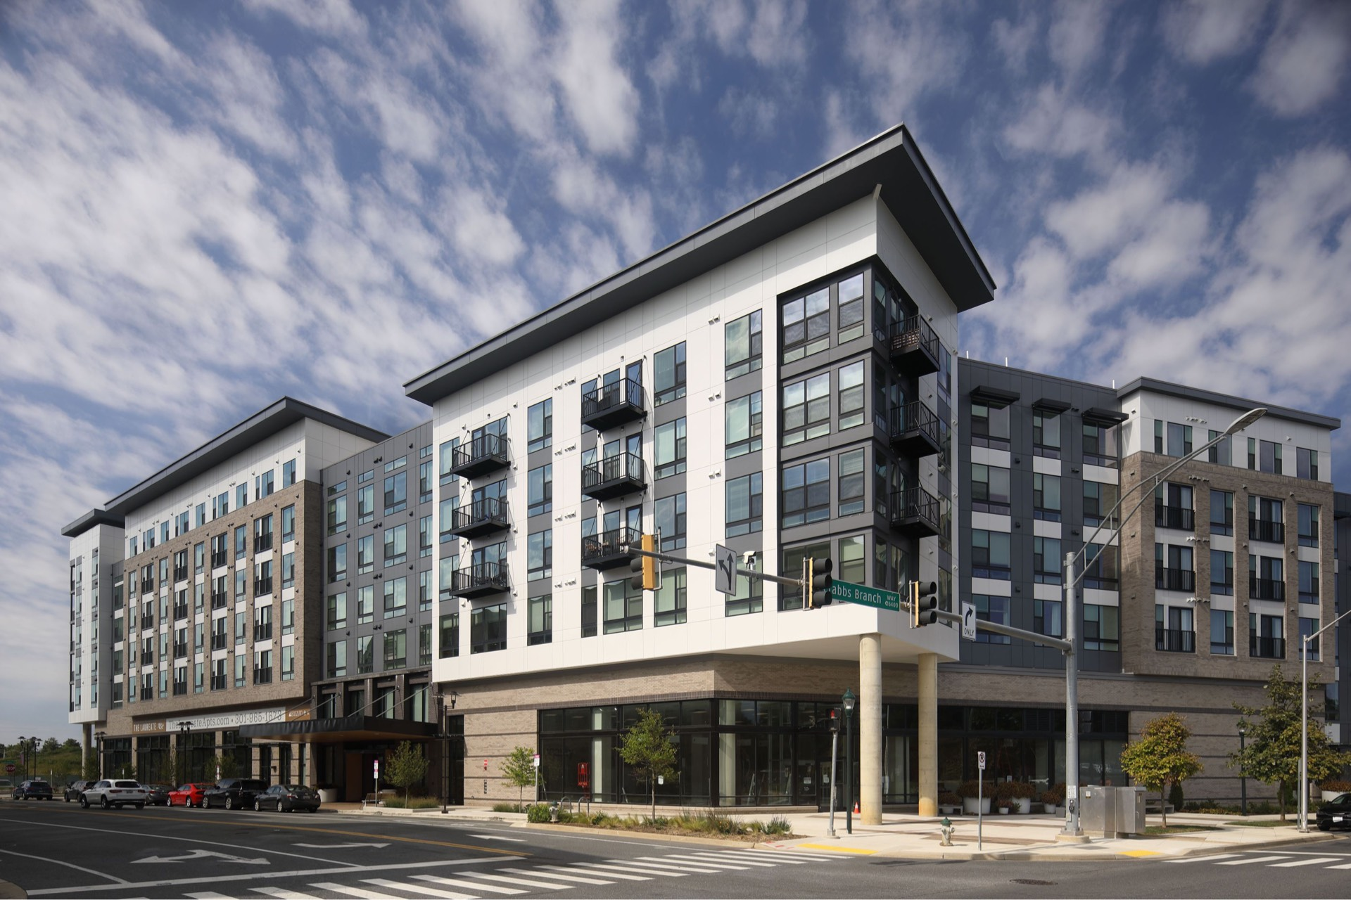
The Laureate is a mixed-use, mixed-income development at the Shady Grove Metro Station. It opened in June 2023, and is fully leased up as of November. Photo: thelaureateapts.com/gallery
Detailed explanations of these steps below use HOC’s approach as a best practice; however, certain aspects can be modified and changed to best suit Virginia Beach.
Use public sector capacity to supplement (or replace) oversubscribed federal resources
Demand for the most common affordable housing funding programs (e.g., LIHTC, Housing Choice Vouchers) regularly exceeds annual allocations from federal and state lawmakers. Therefore, localities must find and dedicate alternative sources of financing to develop affordable housing.
Establishing new production funds can increase a locality’s supply of affordable housing more efficiently and harness multiple strategies to expand affordable housing options, making the most of available resources while working toward long-term funding solutions.
Montgomery County, Maryland, addressed this challenge in 2021 by issuing a $50 million, taxable, 20-year municipal bond. Bond proceeds were put into the new Housing Production Fund (HPF), which provides low-cost construction loans to projects developed by HOC and its partners.
Because interest rates for bonds are generally favorable compared to market averages, the County essentially lends itself cheap debt (as “bridge loans”). This can replace privately sourced equity in a project’s capital stack, which would otherwise require higher returns on investment that would limit the development’s levels of affordability.
Collaborate with and leverage development partners
Establishing a locality-controlled fund specifically for the production of mixed-income housing can facilitate collaborations and private contributions without endangering the overall objective of affordability.
While HOC is using the HPF to finance some projects completely by itself, it’s also using the HPF on developments that include private and/or nonprofit partners. These collaborations leverage additional investments brought to the table, facilitate the inclusion of below-market rate units in new high-value areas, and allow HOC to significantly scale up its work.
Replacing private equity with public equity
Public development models can also play an important role in sustaining counter-cyclic housing construction, when economic conditions generally chill private development activity. As interest rates began increasing in 2022, HOC advertised the HPF to for-profit developers in the county whose upcoming projects no longer penciled out. HOC can “revive” these developments by becoming an equity partner, bringing low-cost money, and structuring the deal to subsequently include a range of affordable units.
In Virginia Beach, strong candidates for development partners include:
- Virginia Beach Community Development Corporation (VBCDC): As a subordinate nonprofit organization whose board is appointed by the City Council, VBCDC could eventually serve in a role similar to HOC in Montgomery County, Maryland. This would require intentional strategic planning and capacity building within the agency to position itself for conducting such activities.
- Private developers: High-capacity developers with experience in affordable rental housing (such as The Lawson Companies and The Franklin Johnston Group) and those who have previously partnered with the City on mixed-use projects (such as The Breeden Company) could easily be collaborators.
- Nonprofit housing providers: Mission-driven organizations that specialize in affordable rental housing and related services (such as Virginia Supportive Housing) could augment new developments by bringing additional grants to secure housing opportunities at a deeper affordability level than delivered by standard mixed-income models.
Secure taxpayer investments to generate revenue
Perhaps the most important part of this model is the permanent equity secured by the public development partner. Rather than fully transferring ownership to private or nonprofit owners, Virginia Beach can retain a stake in the project so that revenues from residential and commercial leases provide ongoing income. A permanent ownership stake by a public entity also helps guarantee that the affordability restrictions on applicable units are enforced.
Use income to manage debt and spur new projects
When projects supported by HOC are completed and leased up, the initial HPF investment is replaced with permanent financing from another source. HOC then revolves the money back into the HPF to be used in a future development.
As income flows from the property, proceeds can be used to cover interest payments on the bond. Over time, increased revenue might exceed the necessary debt service and can therefore be invested to complete needed upgrades or repairs, deepen affordability, or support the construction of other projects.

14.2 HOW TO DO IT
Within 6 months:
- Evaluate capacity needs for successful planning and implementation of this model. Assess possible avenues using existing structures (e.g., Department of Housing and Neighborhood Preservation, VBCDC), as well as possible new entities (such as a standalone public development entity).
- Join and participate in the Public Development Community of Practice, a quarterly working group managed by the Center for Public Enterprise (CPE). CPE has supported HOC’s HPF implementation and is currently advising other cities across the country on starting similar programs.
Within 1 year:
- Develop a strategic plan outlining the goals, objectives, and target populations for a Housing Production Fund.
- Identify the funding levels necessary to make desired mixed-income projects feasible.
- Determine whether issuing a general obligation bond for a revolving fund is feasible with respect to other current and projected debt-financed activities.
- Plan out development priorities to be sensitive to overall tax base needs of the City, relative to appropriate commercial/residential mix.
Within 2 years:
- Announce an interest in fostering mixed-use, mixed-income developments and identify sites and developers interested in pursuing this model. Sites can be privately or publicly owned.
- Systematically rank and prioritize sites and partners based on project feasibility and expected level of impact.
- Align zoning and planning incentives to accommodate this model.
- Select the first project, begin the pre-development stage, and issue the first loan.

14.3 WHO DOES WHAT
City of Virginia Beach: Establish the legal framework and regulations of a new fund. Create oversight committees or designate an existing agency to manage operations. Identify and allocate initial funding and sites from which to build the fund and new projects. Evaluate and amend land use regulations as needed to further mixed-use goals.
Private industries and businesses: Provide capital as an equity investor to the fund. Leverage construction and commercial development expertise to build mixed-use projects.
Nonprofit developers: Provide expertise in affordable housing development and management. Access grants and other funding to complement the production fund.

14.4 FUNDING SCOPE
The level of funding needed for successful mixed-income, mixed-use public development projects can vary significantly based on several factors, including the scale and scope of desired projects, location and land costs, and the affordability goals.
In Montgomery County, Maryland, the level of HPF dollars used per unit has ranged from approximately $50,000 to $80,000. For a 150-unit multifamily project, this would amount to roughly $10 million. While this initial investment is eventually recouped, the money is tied up during construction. Therefore, the full scope of a revolving loan fund should sufficiently cover the size and frequency of desired development.
If this initiative is paired with larger developments spearheaded by VBDA and/or a Housing Trust Fund, the revolving loan fund could act as additional leverage or efficiently fill gaps by targeting smaller projects less competitive for LIHTC awards. Virginia Beach may want to explore focusing this model on “missing middle” scale developments.
A production fund can also scale up over time as more funding partnerships are developed and units begin to sustain the fund. Initial contribution goals should consider how to create the foundation for self-sustaining growth and what is needed to achieve impactful projects.

14.5 POTENTIAL FUNDING SOURCES
The model proposed in this solution could easily serve as the “flagship” use for a Housing Trust Fund. HTFs across the nation commonly use revolving loans to finance projects, but few pair those investments with public ownership. As Virginia Beach pursues the creation of a new HTF, the City should keep this model in mind as a possible long-term strategy for support.
Thus, while the potential funding sources for HTFs can also apply here, the following three are most relevant:
- General obligation bond: Because a revolving loan fund is not permanently tied to a specific project’s revenue, general obligation bonds must be used if Virginia Beach uses municipal bond proceeds.
- Other public funds: Special taxes and fees could be levied as dedicated revenue but may not initially generate the scale of funding needed.
- Private funds: As Virginia Beach explores this model, outside investors with an interest in community development should be engaged. These include hospitals and other institutions (for “program-related investments”), philanthropic foundations, and LISC Hampton Roads.
The funds for equity investments (i.e., the permanent debt used to replace the revolving construction loan) could also be generated by a Housing Trust Fund, project-specific revenue bonds, and/or other public sector financing options.
Richmond-LISC bond partnership
Following a five-year, $50 million commitment of bond proceeds for affordable housing initiatives, the City of Richmond announced a one-for-one match by LISC. LISC will work with financial institutions and philanthropic organizations to bring the total investment to $100 million.

14.6 METRICS TO EVALUATE SUCCESS
- Project diversity: Assessing the mix of housing types developed through the fund, particularly smaller builds, nontraditional housing types (i.e., adaptive reuse, co-living spaces), and mixed-use living. Other considerations include diversity of neighborhoods impacted and equitable distribution of project locations.
- Innovation: Measuring the number of projects that incorporate unique place-making features, sustainable practices, renewable energy sources, or low-impact development techniques.
- Community benefits: Measuring the fund’s ability to impact multiple community goals. Assessing how projects contribute to job creation, activate underutilized spaces, and improve communities holistically.
- Return on investment: Evaluating the financial performance of mixed-use projects, including the return on investment for the fund. Tracking revenue generated and property value appreciation.

14.7 OTHER EXAMPLES
City of Greenville, NC Housing Impact Fund
- Approximately $5 million “blind pool fund” of revolving investment committed in exchange for a small guaranteed return over a term of about five years.
- Operates as an attractive, straightforward way for local banks, businesses, philanthropies, donor-advised funds, or individual investors to make a direct impact.
- Supports mixed-income developments that are too small for successful LIHTC applications.
Atlanta Urban Development Corporation
- Affiliate entity of Atlanta’s housing authority, created in 2023 to serve as vehicle for public development model following Montgomery County, Maryland example.
- Currently seeking $38 million Housing Opportunities Bond to develop new mixed-income rental housing. New projects will use public-private partnerships, but AUDC will permanently own and manage properties.
- Additional information: City of Atlanta presentation on AUDC (June 2023)

15. Streamline permitting

BACKGROUND WORK 2

Research opportunities to simplify and streamline the permitting and review processes
Local governments are the primary entities responsible for reviewing and approving new developments to ensure they are well-sited, adequately designed, and safely built. However, with this authority comes great responsibility: administrative delays and inefficiencies can lead to additional costs and complexities for builders. At best, these expenses get factored into higher home prices. At worst, developers choose another locality to build or give up entirely.
Within existing planning and permitting programs, local governments have ways to streamline components of the new project review process. Virginia Beach should explore three different approaches: improving existing processes, offering expedited “fast track” pathways, and creating a “green tape” program with even more incentives.
The second two options can be specifically designed to apply only to residential or mixed-use proposals that meet certain criteria in line with City objectives, such as including affordable units or establishing environmental sustainability measures. Overall, these strategies help orient the City’s core, day-to-day planning tasks toward achieving its long-term housing and economic growth goals.

15.1 HOW IT WORKS
Assessment of current processes
By cutting down on procedural barriers, developers get to construction faster. Achieving this efficiency requires coordinating various departments within a local planning office and assisting applicants through pre-design consultation and assessments.
The Virginia Beach Development Services Center
In FY 2022-23, Development Services Center (DSC) reviewed nearly 2,800 plans. Its FY 2023-24 budget is about $3.1 million, which funds 28 FTE positions. This reflects no change from the previous year.
The Department of Planning and Community Development also has a Development Liaison team, which is not part of DSC. This team guides and coordinates development proposals for applicants, for a range of project types and sizes.
While Virginia Beach has made intentional efforts to improve its development review process—and notably performs higher than some comparable cities in Virginia—feedback received from stakeholders for this study emphasized a need to reduce wait times and identify opportunities to reduce regulatory burdens.
A comprehensive assessment of current systems would best identify specific challenges and opportunities, although the review would not need to be a formal audit to achieve results. Some areas to consider during the investigation include:
- Staff workloads and backlogs
- Common repetitive requests that occupy staff time
- Average time required to review different applications and permits
- Office workflow and technology inefficiencies
- DSC review and feedback procedures (and coordination with other departments)
The assessment can also align with two recent upgrades for the department.
- Revised stormwater management regulations: Staff have implemented changes to these regulations approved by the City Council in early 2022, with a focus on streamlining development plan reviews. Recent changes include simplifying stormwater assessments by using Excel spreadsheet calculations rather than more complex modeling software. Similar improvements should be explored in other processes.
- Accela software improvements: The planning department is currently working with the Information Technology Department to address functionality gaps and issues in the Accela software platform, which connects citizens with planning and permitting services.
The City should evaluate the benefits and drawbacks of whether this assessment is conducted internally or by an external third party. This decision should be made collaboratively between staff and the City Council, perhaps via the Process Improvement Steering Committee.
Richmond permit office audit
Significant backlogs and poor service led the City of Richmond’s auditor to investigate the Permits and Inspections office in early 2020. The internal report found insufficient recordkeeping, incomplete billing, and inefficient workflows compared to neighboring jurisdictions. Since then, investments in staff levels and reformed procedures have demonstrated major improvements. Building permits originally took longer than a month to approve; as of November 2022, average turnaround time was just five business days.
“Fast track” permitting process
Virginia Beach should explore “fast track” permitting options for certain proposals that reduce both application burdens and wait times. This approach has the dual benefit of reducing costs for developers and streamlining workflows for department staff. While more proactive “green tape” incentives for dedicated affordable housing are described further below, Virginia Beach could develop these simpler “fast tracks” for certain development types that contribute to the City’s overall housing goals.
The eligibility criteria, as well as the suite of options for lowering barriers, should reflect the results from two important documents:
- Permitting assessment: Opportunities to improve certain elements of the application, feedback, and approval processes can set the groundwork for expedited pathways in a “fast track” scenario. These upgrades would be most likely to result in meaningful reductions in costs and wait times.
- 2040 Comprehensive Plan: Particular housing styles that might be encouraged in the upcoming plan should be the first development types prioritized for “fast tracks.” These could be lower-impact—but still lower-cost—buildings such as accessory dwelling units (ADUs) and duplexes.
For example, a “fast track” for ADUs might include:
- A fully administrative approval process with no public hearings required (“by right”)
- Pre-defined review steps across departments with simple checklists
- Simplified application forms that are legible and accessible to homeowners and first-time developers
- Reviews completed within two or three business days
- A series of pre-approved designs and floor plans
Norfolk “Missing Middle” Pattern Book
The Norfolk Missing Middle Pattern Book serves as an exemplary model for localities seeking to promote affordable housing. This resource showcases pre-approved building designs that align with the specific needs and characteristics of Norfolk, facilitating easier and more efficient development processes for builders and developers. By offering a range of vetted design options, the Pattern Book streamlines the approval process, reduces uncertainties, and encourages the development of diverse housing types. This approach can be adapted by other localities to address their unique housing challenges, supporting strategic growth and affordability in housing markets.
For more information: City of Norfolk Missing Middle Pattern Book (PDF)
To ensure smart development, the City could set specific criteria to benefit from the “fast track,” such as requiring the property to be in a designated growth zone. Aligning the “fast track” with the future residential use recommendations in the new comprehensive plan is also critical. For a “fast track” to be effective, it should likely only apply to developments that are a permitted use in the property’s base zoning. Public hearings to approve a conditional or special use would introduce significantly higher costs and timelines.
Streamlining certain projects may raise equity concerns, especially if they benefit specific developers or types of housing. Therefore, the City should be transparent about what applications are eligible and why those particular projects align with pre-established growth objectives in the 2040 Comprehensive Plan and other guiding policies.
“Green tape” incentives for new affordable housing
Larger multifamily and mixed-use projects that include affordable housing are generally more difficult to finance and often face additional opposition from a vocal minority of residents. Unexpected costs and delays that a market-rate proposal could absorb can much more easily sink its affordable counterpart.
To mitigate these challenges, local governments can leverage their development approval powers to proactively help affordable housing projects succeed. This approach is sometimes referred to as a “green tape” program. Whereas “fast track” programs look to simplify the process, “green tape” programs offer much more substantial incentives, and are generally designed for larger projects. Strategic Growth Area (SGAs) would be the ideal places to offer green tape incentives within the city.
These incentives could include:
- Fully expedited reviews of site plans and other submissions
- Dedicated staff liaison(s) for the full process
- Reduced or waived fees for permits and utility hookups
Other meaningful incentives that would need to be incorporated into the zoning ordinance include:
- Density bonuses (i.e., Workforce Housing Program)
- Reduced parking requirements
- More flexible setback and height allowances
In exchange for these incentives, the program should be eligible for proposals that meet a set of standards, such as:
- Minimum number and/or percentage of affordable units
- Income levels served by affordable units
- Length of affordability terms
- Identical design and quality for market-rate and affordable units
- Proximity to transit
- Location in designated growth area
- Current site control
Virginia Beach should consider other minimum criteria but should avoid artificially restricting eligibility with unworkable requirements.

15.2 HOW TO DO IT
Within 6 months:
- Outline methods and objectives for a needs assessment to identify specific areas of the permitting and approval process that most need streamlining or that cause the biggest barriers for developers.
- Determine whether assessment can be conducted internally or if an external consultant would be more appropriate. Draft and prepare RFP if outside firm is desired.
- Based on historical trends, set desired timelines for permit issuance.
Within 1 year:
- Begin and complete needs assessment, either via internal review process or external audit.
- Compare performance with peer localities for valuable benchmarking data to assess the competitiveness and effectiveness of the current processes.
- Identify preliminary residential uses and development types desired in the updated comprehensive plan. Begin evaluating specific ways for approval processes to ensure that these projects receive swift approvals when conditions are met.
- Redesign the permitting and approval process based on findings from the needs assessment and stakeholder engagement.
- Outline standardized procedures and requirements for “fast track” pathways.
- Determine need for additional positions and training to ensure that staff can effectively execute proposed changes.
- Begin designing a pilot “green tape” program that aligns with the comprehensive plan and gather feedback from applicants and stakeholders.
Within 2 years:
- Establish policies and procedures for a “green tape” program. Begin advertising incentives with affordable housing developers.
- Expand the “fast track” program to cover a wider range of projects; make adjustments as necessary.
- Perform legal and policy review of the approval processes to ensure that quality and compliance are not compromised.
- Establish and track key performance indicators to measure ongoing program performance (including average permit issuance time, applicant satisfaction, and number of affordable units developed).

15.3 WHO DOES WHAT
Department of Planning and Community Development: Lead effort to assess internal operations, consult with stakeholders and consultants as necessary, determine and request additional capacity needed to achieve objectives, design and roll out incentive programs.
Department of Housing and Neighborhood Preservation: Advise planning department on specific challenges and needs faced by affordable housing development, assist with design of incentive program guidelines and criteria.
Process Improvement Steering Committee: Help guide and oversee operational changes to improve efficiency, serve as liaison between departments and the City Council.
Planning Commission and City Council: Review, advise, adopt, and oversee any administrative changes and any new or updated policies.

15.4 FUNDING SCOPE
Dedicated funding for the assessment is necessary, and depends on the scope of work desired. A basic internal review could be incorporated into the staffing budget and workplan for the applicable department(s), while a more extensive review by a third party might require a specific allocation by the City Council.
Although a long-term outcome for these possible reforms includes greater real estate tax revenue from new developments, any substantial fee waivers could have short-term consequences on income to cover operational expenses.

15.5 POTENTIAL FUNDING SOURCES
Virginia Housing: Pursuing additional planning grants from Virginia Housing could help cover costs for determining how the current permitting process impacts affordable housing development, as well as drafting new policies to reduce barriers. Staff should have proactive conversations with Virginia Housing representatives to explore options.
Competitive public grants: Virginia Beach should monitor federal and state grant opportunities that support work to cut red tape for affordable housing and design better approaches. For example, HUD’s recent Pathways to Removing Obstacles to Housing (PRO Housing) grant was a special CDBG allocation designed to help local governments identify and resolve regulatory and administrative roadblocks for affordable housing.
Private funds: Grants from philanthropic foundations that support community development and civic innovation could also be explored.

15.6 METRICS TO EVALUATE SUCCESS
- Volume: Measuring increase in approved permits for affordable housing developments and other residential projects that contribute to the City’s housing goals.
- Processing times: Quantifying shorter timeframes between application submittal and approval compared to regular process.
- Applicant satisfaction: Collecting feedback from stakeholder developers and analyzing cost savings for applicants due to expedited processing.
- Diversity of projects: Identifying the mix of developments, incomes served, and types of housing produced.

15.7 EXAMPLES
City of Charlottesville Affordable Housing Expedited Review
- Expedited process enabled through §34-12(f) in local code prioritizes affordable housing projects that align with the City’s goals to have their review complete within a month
Montgomery County, Maryland Green Tape Process (PDF)
- Expedited permitting and review process for projects that designate at least 20% of the total units to affordable housing.
City of Richmond Third-Party Program
- Applicants can contract directly with a third-party service for permit review as an alternative to in-house process. Available for certain scenarios and not all cases.
- Created in response to significant ongoing delays and problems with the permit office, many of which were highlighted in a 2020 internal audit of the permit office.

16. Explore zoning advisory board

BACKGROUND WORK 3

Consider an advisory board to guide new zoning ordinance changes and to redesign the Workforce Housing Program
After finalizing a comprehensive plan in 2024, Virginia Beach will start revising its zoning ordinance to align with new land use goals. Gathering input from those most impacted by the ordinance could help alleviate past challenges and establish rules that bolster the City’s housing objectives.
An affordable housing advisory board consisting of renters, homeowners, developers, engineers, architects, land use attorneys, and other important stakeholders can provide valuable input on how to optimize zoning and better address the city’s needs.
Furthermore, this process can incorporate a specific evaluation of the current Workforce Housing Program (WHP), which has been used to deliver new affordable homes only twice in more than a decade. Finding ways to improve the program in concert with a broader rethinking of residential development regulations can prime the WHP for success.

16.1 HOW IT WORKS
An informed and diverse advisory board combines experience and expertise to make recommendations for transforming the comprehensive plan guidance into new zoning policies that advance the City’s housing goals. The board could also dedicate itself to ongoing public outreach and interviews to evaluate existing obstacles in zoning and land use within the larger community.
Creation and recruitment
The Department of Planning and Community Development, with guidance from the Planning Commission, the City Council, and other partners, should propose how the advisory board will be chartered, and what representation to prioritize.
Important governance considerations include:
- How many board members are desired and how board leadership will work
- Who has authority to appoint board members
- Whether the board is a temporary ad hoc committee with a sole purpose, or if it will continue to meet after its initial objectives are complete
- How meetings will be scheduled, conducted, and available for public input
The advisory board’s makeup should reflect the diversity of backgrounds, expertise, and perspectives necessary to find strong, lasting consensus on zoning reforms. The exact breakdown of preferred representation is up to staff and city leadership, but could include:
- A member of the City Council
- A member of the Planning Commission
- A member of the Board of Zoning Appeals
- A member of the Housing Advisory Board
- An architect with expertise in residential and mixed-use development
- A multifamily/mixed-use developer
- A single-family developer
- A land use attorney
- An affordable housing and/or homelessness services practitioner
- Community representative(s), both homeowner(s) and renter(s)
Scope of work
Staff should work with the new board to finalize a work plan with clear objectives. A basic scope might include the following tasks:
- Examine the final comprehensive plan and identify specific housing and community development strategies where zoning regulations play a role
- Prioritize those issues based on level of impact, importance to the community, and difficulty to implement
- Investigate best practices from across the state and country to find successful solutions
- Collaborate with staff, city leaders, practitioners, and the public to draft and develop a series of specific recommendations for changes to the city’s zoning ordinance
- Develop explanatory presentations and fact sheets about the proposals to help educate residents and interested parties
- Deliver final recommendations to the Planning Commission and the City Council for their review and approval
Recommendations
Most importantly, there should be clear expectations about the process for adopting recommendations and for what occurs once those are delivered to the Planning Commission and the City Council.
Because the advisory board is not a formal rule-making entity, its report will be nonbinding. It will, however, reflect a significant amount of research and collaboration that ideally leads to a swift legislative review and approval.
The two main recommendation process options are, therefore:
- A plain-language report that includes a list of prioritized policy changes, and preferred options for those reforms, or
- A summary report alongside a package of actual drafts for new zoning ordinances.
If the first option is chosen, city leadership can endorse the proposed recommendations, but actual ordinances will still need to be drafted and brought back for formal review and adoption. This would likely be a longer process.
The second option, on the other hand, may extend the advisory board’s total workload and timeframe but will generate ordinances for consideration. This gives the board greater agency and influence, and would likely expedite the overall process of completing the comprehensive plan and starting real policy changes to implement its strategies.
Evaluating the Workforce Housing Program
While the advisory board’s primary mission should be to promote affordability throughout the full range of residential zoning changes, the City has an important opportunity to explore the future of its current Workforce Housing Program. Designed to reward developers who set aside a share of new affordable units in their projects with a density bonus, the program has been used only two times since its inception in 2007.
The advisory board, a subgroup of its members, or another duly appointed body should evaluate the WHP using a framework similar to the outline below.
- Program outcomes: How many total homes were produced, and how many of those were affordable? What income levels were served? Are the affordable units in compliance?
- Administrative requirements: Were internal policies and procedures adequate? Did the planning and housing departments collaborate effectively? Does the Housing Advisory Board contribute appropriately and productively?
- Stakeholder feedback: Do developers find the program beneficial? What changes would be needed to scale up? Does the greater public understand the program’s objectives?
- Context: How has the existing zoning ordinance and other land development regulations affected program effectiveness? Are proposals using LIHTC and other dedicated affordable housing programs easily able to participate?
Following that analysis, the group should examine options to overhaul the WHP. Program design elements can include the following:
Enabling authority
Virginia Beach does not have broader “inclusionary zoning” powers under Va. Code Ann. § 15.2-2304; most successful “inclusionary zoning” programs in Virginia are localities included in this statute, which allows jurisdiction to apply affordability requirements to a wider range of development proposals.
The current WHP is based on Va. Code Ann. § 15.2-2305, which limits density bonuses and affordability requirements to 30% and 17%, respectively. However, the newer Va. Code Ann. § 15.2-2305.1 statute provides a greater range of options and should be evaluated.
Applicability
Both applicable statutes allow Virginia Beach to apply the WHP to developments with densities greater than one home per acre in an “approved sewer area.” Furthermore, proposals must be subject to a rezoning, special exception, site plan, or subdivision plat.
The City should determine whether to exempt developments with fewer than a certain number of units, with densities above the statutory limit, or with other characteristics. These exemptions would reduce the burden on smaller proposals where the WHP may be financially infeasible.
Density bonus and affordability ratios
While Va. Code Ann. § 15.2-2305 has simple but hard limits on the percentages permitted for added density and affordable units, Va. Code Ann. § 15.2-2305.1 has a much larger scope. It is also very prescriptive. Density bonuses and affordability ratios are enumerated in two tables, depending on whether the incomes served are 80% AMI or 50% AMI. Greater densities are afforded to developments that serve lower incomes.
Additional incentives
Reduced or waived parking minimums, reduced or waived fees, expedited permit review, and other meaningful incentives should be evaluated and considered, especially in response to specific developer feedback regarding costs and project feasibility. However, any exemptions or waivers should not diverge from comprehensive plan guidelines.
Other program elements
Along with the core ratios, other important aspects of a successful WHP include developer education and outreach, efficiency of application review and approval, and monitoring and compliance of affordable units.
Fostering civic engagement
During and following the zoning rewrite process, advisory board members can serve as advocates within the community to help explain and promote recommended revisions. They can help spread information and address common concerns related to development changes.

16.2 HOW TO DO IT
Within 6 months:
- Determine whether this board will be a new and distinct entity, a special committee derived from existing boards, or another arrangement.
- Determine whether this board has the option to continue beyond the zoning rewrite process, or if it will be dissolved after reaching that milestone.
- Identify an appropriate name for the group to reflect its mission, powers, and role relative to other working bodies established by the City.
- Establish core governance principles, including minimum qualifications, term limits, and officer designations.
- Recruit diverse board members who represent the various industries and stakeholders that regularly interact with the zoning process.
Within 1 year:
- Finalize board selection through a transparent and inclusive process.
- Convene the board and establish regular meeting dates and times.
- Define the board’s objectives, mission, and scope of work, including the specific areas of affordable housing it will seek to address.
- Develop accessible materials that explain zoning and how it impacts housing.
- Create concise presentations on the most recent developments in land use planning and zoning to share with the board, including specific case studies from Virginia Beach and other relevant communities.
- Implement a community engagement plan to further solicit input and inform the board’s priorities.
Within 2 years:
- Develop actionable strategies for successful zoning changes.
- Draft preliminary report with recommendations for stakeholders, public, and city leaders to review and provide input.
- Revise recommendations as needed into a final report, including suggestions for priority reforms. Seek formal approval from the Planning Commission and the City Council.
- Collaborate with staff to formally begin drafting new ordinances in accordance with consensus recommendations and priorities.

16.3 WHO DOES WHAT
Department of Planning and Community Development: Provide support and help guide the advisory board on overall zoning rewrite.
Department of Housing and Neighborhood Preservation and Housing Advisory Board: Provide support and help guide the advisory board (or related group, as designated) on evaluating and updating the WHP.
Zoning advisory board: Collaborate with staff to develop recommendations, serve as liaison with the Planning Commission and the City Council, and conduct public meetings to gather feedback from stakeholders and community members.
Planning Commission and City Council: Establish and set initial guidance for new board, appoint board members, periodically review and provide input, and evaluate final recommendations.
Consultant: If hired, assist staff and advisory board throughout the process, conduct additional research, help draft and implement new ordinances.

16.4 FUNDING SCOPE
Generally, local advisory board members are volunteers not reimbursed for their time. However, the City may want to consider offering a stipend to demonstrate appreciation for members’ time and contributions.
Coordinating and maintaining the advisory board can require significant staff time and resources. Likewise, while a potential consultant would provide additional personnel, bring outside expertise, and keep the process moving, his or her costs could easily exceed the equivalent annual compensation for the average full-time employee in either department.

16.5 POTENTIAL FUNDING SOURCES
City budget: Virginia Beach should proactively budget funding to support staff (and potential consultant) time for this work, as it did for the comprehensive plan update.
Other public funds: The Virginia Department of Housing and Community Development (DHCD) provides planning grants under the CDBG program to enhance the likelihood of project impact and success. In coordination with citizen participation, these grants support the creation of well-defined strategies to address the most pressing community development needs in a given area. Virginia Housing also provides funding through its grants to support up to $50,000 in community engagement planning.

16.6 METRICS TO EVALUATE SUCCESS
- Diversity of board: Identifying types of stakeholders, number of organizations, and neighborhoods represented on the advisory board.
- Number of actionable recommendations: Quantifying how input from the advisory board leads to zoning changes that positively impact affordable housing.
- Increased public awareness and support: Measuring reduced opposition to proposed changes or the number of public residents engaged through the process. Number of engagement materials consumed/shared is another indicator of public awareness.

16.7 EXAMPLES
Examples of zoning advisory boards:
Arlington County, Zoning Ordinance Committee
- Advises the County Board on proposed changes to the county’s zoning ordinance.
- Members are publicly elected planning commissioners from various sectors, including real estate, development, and community organizations.
Prince William County DORAC
- DORAC stands for Design and Construction Standards Manual (DCSM) and Zoning Ordinance Advisory Committee.
- Independent 26-member advisory group reviews zoning text amendments and other related short- or long-term reforms.
City of Harrisonburg Ordinance Advisory Committee
- 14-member advisory group to work with staff and consultant on rewrite of zoning ordinance following comprehensive plan update.
Examples of alternative zoning analysis and programs relevant to the board:
City of Charlottesville Bonus Height/Affordable Housing Financial Analysis (PDF)
- Financial analysis study to determine possible opportunities for Charlottesville to incentivize affordable units in new residential development via density bonuses.
Operational and productive inclusionary zoning programs in Virginia:
- Fairfax County Affordable Dwelling Unit (ADU) and Workforce Dwelling Unit (WDU) programs
- Loudoun County ADU Program
- Arlington County ADU Program
- City of Falls Church ADU Program

Appendix A — Public and expert engagement

A.1 Public engagement summary/themes
City of Virginia Beach staff received 109 responses to the online survey posted on the city's town hall platform. Housing affordability was the most common theme in survey responses. Respondents called on the City to address affordability challenges, either generally or via specific mechanisms, which included:
- building or purchasing affordable housing
- requiring or incentivizing developers to build affordable housing
- capping rents or regulating rent increases
- preventing new developments considered to be unaffordable
- reforming the zoning code to enable more multifamily and accessory dwellings, thereby increasing supply
Respondents observed that high housing costs have pushed families to unsafe, poorly maintained dwelling units in less safe and desirable neighborhoods, and in some cases, forced households to leave Virginia Beach.
Survey respondents identified specific housing affordability challenges affecting various resident groups. Middle- and lower-income workers (people with "regular jobs") are affected by the imbalance between prevailing wages and housing costs; they frequently cannot afford decent-quality, family-sized dwelling units in desirable neighborhoods. Meanwhile, young families cannot find affordable starter homes, and smaller households, such as single workers, single-parent families, or downsizing empty-nesters, face a shortage of smaller dwelling units appropriate to their household size.
For homeowners, most respondents focused on the affordability challenges caused by rising home values — most frequently higher tax payments — rather than equity gains. Owner responsibilities such as maintenance and upkeep costs were also cited as an affordability challenge for many households. Rising ownership costs particularly affect seniors and retirees living on fixed incomes. Middle-income seniors, receiving both Social Security and a private pension, may earn too much to qualify for housing assistance or subsidized dwelling units but too little to purchase housing at the market rate.
Households with incomes low enough to qualify for rental assistance face a long waitlist for Section 8 vouchers — thus the assistance needed to stabilize housing and prevent homelessness may not be available. Respondents called for expedited and expanded emergency housing assistance or shelter capacity for households at acute risk of, or experiencing, homelessness. Respondents also cited the need for supportive housing for residents with disabilities, psychological or behavioral challenges, or addiction. Respondents identified micro-housing or single-room units as potential emergency housing for those who would otherwise be unsheltered.
Survey respondents also voiced qualitative considerations beyond basic affordability. Many respondents placed a high value on dwelling units offering space, lawns, and space between units, and were concerned that dedicated affordable housing lacked these qualities. Respondents wanted to avoid affordable housing that looked like "sardine boxes." Furthermore, given the affordability challenges specific to seniors and residents with disabilities, respondents underscored the importance of making dedicated affordable housing accessible for people with mobility constraints.
Survey respondents also recognized the correlation between housing and transportation costs, calling for improved transit service, especially between the oceanfront areas where lower-wage service jobs are concentrated, and the more peripheral neighborhoods where many lower-wage workers must live to afford housing. Respondents called for safer pedestrian and bicycle routes, while wanting to avoid traffic congestion and noise. Some respondents also noted the lack of street parking in neighborhoods and objected to the expense of parking in amenity-rich areas.
Responses pointed to divides between renters, landlords, and homeowners. Many responses attributed rising rents and purchase prices to the greed of landlords, developers, or house-flippers. Some responses blamed rentals for reducing the supply of housing for purchase; others claimed the lack of affordable rental options allows landlords to offer unsafe or poorly maintained dwellings. Many responses connected rental housing to nuisances such as unkept structures, yards, and fences and either blamed the character of tenants or their ignorance of responsibilities or landlords for failing to maintain investment properties.
Finally, despite the importance of the hospitality industry to the city's economy, many respondents identified tourism as a problem, believing that the City favors tourist areas over residential communities. Short-term rentals (STRs) in particular were associated with nuisances such as noise, littering, and violence, as well as disruptions to the housing market because they reduce the supply of rental housing.
In addition to soliciting responses online, the city hosted several in-person meetings.

A.2 Expert focus group summary/themes
Expert stakeholders offered information about the state of the housing market and housing challenges experienced by residents and workers, as well as builders and developers. These stakeholders explained that both renters and prospective buyers face a "take what you can get" market that is already excluding less-competitive households. They emphasized the need for committed affordable housing to recruit and retain workers with families. Participants specifically encouraged more rental and homeownership opportunities for public school employees, hospitality management workers, and people transitioning from non-career military.
In the rental market, they described landlords rejecting (illegally) people with housing assistance, Housing Choice Vouchers, and other voucher types, as well as temporary, emergency assistance. They also described households with children, people aging out of foster care, and seniors being effectively evicted or experiencing discrimination. Stakeholders also explained that discrimination and decreased unit availability have led to prolonged homelessness.
They explained that those who need non-conventional financing (e.g., FHA, VHDA, VA) are at a disadvantage in the homebuying process because of inspection requirements and the lengthier time for loan approval. As more investors and buyers who have substantial cash assets compete in the market and shrink inventory, households with financing requirements are disadvantaged. Stakeholders also discussed the benefits gap for families who don't make enough to buy but don't qualify for unconventional lending or down payment assistance programs.
Stakeholders also identified elder homeowners as being extremely vulnerable. They explained that in addition to home repair and modification, many need services and case management. They explained that many are worried about asking for assistance because they're afraid of being forced to leave their home and therefore enduring isolation and substandard living conditions. Respondents advocated for expanding the existing critical home repair program, adding supports for aging in place, and creating more affordable, attainable choices for independent and assisted living. Because affordable assisted living has long waitlists, stakeholders suggested a coordinated waitlist for all units across the city to benefit seniors seeking alternative residences.
Focus group participants also discussed development challenges faced in the city. Developers (for-profit and nonprofit) need more by-right development and re-development opportunities because they face increasing development costs (e.g., land, redevelopment, stormwater, labor, materials, process risks). Stakeholders (and citizens) want to see a clear housing plan and progress toward explicit goals. Participants referenced the Richmond 300 plan and the Fairfax Housing Blueprint.

Appendix B — Workforce housing affordability analysis
Using annual wage data of the Virginia Beach-Norfolk-Newport News MSA from the Bureau of Labor Statistics (BLS), VCHR calculated maximum affordable monthly housing costs (30% of monthly income) for each occupation using three scenarios:
- a single earner with a median wage
- a single earner with a 90th percentile wage to represent highly skilled or experienced workers
- two earners with a median wage for a single occupation to represent a dual earner household
This analysis investigates housing affordability in Virginia Beach for employees working in the Virginia Beach-Norfolk-Newport News MSA. It helps to evaluate whether the housing market adequately meets the needs of the labor market. Households spending more than 30% of household income each month for housing are considered cost-burdened and may have to sacrifice other necessities to obtain housing. VCHR compared the maximum affordable housing costs by occupation for workers in the scenarios described above to the lower quartile rent ($1,169), median rent ($1,433), upper quartile rent ($1,766), and median owner costs with a mortgage ($1,888) in Virginia Beach to identify workers (by occupation) who may not be able to access appropriate, affordable housing in the city.
VCHR analyzed housing affordability and occupational wages for the following occupation groups:
- the top 10 Virginia Beach city occupations by employment
- selected state and local government sector and mandatory service occupations

B.1 Housing affordability for the top 10 occupations in Virginia Beach
VCHR analyzed housing affordability for the top 10 occupations by employment — those with the highest number of employees — in Virginia Beach. Combined, these occupations make up about 21% of all employees who work in the MSA. These occupations can for the most part be categorized as service sector occupations and generally have the lowest wages. VCHR analyzed housing affordability for households in three household/earner scenarios (single earner with median wage, single earner with 90th percentile wage, and two earners with the same median wage).
As shown in Table B.1 afford below, workers in most of these occupations (8/10) cannot afford lower quartile rent as single earners, with two exceptions: general and operations managers (who can afford owner cost with a mortgage) and registered nurses (who can afford upper quartile rent). In fact, workers in the majority of these occupations (7/10) cannot afford to rent or own even if they earn in the 90th percentile. If a household has two earners at the same median wage, the situation improves. However, workers in three occupations — fast food and counter workers, cashiers, and home health and personal care aides — still cannot afford the median rent.
In terms of homeownership, the only occupation that can afford the owner costs with a mortgage for a single earner is the general and operations manager. When considering a single earner at the 90th percentile wage or a dual-earner scenario, registered nurses can also manage the owner costs.
Table B.1: Housing Affordability for the Top 10 Occupations by Employment
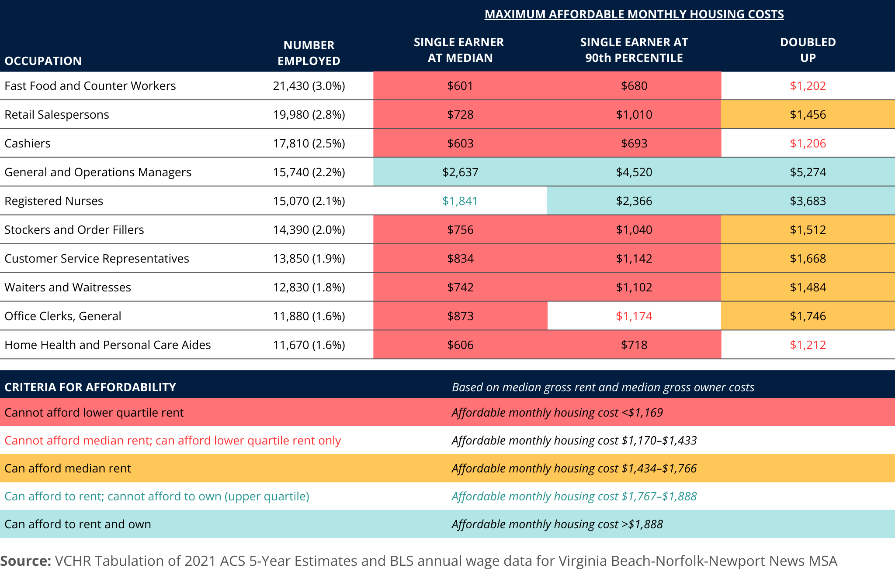

B.2 Housing affordability for state and local government employees/mandatory services
The state and local government sector is the essential job sector in the city, thus VCHR examined housing affordability for this occupation group. Occupations selected for analysis were those considered to provide mandatory services, such as teachers, firefighters, and childcare workers. Among workers in these occupations, both home health and personal care aides and childcare workers cannot afford the lower quartile rent even when earning at the 90th percentile wage. Furthermore, even when their earnings are doubled-up, they still cannot manage the median rent. In other words, these two occupations do not offer wages to afford rent in any given scenario. On the other hand, firefighters and postal service mail carriers can handle the median rent when earning at the 90th percentile and can afford ownership costs when their earnings are doubled-up.
The remaining six occupations — postsecondary teachers; kindergarten teachers, except special education; elementary school teachers, except special education; middle school teachers, except special and career/technical education; secondary school teachers, except special and career/technical education; and registered nurses — can afford the median rent as a single earner. Moreover, they can manage ownership costs when earning at the 90th percentile or when doubled-up.
Table B.2: Housing Affordability for Mandatory Service Occupations
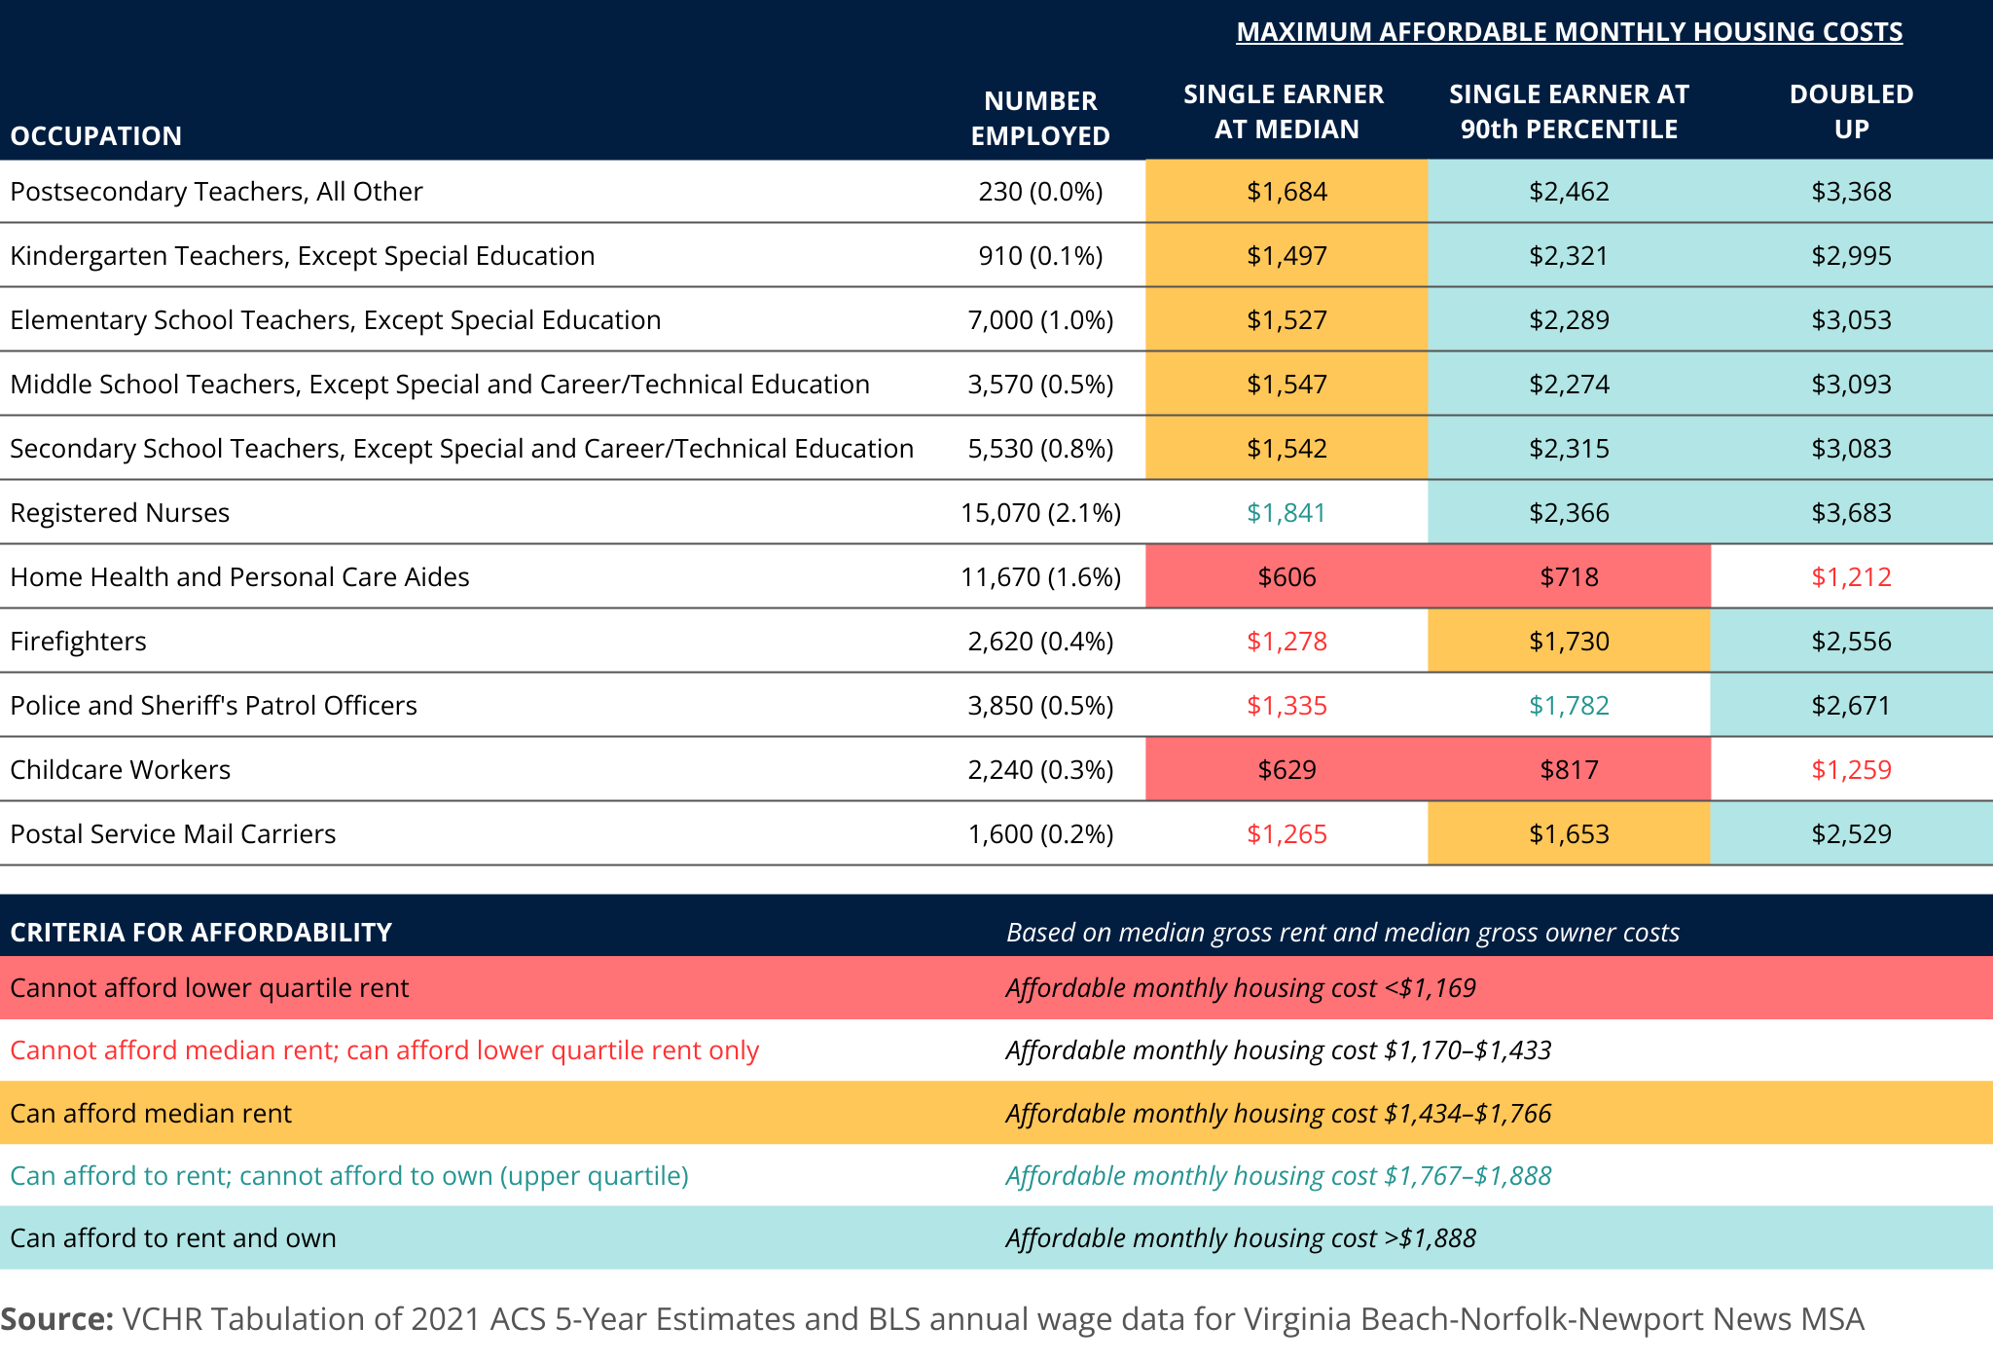

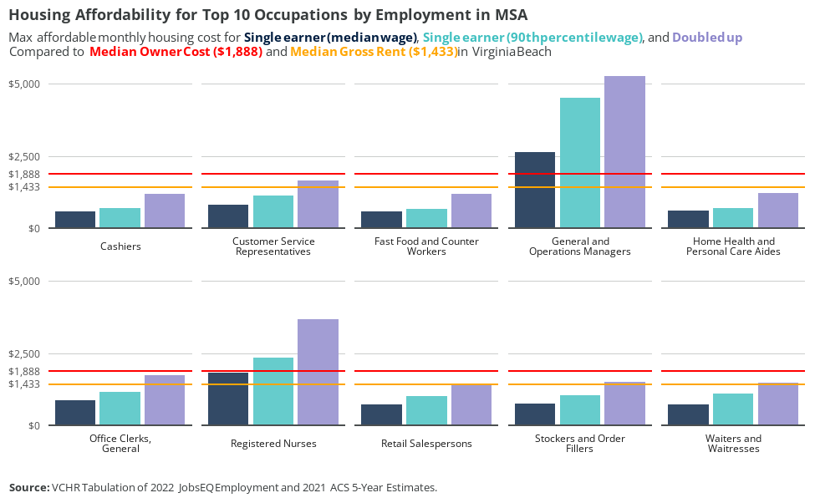
Figure B.1: Housing Affordability for the Top 10 Occupations by Employment in MSA

Appendix C — Naturally occurring affordable housing analysis

C.1 Homeownership: single-family and condo units
VCHR applied HUD FY 2022 Income Limits to assign an affordability level to each of 145,498 units included in the Virginia Beach Assessment Data. Table C.1 and Table C.7 provide the income limits and associated maximum affordable housing cost by number of bedrooms in the unit. These are the same limits applied in the HUD Consolidated Housing Affordability Strategy (CHAS) data to estimate the availability of units by income level. HUD uses multiples of the 1- and 4-person limits (1.5 and 4.5) to set affordable costs for 1-, 3- and 4-bedroom units based on occupancy assumptions. VCHR assigned affordability levels to units using both the 1.5-person limits and the 4.5-person limits. The 1.5-person limits are more likely to reflect the capacity of first-time homebuyers, while the 4.5-person limit may more readily correspond to more-established family income.
Table C.1: 2022 Income Limits by Household Size
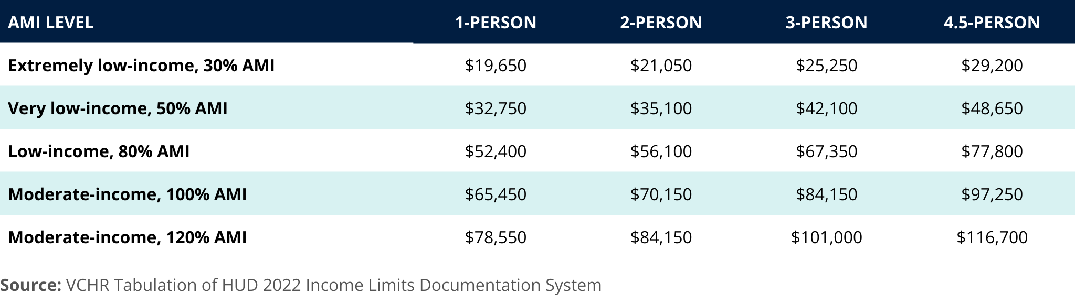

Table C.2: Maximum Affordable Housing Cost by Unit Size
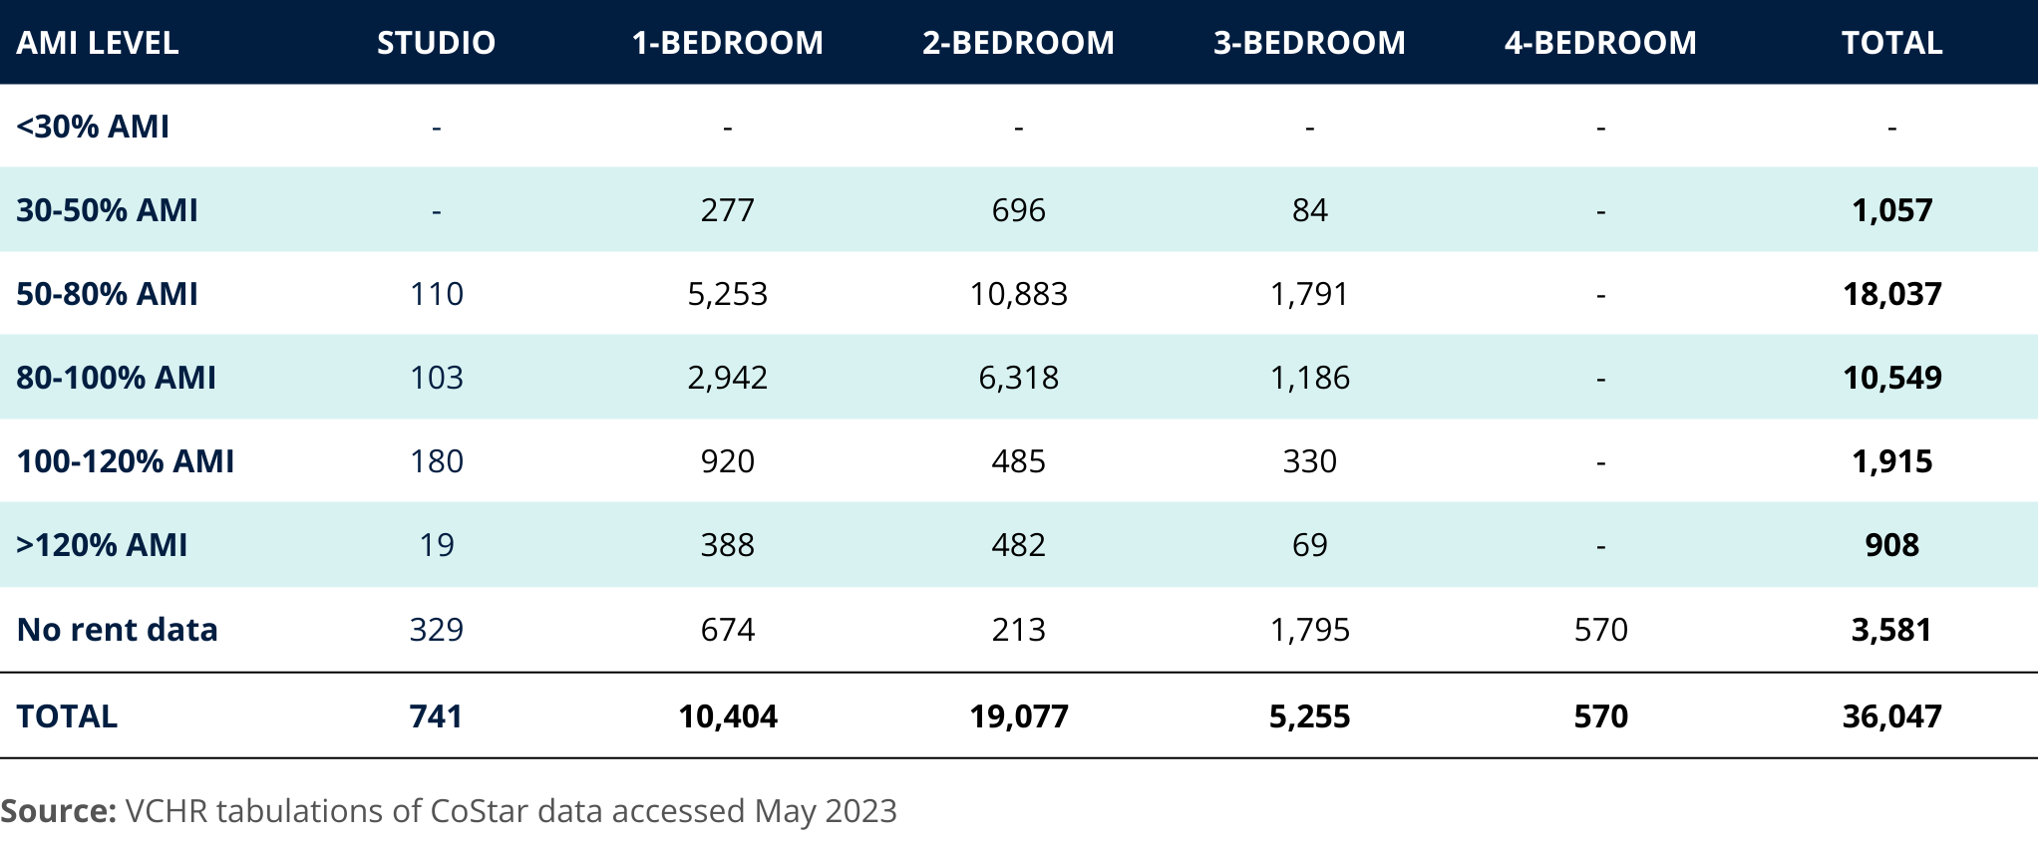
VCHR used the Virginia Beach MLS data to calculate the percent difference between the close price and tax assessed values for homes sold in 2022. The median percent difference for all units included in the recent MLS sales was then applied to the total taxable value of each home to adjust assessed value to an estimated value that homebuyers would be more likely to pay in the market. VCHR estimated a mortgage payment for each unit using two down-payment scenarios: 5% down and 10% down. To determine a monthly payment, analysts used the standard mortgage payment formula:
$$M=P\left[i{\left(1+i\right)}^{n}/\left(\left({\left(1+i\right)}^{n}\right)−1\right)\right]$$
Here, M is the monthly payment, P is the principal amount (or the difference between the adjusted value and the down payment), i is the monthly interest rate, and n is the number of months (in this case, 360 for a 30-year mortgage). VCHR used the mortgage interest rate (0.0642%) for Freddie Mac’s 30-year fixed rate as of December 2022. It’s important to note that in recent years, the interest rate has increased significantly, so depending on the timing of the contract, the mortgage payment may have some volatility.
VCHR combined the mortgage payment with estimated monthly insurance payment, utility costs, real estate taxes, and HOA and condo fees to estimate the total monthly housing expenses. The average utility cost ($244.32) was calculated based on the 2021 Virginia Beach city PUMS data, encompassing monthly payments for fuel, water, electricity, and gas. Annual average insurance premiums in Virginia were applied from the 2020 National Association of Insurance Commissioners (NAIC) report. The annual real estate tax was calculated by applying Virginia Beach’s general tax rate of 0.99%. The HOA and condo fees were derived from 2022 MLS data, with the average fee for single-family detached and attached properties in Virginia Beach being $63.30, and the average condo properties being $272.20.
VCHR evaluated the affordability of 145,498 identified single-family detached, attached, and condo properties from assessment data based on down-payment percentages (5%/10%) and household sizes (1.5 person/4.5 person). These are presented in Table C.3 and Table C.4. For example, when a 5% down payment is made, approximately 8,123 properties are considered affordable for households with 1.5 persons and an income in the range of 80%-100%.
For 1.5-person households, approximately 9,213 units with a 5% down payment are affordable to households with incomes of $70,150 or less. For 4.5-person households, approximately 45,091 units with a 5% down payment are affordable to households with incomes of $97,250 or less. Though the units identified in this analysis may be affordable to low- and moderate-income households, they are not necessarily available to low- and moderate-income households. Many of those units are not reserved for low- and moderate-income households via income restrictions and are occupied by households with higher incomes.
Table C.3: Number of Units by Down Payment Percentage (1.5 person / 1 bedroom)

Table C.4: Number of Units by Down Payment Percentage (4.5 persons / 3 bedrooms)
With 35% of homes in the overall housing market considered affordable options for ownership, when a 10% down payment is made, the scarcity of affordable housing options for households with moderate incomes or below (4.5-person households) is evident. Furthermore, according to VCHR's analysis, 98% of these units were constructed prior to the year 2000. This raises concerns about potential additional costs for renovations and maintenance due to age-related issues and overall condition. In the end, the majority of residents in Virginia Beach inevitably face cost-burden problems when it comes to homeownership. Affordable housing remains a scarce resource, making it difficult for many individuals and families to find suitable and affordable housing options.
VCHR conducted an analysis of Naturally Occurring Affordable Housing (NOAH) on a City Council district basis for 1.5 persons (1-bedroom) and 4.5 persons (3-bedroom) with a 5% down payment. The assessment was focused on units suitable for households earning 80% or less / 100% or less of the Area Median Income (AMI). The results are presented in Table C.5, Table C.6, and Figure C.1.
City Council District 4 stands out with a higher proportion of affordable units, particularly in comparison to other districts. Around 46% of the units are affordable to households with incomes of 80% or less of the AMI, and 73% are affordable for those with incomes equal to or below 100% of the AMI. On the other hand, City Council District 2 shows a comparatively lower percentage of affordable units. Only 2% of the units are affordable to households with incomes of 80% or less of the AMI, and 4% are affordable for those with incomes equal to or below 100% of the AMI.
Table C.5: Number of Units by City Council District (1.5 person / 1 bedroom)
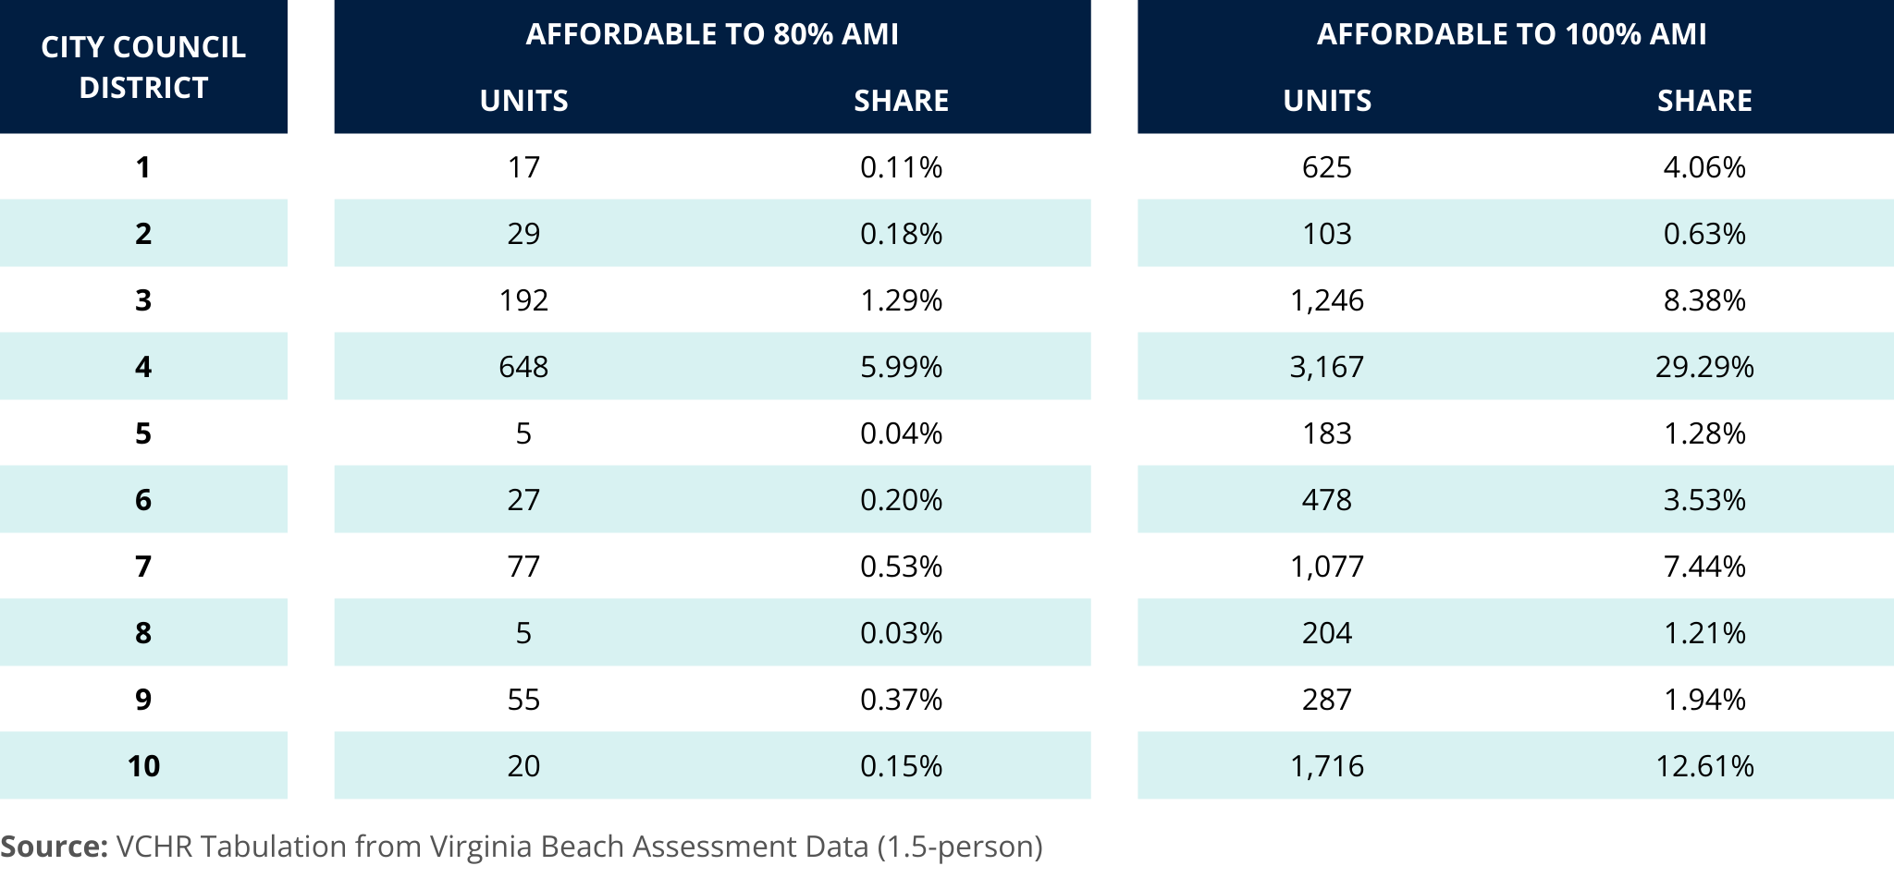

Table C.6: Number of Units by City Council District (4.5 persons / 3 bedrooms)
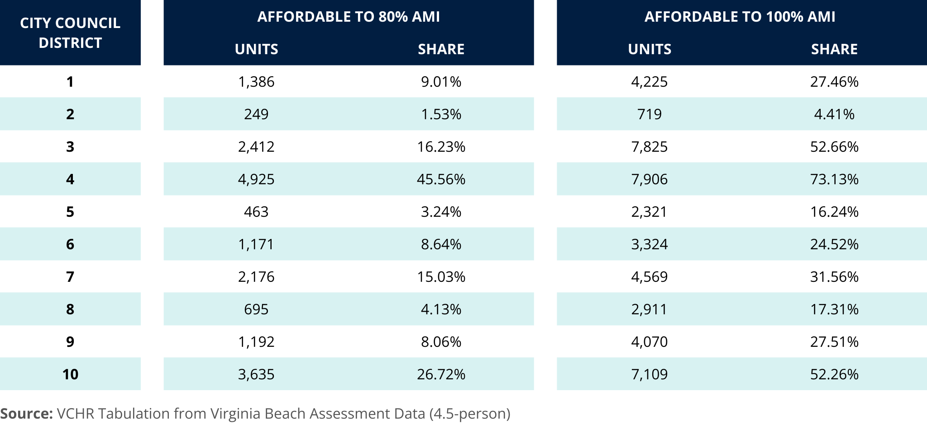

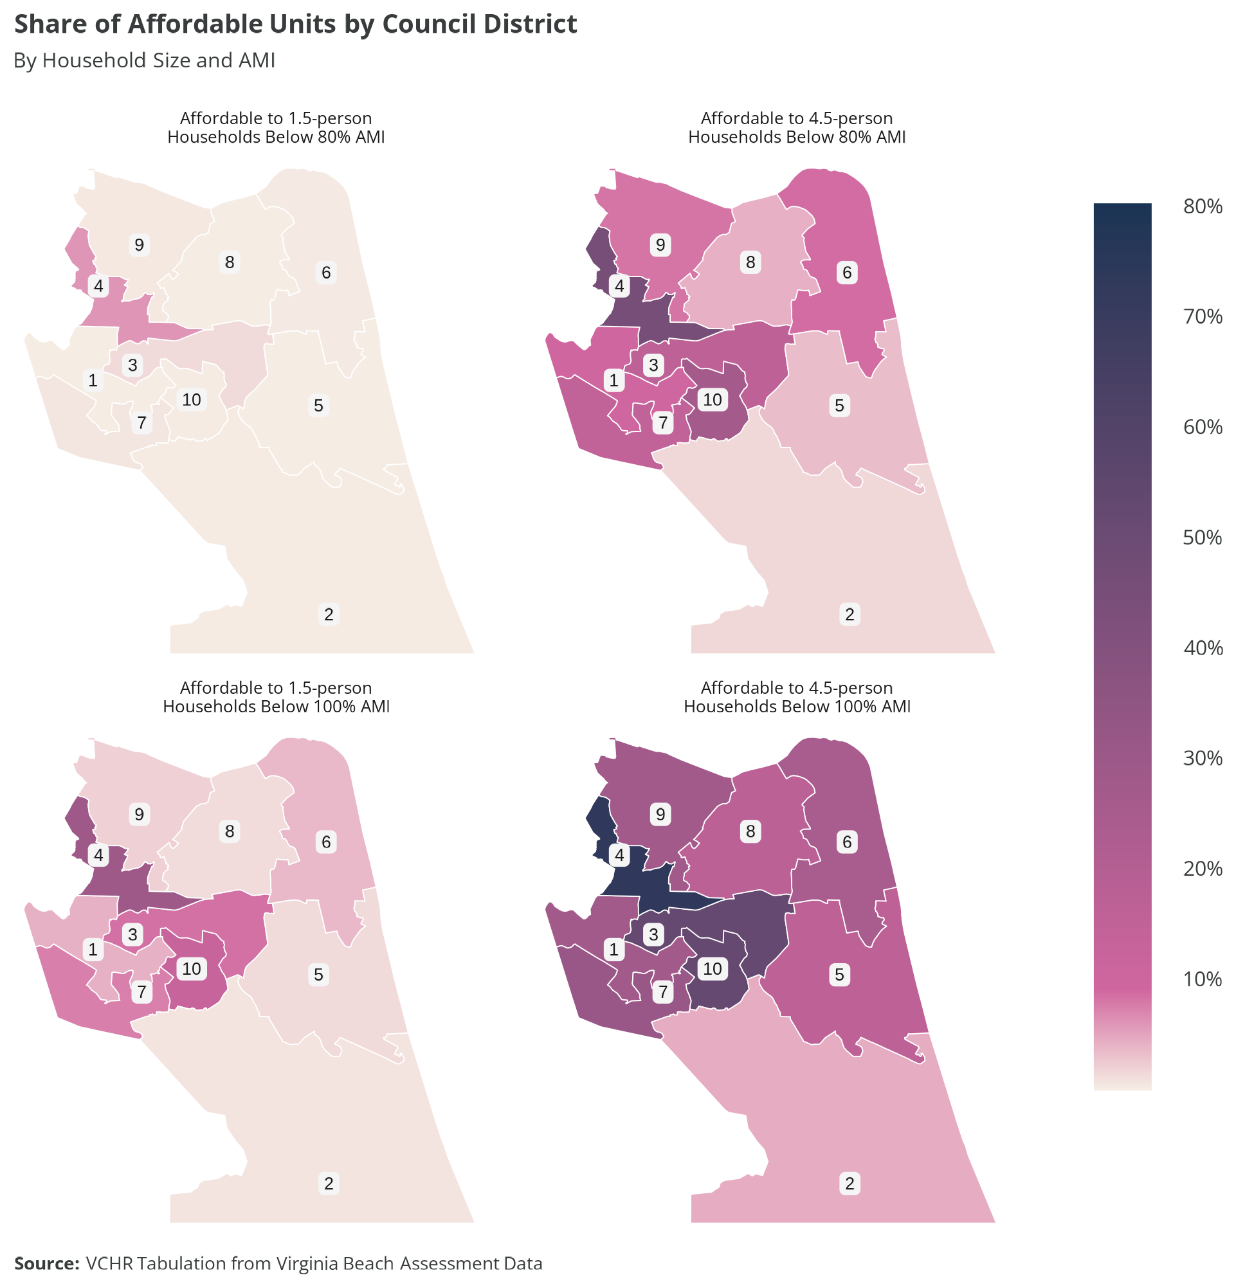
Figure C.1: Share of Affordable Units by Council District, Household Size, and AMI

C.2 Rental: multifamily units
VCHR applied HUD Income Limits — as well as rules for housing affordability by household size and unit size — to categorize multifamily rental units by affordability level. VCHR completed this analysis for 287 properties included in CoStar data extracted in May 2023. These properties represent 42,021 units, approximately 81% of the American Community Survey's estimated 52,066 multifamily rental units.
Of the 287 properties, 230 properties with 36,367 units are fully "market rate" and do not include subsidy or affordability restrictions. These units span sizes, ranging from studios to 1-bedroom, 2-bedroom, 3-bedroom, and even 4-bedroom units. Among these units with available rent data, 91% are affordable to households with incomes less than or equal to 100% of Area Median Income (AMI).
VCHR used the income limits shown in Table C.1 and the associated maximum affordable rent (30% of the income limit divided into 12 monthly rent payments) shown in Table C.7, to categorize units by affordability level. The maximum affordable rent for a 1-person household is applied to studio apartments, the affordable rent for 1.5-person households is applied to 1-bedroom units, the affordable rent for a 3-person household is applied to 2-bedroom units, and the affordable rent for a 4.5-person household is applied to 3- and 4-bedroom units. VCHR adopted this convention from the rules applied by HUD to classify units for the Consolidated Housing Affordability Strategy (CHAS) data tabulations. VCHR used the maximum affordable rents in Table C.7 to set ranges for property-wide average rents by unit type reported to CoStar.
Table C.7: Total Market Affordable Housing Units by Unit Size and Affordability Category
Table C.7 shows the number of market-rate units that are affordable to households by income categories. More than half these units are 2-bedroom units, while 29% are 1-bedroom units. Approximately 16% are 3+ bedroom units, and studios make up only 2%. Nearly 90% of units are affordable to households with incomes 50%-100% of AMI, and few units are affordable to households with very-low or extremely low incomes, below 50% of AMI. This distribution pattern underscores the challenges faced by individuals and families with lower incomes in accessing affordable market-rate units, highlighting the need for more extensive affordable housing options for this population.

Myers, D. (2016). Peak millennials: Three reinforcing cycles that amplify the rise and fall of urban concentration by millennials. Housing Policy Debate, 26(6), 928-947.
Goodman, L. S., & Mayer, C. (2018). Homeownership and the American dream. Journal of Economic Perspectives, 32(1), 31-58.
See Alba, R. D., & Logan, J. R. (1992). Assimilation and stratification in the homeownership patterns of racial and ethnic groups. International migration review, 26(4), 1314-1341. Wachter, S. M., & Megbolugbe, I. F. (1992). Impacts of housing and mortgage market discrimination racial and ethnic disparities in homeownership. Housing Policy Debate, 3(2), 332-370. Hall, M., & Crowder, K. (2011). Extended-family resources and racial inequality in the transition to homeownership. Social Science Research, 40(6), 1534-1546. Hilber, C. A., & Liu, Y. (2008). Explaining the black–white homeownership gap: the role of own wealth, parental externalities and locational preferences. Journal of Housing Economics, 17(2), 152-174.
Gyourko, J., Linneman, P., & Wachter, S. (1999). Analyzing the relationships among race, wealth, and home ownership in America. Journal of Housing Economics, 8(2), 63-89.
Engelhardt, G. V., & Mayer, C. J. (1998). Intergenerational transfers, borrowing constraints, and saving behavior: Evidence from the housing market. Journal of Urban Economics, 44(1), 135-157.
Hall, M., & Crowder, K. (2011). Extended-family resources and racial inequality in the transition to homeownership. Social Science Research, 40(6), 1534-1546.
Chiteji, N. S., & Hamilton, D. (2002). Family connections and the black-white wealth gap among middle-class families. The Review of Black Political Economy, 30(1), 9-28.
Charles, K. K., & Hurst, E. (2002). The transition to home ownership and the black-white wealth gap. Review of Economics and Statistics, 84(2), 281-297.
Faber, J. W. (2018). Segregation and the geography of creditworthiness: Racial inequality in a recovered mortgage market. Housing Policy Debate, 28(2), 215-247.
Pager, D., & Shepherd, H. (2008). The sociology of discrimination: Racial discrimination in employment, housing, credit, and consumer markets. Annual Review of Sociology, 34, 181-209.
Kuebler, M., & Rugh, J. S. (2013). New evidence on racial and ethnic disparities in homeownership in the United States from 2001 to 2010. Social Science Research, 42(5), 1357-1374.
National Association of REALTORS® Research Group. (2023). 2023 Home Buyers and Sellers Generational Trends Report. Retrieved October 27, 2023, from https://www.nar.realtor/sites/default/files/documents/2023-home-buyers-and-sellers-generational-trends-report-03-28-2023.pdf
Ibid.
National Association of REALTORS® Research Group. (2021). 2021 Home Buyers and Sellers Generational Trends Report. Retrieved October 11, 2022, from https://www.nar.realtor/sites/default/files/documents/2021-home-buyers-and-sellers-generational-trends-03-16-2021.pdf
National Association of REALTORS® Research Group. (2023). 2023 Home Buyers and Sellers Generational Trends Report. Retrieved October 27, 2023, from https://www.nar.realtor/sites/default/files/documents/2023-home-buyers-and-sellers-generational-trends-report-03-28-2023.pdf
Ibid.
The U.S. Census Bureau defines family households as two or more people related by birth, marriage, or adoption. Family households may include other members who are non-related. See: https://www.census.gov/programs-surveys/cps/technical-documentation/subject-definitions.html#family
Anderson, D., & Bokhari, S. (2023). The Race to Homeownership: Gen Z Tracking Ahead of Their Parents’ Generation, Millennials Tracking Behind. REDFIN. https://www.redfin.com/news/gen-z-millennial-homeownership-rate-home-purchases/
Myers, D., Lee, H., & Simmons, P. A. (2020). Cohort insights into recovery of Millennial homeownership after the Great Recession. Journal of Housing Economics, 47, 101619.
Ibid.
Anderson, D., & Bokhari, S. (2023). The Race to Homeownership: Gen Z Tracking Ahead of Their Parents’ Generation, Millennials Tracking Behind. REDFIN. https://www.redfin.com/news/gen-z-millennial-homeownership-rate-home-purchases/
As of Janaury 2024, CoStar tracks a total inventory of 42,703 rental units in Virginia Beach. Only 1,020 (2.4%) of these are townhomes or single-family homes. This is also a very small amount compared to the 24,551 estimated detached and attached single-family homes occupied by renters shown in Figure 4.1.
Source: ACS Published Tables, 2021 5-year, B25004.
The Housing Economic Recovery Act of 2008 established a $7,500 tax credit that is similar to a no-interest loan and must be repaid in 15 equal, annual installments beginning in 2010. For homes purchased in 2009, the credit does not have to be paid back unless the home ceases to be the taxpayer’s main residence within a three-year period following the purchase. https://www.irs.gov/taxtopics/tc611
See https://www.census.gov/housing/hvs/definitions.pdf
Benfer, E. A., Koehler, R., Mark, A., Nazzaro, V., Alexander, A. K., Hepburn, P., ... & Desmond, M. (2022). COVID-19 housing policy: State and federal eviction moratoria and supportive measures in the United States during the pandemic. Housing Policy Debate, 1-25.
Airgood-Obrycki, W., & Hermann, A. (2022, July 20). “Affordability gaps widened for renters in the first year of the pandemic.” Joint Center for Housing Studies. https://www.jchs.harvard.edu/blog/affordability-gaps-widened-renters-first-year-pandemic
The number of military households who own free and clear is too small to generate a reliable estimate.
Torres 2023, accessed October 2023, https://bipartisanpolicy.org/blog/faqs-housing-military-families/#:~:text=Service%20members%20living%20in%20government,rents%20above%20the%20BAH%20rate.
Based on interview with Shawn Crumlish, Executive Director of the Virginia Resource Authority, August 2023.
This data comes from 104 organizations that offer “shared-equity” housing programming in the United States. See The 2022 Census of Community Land Trusts and Shared Equity Entities in the United States: Prevalence, Practice and Impact. (PDF)
See Tracking Growth and Evaluating Performance of Shared Equity Homeownership Programs During Housing Market Fluctuations.
The equity gained is the difference in the sales value of the home from the mortgage owed, plus the value of the principal payments made over time.

